

EXPLODED VIEW

VS-DELTA
PASTRY

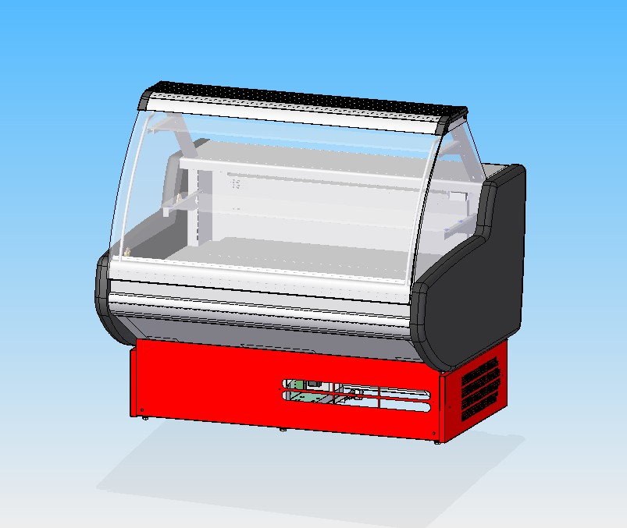

GENERAL SPLITTING UP

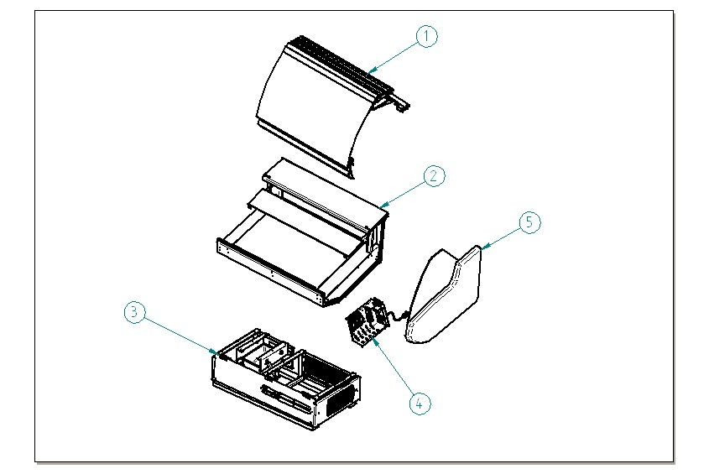

- GLASSES SUPERSTRUCTURE
- DISPLAY AREA INTERNAL FINISH
- FRONTAL DECORATION, FRAME, DRAIN
- CONTROL BOARD
- COMPLETE SIDE WALL

  - GLASSES SUPERSTRUCTURE

1.1 GLASS AND PROFILES
1.2 INTERMEDIATE SHELF
1.3 ALUMINIUM TOP AND LAMPS
1.4 GLASS UPRIGHT
1.5 BUMPER BAND

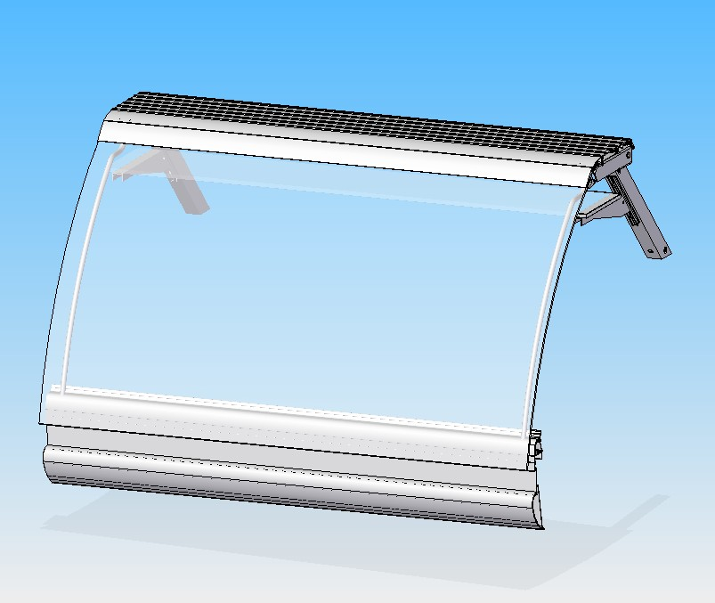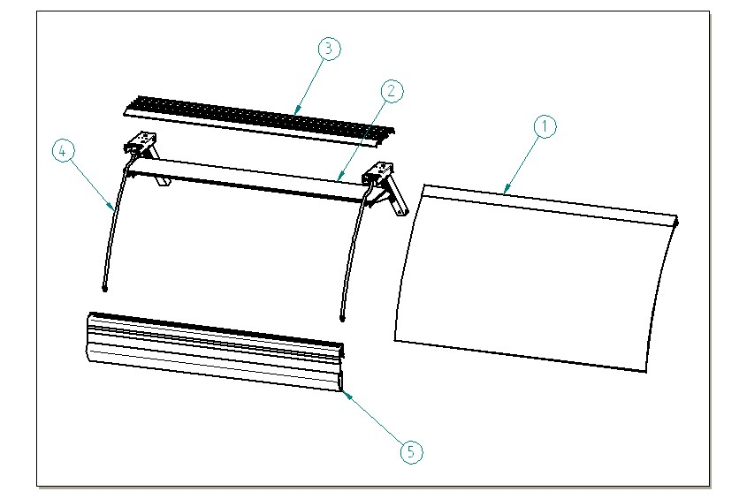

  - GLASS AND PROFILES

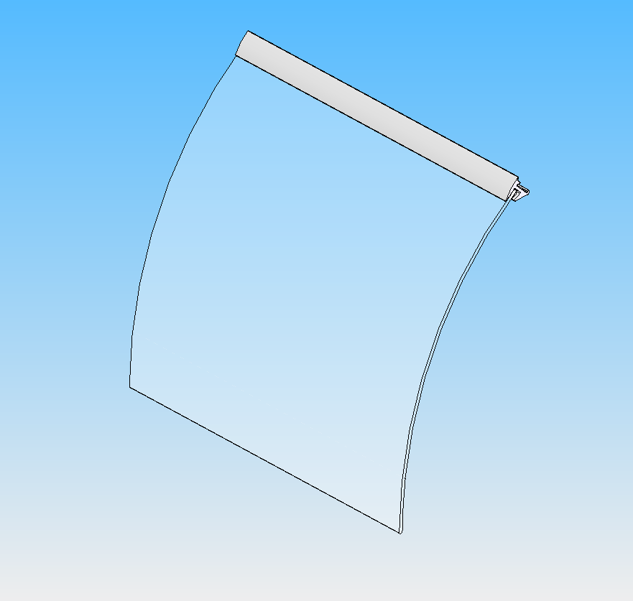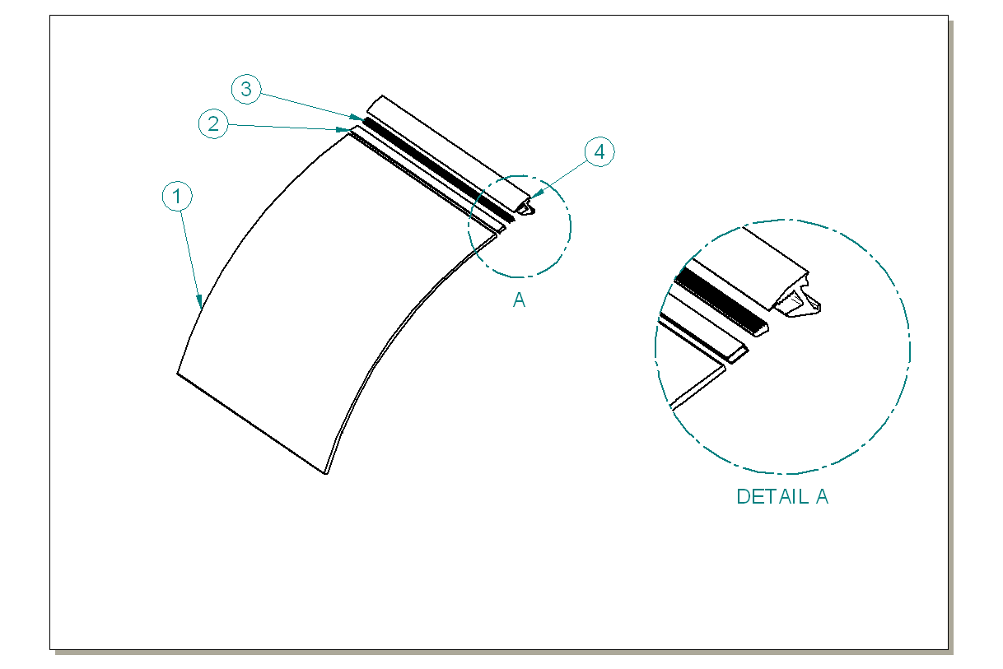

ITEM  NUMBER | DOCUMENT  NUMBER | TITLE | MATERIAL | PART NO. FOR EACH MODULE
 |  |  |  | 1190 | 1785
1 | EEAV 106 | SILKSCREEN R1000 GLASS | FLOAT 6mm SILKSCREEN | 4191915 | 4191917
2 |  | GLASS GASKET PROFILE | PVC | 4180100 | 4180100
3 | DA0D 023 | JAW INSERT PROFILE CUT | ALUMINIUM PROFILE E5628A | 2PV120030006 | 2PV200030006
4 | DA0D 015 | GLASSES JAW CUT AND DRILLING | ALUMINIUM | 2PV120030005 | 2PV200030005

1.2 INTERMEDIATE SHELF
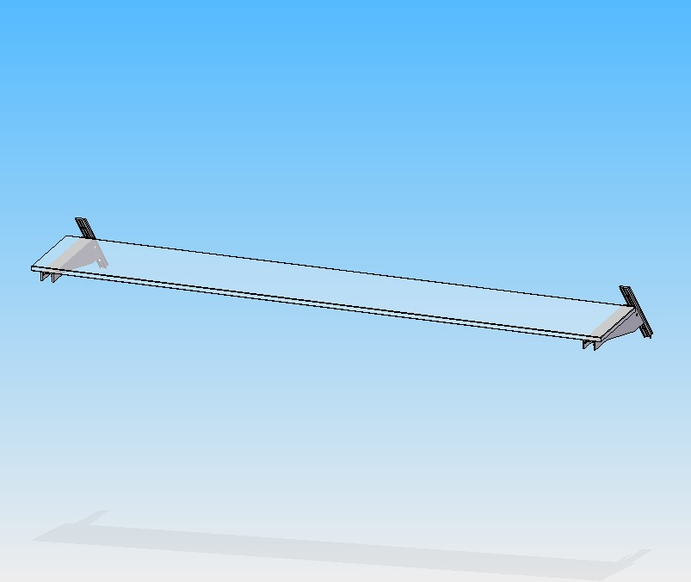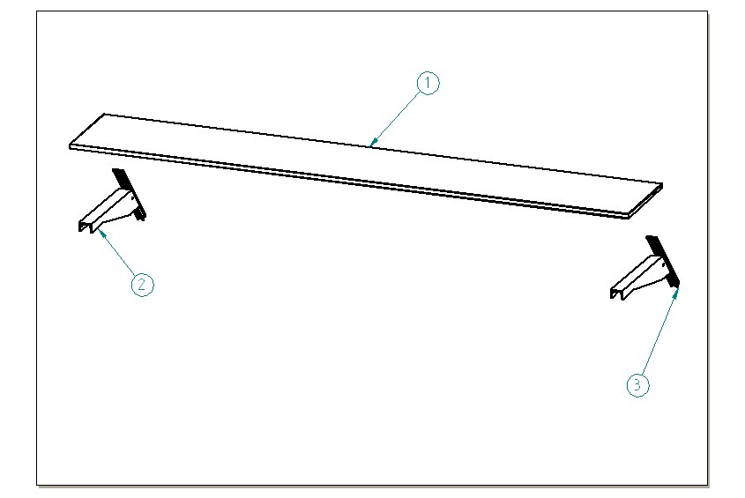

ITEM  NUMBER | DOCUMENT  NUMBER | TITLE | MATERIAL | PART NO. FOR EACH MODULE
 |  |  |  | 1190 | 1785
1 | ET0T 010 | GLASS FOR SHELF | FLOAT 10 mm TRANSPARENT | 4190945 | 4190946
2 | ET0T 009 | BRACKET FOR INTERMEDIATE SHELF 400 | ALUMINIUM PROFILE | 4141200
3 | ET0T 009 | GUIDE FOR INTERMEDIATE SHELF | ALUMINIUM PROFILE | 4141203

1.3 ALUMINIUM TOP AND LAMPS

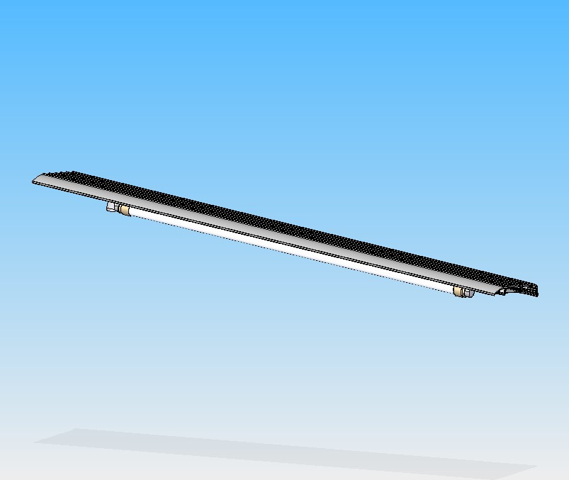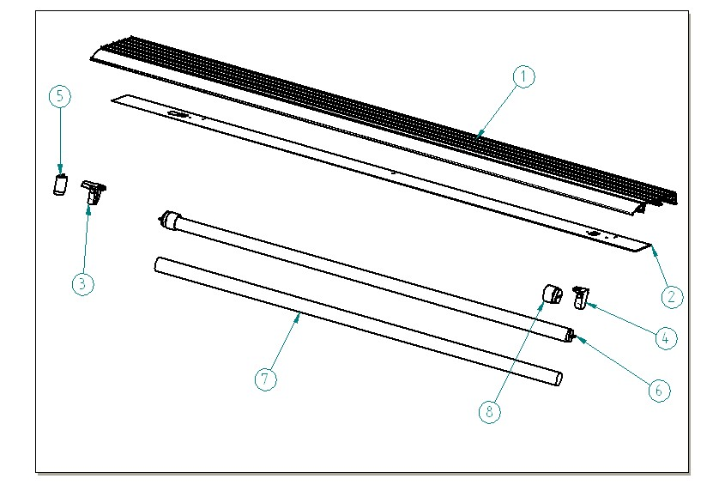

ITEM  NUMBER | DOCUMENT  NUMBER | TITLE | MATERIAL | PART NO. FOR EACH MODULE
 |  |  |  | 1190 | 1785
1 | ET0D 002 | LINEAR MODULE TOP PROFILE MOD 1190 | ALUMINIUM PROFILE Q 1238 | 2BV120032003 | 2BV200032003
2 | ET0E 001 | TOP LAMP-HOLDER MOD VS-V130 | PLASTICIZED SHEET 8/10 | 6BV120022004 | 6BV200022004
3 |  | LAMP-HOLDER + STARTER-HOLDER 249 TCR "UL" | PVC | 4114726
4 |  | LAMP-HOLDER 249 TS "UL" | PVC | 4114727
5 |  | STARTER OSAMA ST 111 |  | 4116001
6 |  | WHITE NEON D.26 L 895 |  | 4114303 | 4114307
7 |  | NEON AKO PROTECTION TUBE | PVC | 4114716 | 4114718
8 |  | NEON CAP | PVC | 4114716 | 4114719

1.4 RIGHT SIDE UPRIGHT

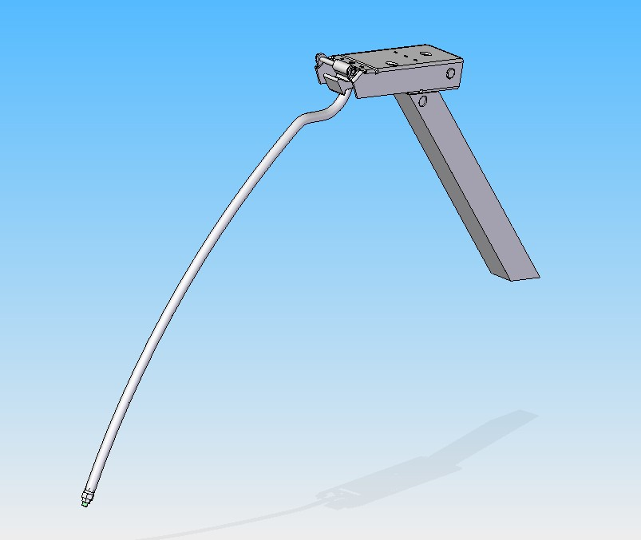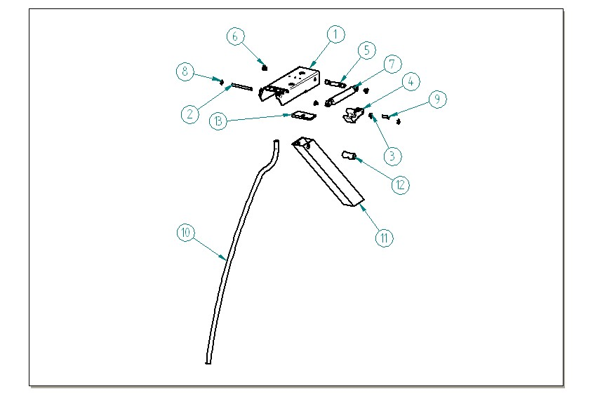

ITEM  NUMBER | DOCUMENT  NUMBER | TITLE | MATERIAL | PART NO. FOR EACH MODULE
 |  |  |  | 1190 | 1785
1 | EEAV 104 | PLIERS CASING | SHEET 25/10 | 4140010
2 | EEAV 017 | ARM PIN | DRAWN GROUND D6 GALVANIZED
3 | EEAV 016 | PISTON NYLON BUSH | NYLON | 8291718
4 | EEAV 011 | RIGHT ROTATION LEVER | ALUMINIUM ALLOY | 4282113
5 | EEAV 019 | PISTON BACK PIN | DRAWN IRON
6 | EEAV 086 | BOLT FOR BACK PIN | DRAWN IRON
7 |  | PISTON STROKE 60 | STEEL | 4145020 | 4145023
8 |  | SEGGER 5 | GALVANIZED STEEL | 8298303
9 | EEAV 018 | PISTON FRONT PIN | DROWN GROUND GALVANIZED
10 | EEAV 116 | FRONT UPRIGHT | TUBE 12X1.2 | 4283104
11 | ET0D 001 | BACK UPRIGHT WITHOUT HOLE | ALUMINIUM PROFILE PE3107 | 2BV120030352
12 | EEAV 001 | UPRIGHT BLOCK | GALVANIZED DRAWN
13 | EEAV 052 | PLIERS FIXING BLOCK 58 X 30 | ALUMINIUM PROFILE 30 X 6 | 4282002

1.5 BUMPER BAND

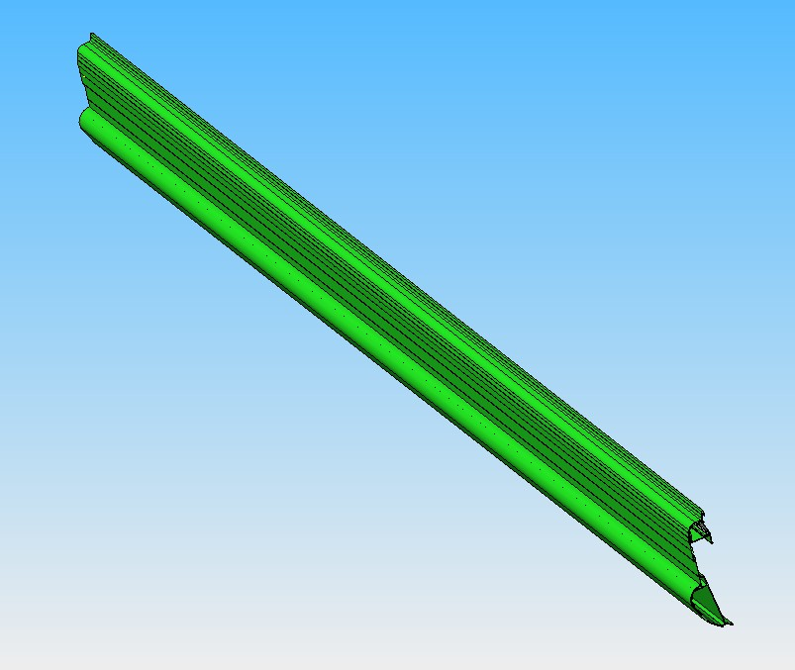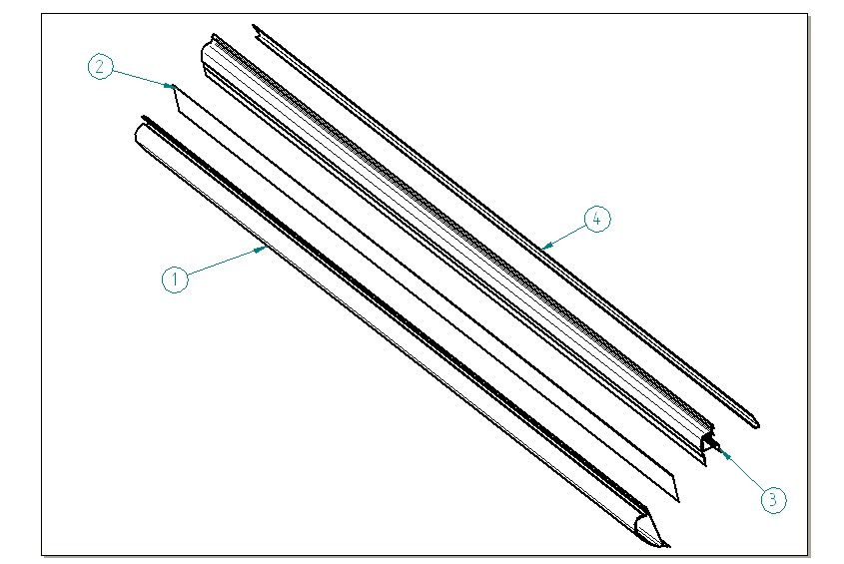

ITEM  NUMBER | DOCUMENT  NUMBER | TITLE | MATERIAL | PART NO. FOR EACH MODULE
 |  |  |  | 1190 | 1785
1 | ET0J 004 | LINEAR FRONT PROFILE | PVC PROFILE P1421 | 2DV1200F2001 | 2DV2000F2001
2 | DEAV 503 | PAINTED FRONT STRIPE | PLAST. SHEET 5/10 | 6DV360070106 | 6DV360070106
3 | ET0L 002 | ANTI-MIST BAND | ALUMINIUM PROFILE PE 3109
4 | EEAV 014 | ANTI-MIST HEATER PROTECTION | ALUMINIUM | 6DV120030058 | 6DV200030058

  - INTERNAL FINISH

2.1 INTERNAL FINISH
2.2 MOVABLE CHEST
2.3 WORKING TABLE
2.4 BOTTOM SHELF

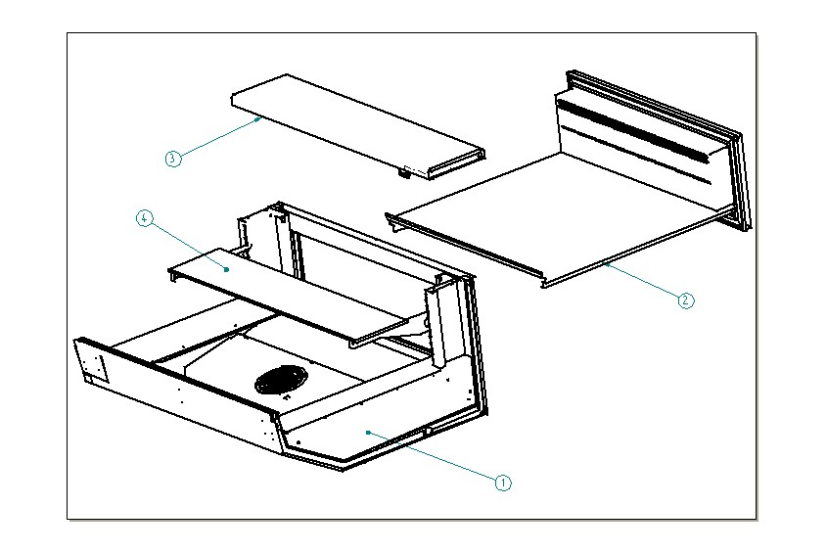

2.1 INTERNAL FINISH

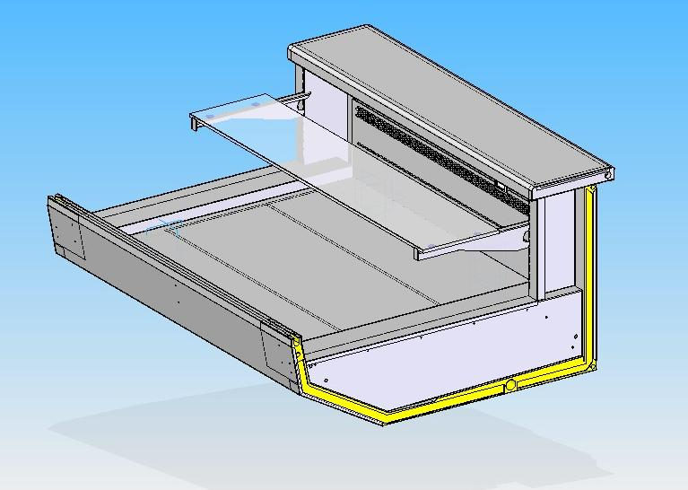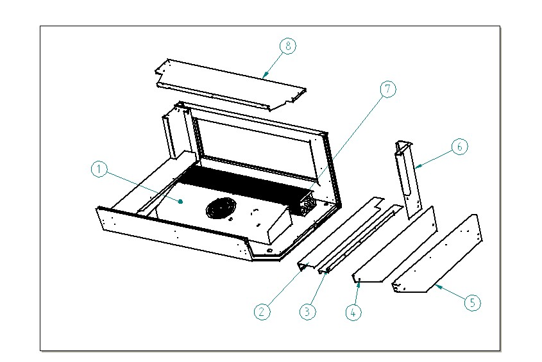

ITEM  NUMBER | DOCUMENT  NUMBER | TITLE | MATERIAL | PART NO. FOR EACH MODULE
 |  |  |  | 1190 | 1785
1 |  | FANS HOLDER ASSEMBLED |  | 2DV120040111 | 2DV200040111
2 | EEAZ 204 | LEFT DRAWER CLOSURE | STAINLESS STEEL AISI 304 8/10 | 6DV120040109
3 | EEAZ 202 | LEFT SLIDE GUIDE SUPPORT | STAINLESS STEEL AISI 304 15/10 | 6DV120040106
4 | EEAS 205 | LEFT CLOSURE FOR BASIN STOPPER | STAINLESS STEEL AISI 304 6/10 | 6DV120040120
5 | EEAS 204 | LEFT BASIN STOPPER | STAINLESS STEEL AISI 304 15/10 | 6DV120040102
6 | EEAZ 201 | LEFT RACK | STAINLESS STEEL AISI 304 15/10 | 6DV120040104
7 |  | EVAPORATOR ASSEMBLED |  | 2DV120172111 | 2DV200172111
8 |  | EVAPORATOR COVER | STAINLESS STEEL AISI 304 6/10 | 6DV120040110  (EEAZ 205/2) | 6DV200040110  (EEAZ 217)

FANS HOLDER

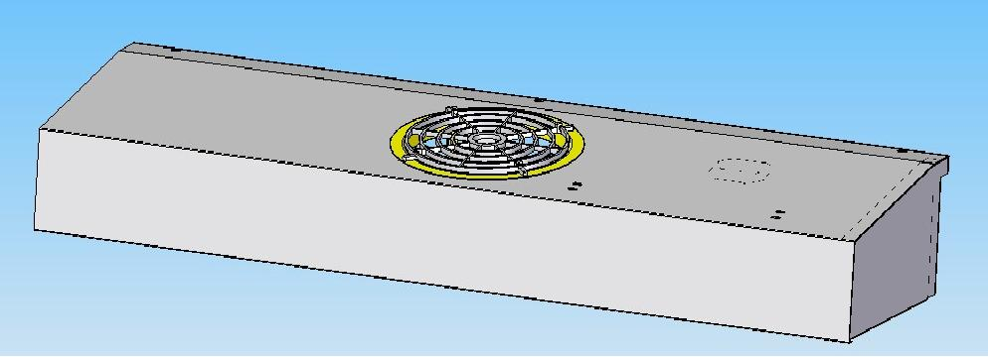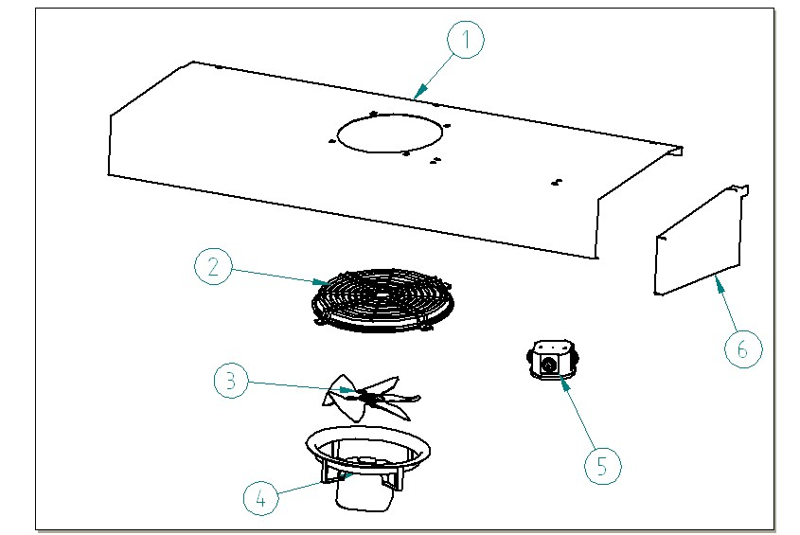

ITEM  NUMBER | DOCUMENT  NUMBER | TITLE | MATERIAL | PART NO. FOR EACH MODULE
 |  |  |  | 1190 | 1785
1 |  | FANS HOLDER | STAINLESS STELL AISI 304 6/10 | 6DV120040111  (EEAZ 206) | 6DV200040111 (EEAZ 218 DX)
 |  |  |  |  | 6DV200040126 (EEAZ 218 SX)
2 |  | PVC PROTECTION GRID | PLAST. | 4271908
3 |  | FAN |  | 4249926 | 4249927
4 |  | MOTORFAN 5W D.154 |  | 4240501
5 |  | SHUNT BOX D.65 GEWISS 44001 | PLAST. INSULATING MAT. GW | 4115401
6 | EEAZ 207 | LEFT FANS HOLDER HEAD | STAINLESS STELL AISI 304 6/10 | 6DV120040113

ASSEMBLED EVAPORATOR

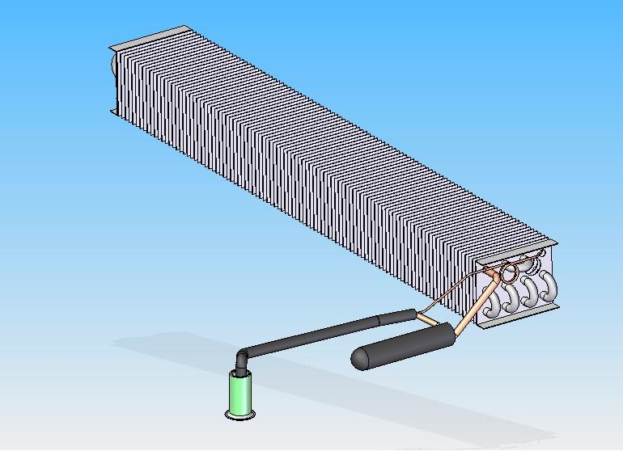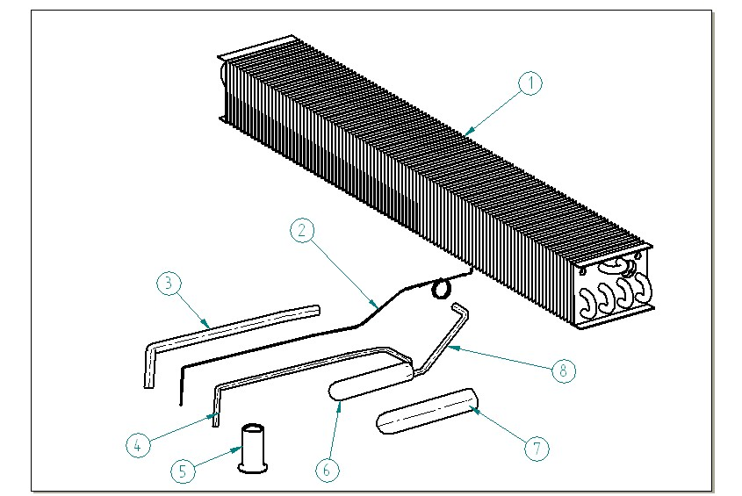

ITEM  NUMBER | DOCUMENT  NUMBER | TITLE | MATERIAL | PART NO. FOR EACH MODULE
 |  |  |  | 1190 | 1785
1 | ET0F 001 | EVAPORATOR | TUBES COPPER-SHEET.ALU. | 4222110 | 4222111
2 |  | CAPILLARY TUBE | CAPILLARY D.1,2 X 2,40 | 4260203
3 |  | ANTICONDENSATE TUBE | INSULATING SPONGE 6X12 | 4270502
4 |  | SUCTION TUBE | COOPER D. 8X10 (10 X 1) | 4260103
5 |  | PIPE D.32 mm |  | 4102125
6 |  | EVAPORATOR LIQUID SEPARATOR | COOPER TUBES
7 |  | ANTICONDENSATE TUBE | INSULATING SPONGE
8 |  | SUCTION TUBE | COOPER D. 8X10 (10 X 1) | 4260103

2.2 EXTRACTABLE DRAWERS

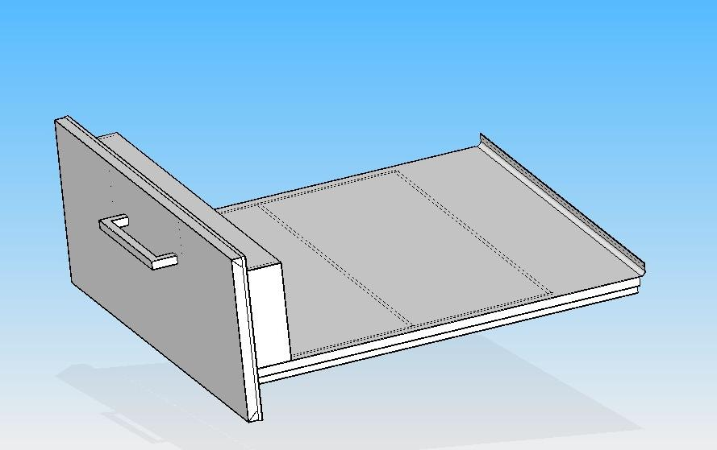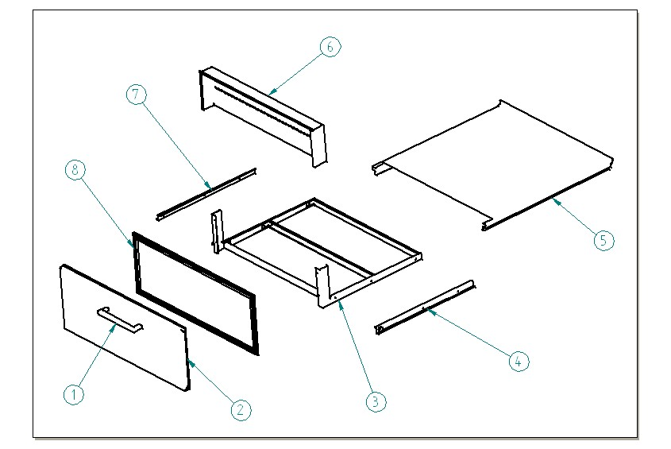

ITEM  NUMBER | DOCUMENT  NUMBER | TITLE | MATERIAL | PART NO. FOR EACH MODULE
 |  |  |  | 1190 | 1785
1 |  | LITTLE CHROMATE HANDLE E 222 |  | 4333701
2 | EEH0 205 | FOAMED DOOR | PLAST. SHEET 6/10 | 2DV120060109 | 2DV200060109
3 | EEH0 202 | DRAWER FRAME | STAINLESS STELL AISI 304 15/10 | 2DV120060106 | 2DV200060106
4 |  | PAINTED LEFT DRAWER SLIDE GUIDE |  | 4333310
5 | EEH0 203 | DRAWER PLATE | STAINLESS STELL AISI 304 8/10 | 6DV120060102  (EEH0 303) | 6DV200060102  (EEHO 208)
6 | DA1K 001 | BOTTOM BACK DISPLAY PLATE | STAINLESS STELL AISI 304 6/10 | 6PV120061001  (DA1K 001) | 6PV200061001  (DA1K 002)
7 |  | PAINTED RIGHT DRAWER SLIDE GUIDE |  | 4333311
8 | EEH0 205-3 | BACK DOOR GASKET | PVC | 4181901 | 4181900

2.3 WORKING TABLE

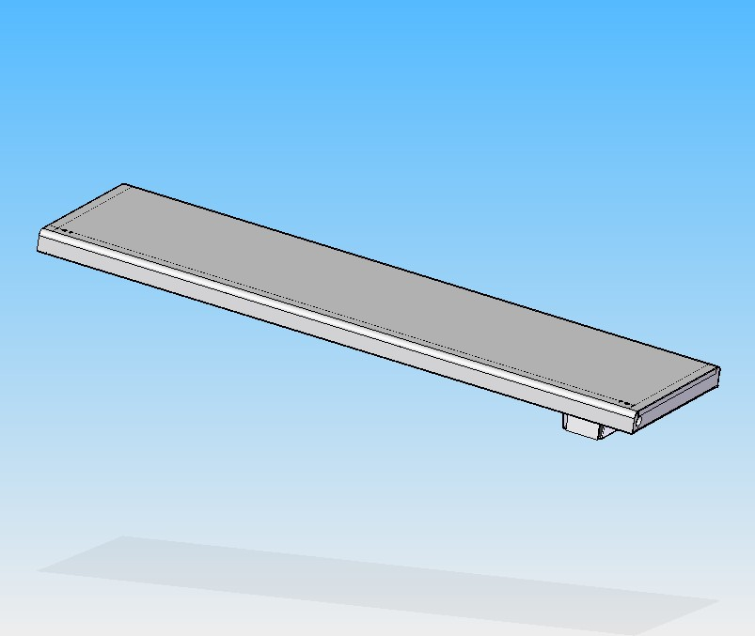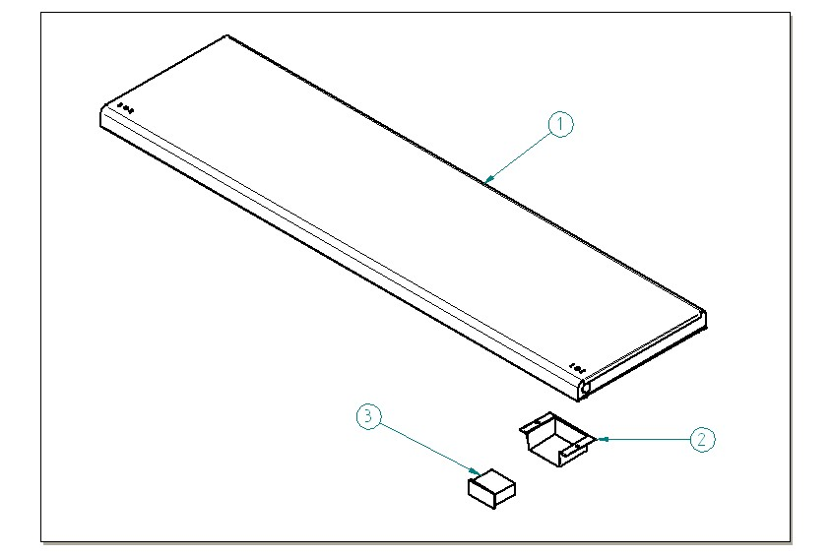

ITEM  NUMBER | DOCUMENT  NUMBER | TITLE | MATERIAL | PART NO. FOR EACH MODULE
 |  |  |  | 1190 | 1785
1 | ET0H 007 | WORKING TABLE | STAINLESS STELL AISI 304 8/10 | 2BV120012001 | 2BV200012001
2 |  | THERMOMETER-HOLDER |  | 4102114
3 |  | THERMOMETRO RECT.-40°+40°C°+ F°ROF88 |  | 4131300

2.4 BOTTOM SHELF

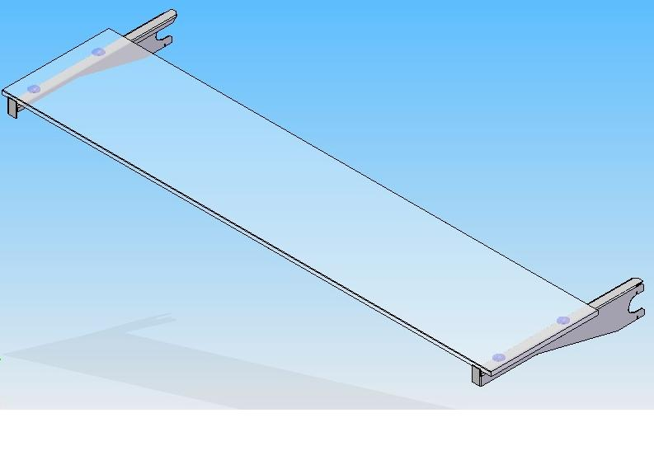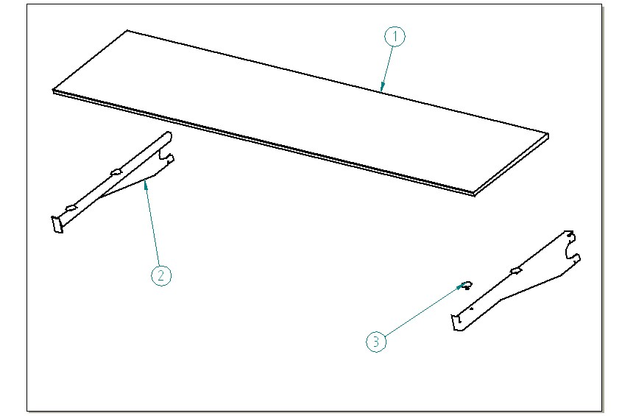

ITEM  NUMBER | DOCUMENT  NUMBER | TITLE | MATERIAL | PART NO. FOR EACH MODULE
 |  |  |  | 1190 | 1785
1 | EEAV 202 | GLASS FOR INTERMEDIATE SHELF | FLOAT 10 mm TRANSPARENT | 4190933 | 4190934
2 | EEAV 205/2 | RIGHT BOTTOM SHELF | STAINLESS STELL AISI 304 15/10 | 6DV120030101
3 |  | FEEDING SUCKER WITH TRANSPARENT BALL D.20 |  | 4336802
4 | EEAV 205/2 | LEFT BOTTOM SHELF | STAINLESS STELL AISI 304 15/10 | 6DV120030102

3. DECORATION-FRAME-DRAIN

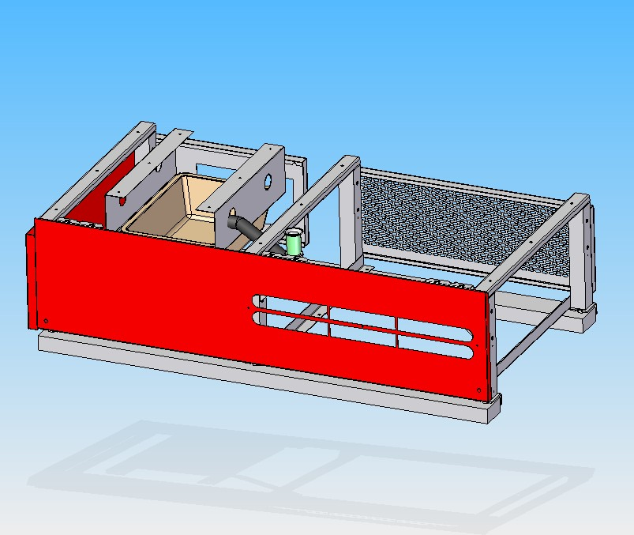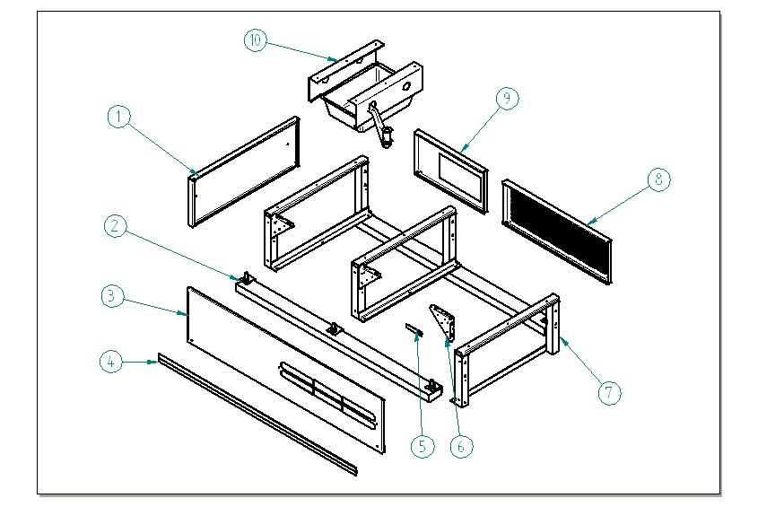

ITEM  NUMBER | DOCUMENT  NUMBER | TITLE | MATERIAL | PART NO. FOR EACH MODULE
 |  |  |  | 1190 | 1785
1 | ET0J 015 | RIGHT SIDE DECORATION PANEL | PLAST. SHEET 6/10 | 6DV120072056
2 |  | LOADING SLIDE |  | 4321219 | 4321220
3 | DEF0 501 | FRONTAL PANEL | PLAST. SHEET 8/10 | 6DV120070030 | 6DV200070030
4 |  | ‘MINIGONNA’ BLACK PROFILE |  | 4161901 | 4161903
5 | ET0J 001 | DECORATION SUPPORT BRACKET | SHEET 15/10 | 6BV120072007
6 | ET0B 002 | FRAME BRACKET | SHEET 15/10 | 6BV120002017
7 | ET0B 001 | GALVANIZED FRAME | IRON 360 | 4280114
8 | ET0J 002 | SLOT PANEL FOR COMPRESSOR AREA | PLAST. SHEET 6/10 | 6BV120072009 | 6BV120072009
9 | ET0J 003 | PIERCED BACK PANEL | PLAST. SHEET 6/10 | 6BV120072029 | 6BV200072029
10 |  | DRAIN |  | 2BV120052000 | 2BV200052000

LOADING SLIDE

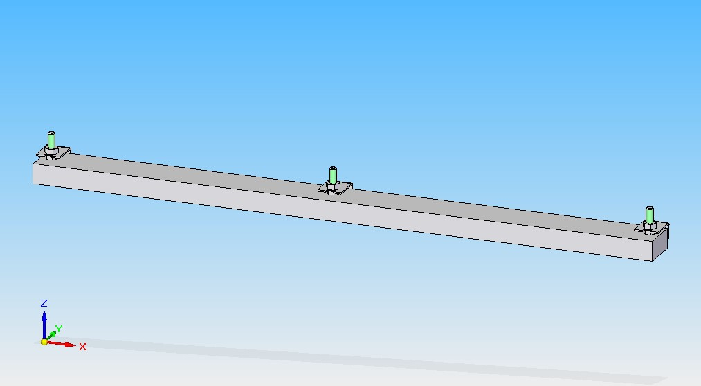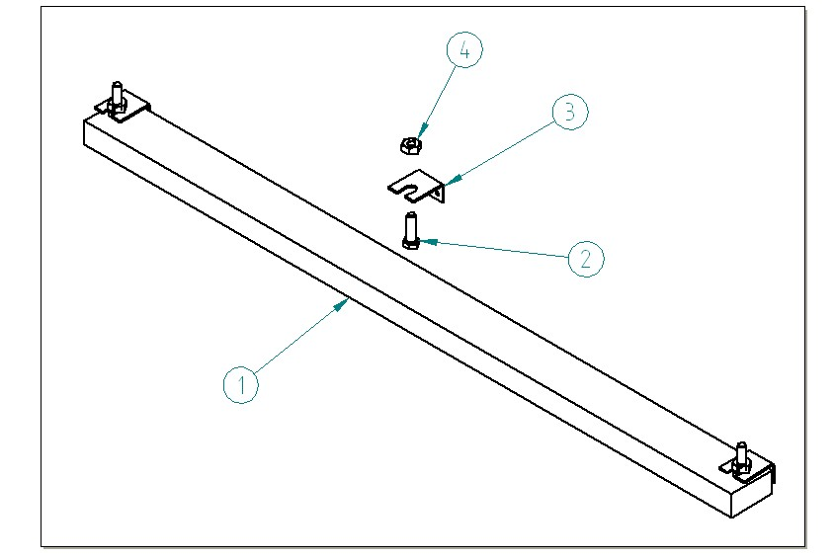

ITEM  NUMBER | DOCUMENT  NUMBER | TITLE | MATERIAL | PART NO. FOR EACH MODULE
 |  |  |  | 1190 | 1785
1 | ET0B 007 | LOADING SLIDE LINEAR MOD. 250 | SPRUCE WOOD | 4321219 | 4321220
2 |  | FEET BOLT M12 | GALVANIZED SHEET | 8293413
3 | DA0B 006 | LOADING SLIDE BLOCKING BRACKET | SHEET 30/10 | 4282883
4 |  | NUT M12 | GALVANIZED IRON

DRAIN

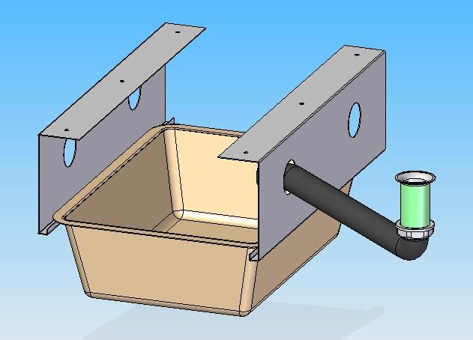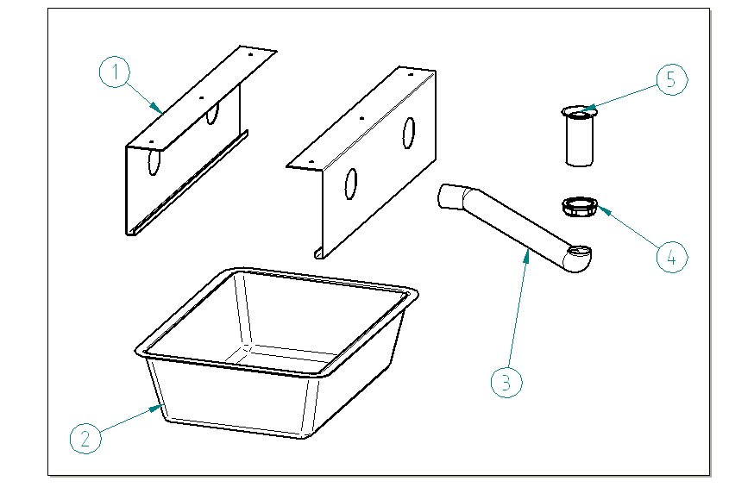

ITEM  NUMBER | DOCUMENT  NUMBER | TITLE | MATERIAL | PART NO. FOR EACH MODULE
 |  |  |  | 1190 | 1785
1 | ET0I 001 | DRAIN BASIN SUPPORT | SHEET 10/10 | 6BV120052001
2 |  | BASIN | PVC | 4100102 | 4100109
3 |  | DRAIN TUBE D32 | PVC | 4180815
4 |  | PIPE D32 | ABS | 4102125
5 |  | PIPE NUT D32 | ABS | 4102126

- CONTROL BOARD
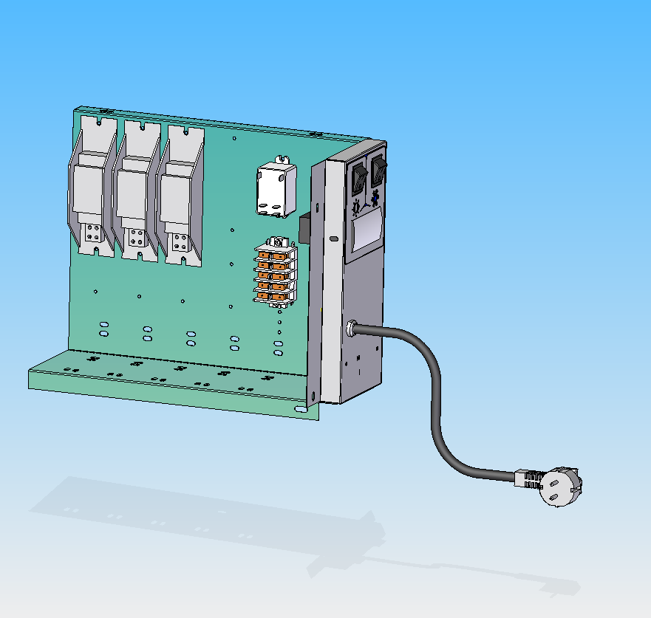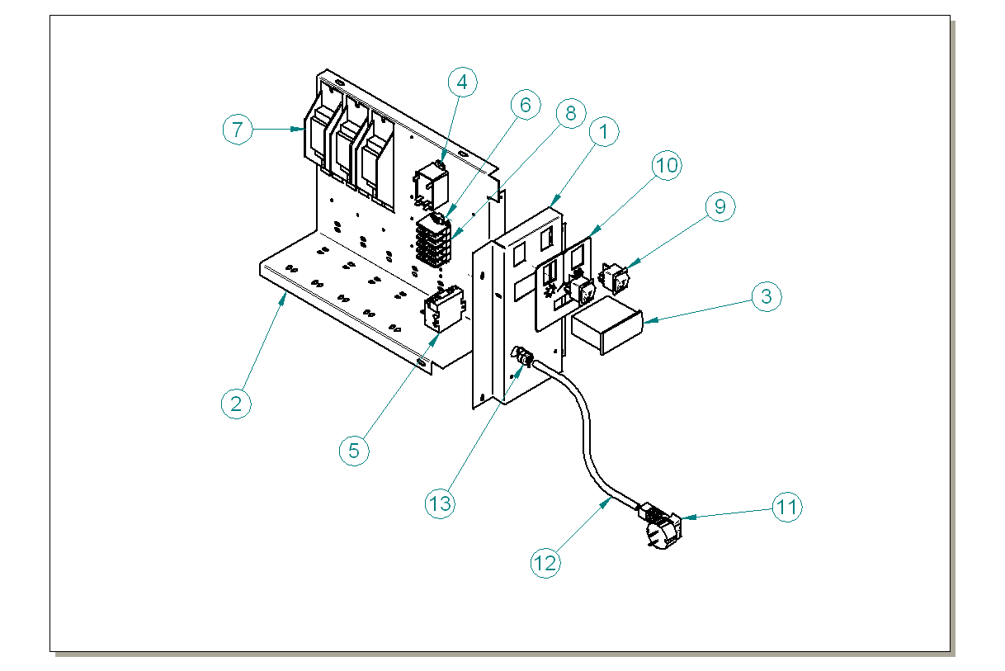

ITEM  NUMBER | DOCUMENT  NUMBER | TITLE | MATERIAL | PART NO. FOR EACH MODULE
 |  |  |  | 1190 | 1785
1 | ET0C 003 | ELECTRONIC FRONT CONTROL PANEL | PLAST. SHEET 6/10 | 6BV120020118
2 | ET0C 001 | BALLAST HOLDER | SHEET 10/10 | 6BV120020182
3 |  | ELECTRONIC CONTROL ELIWELL |  | 4131712
4 |  | RELE FINDER 66.82.8.230.0300 |  | 4111012
5 |  | TRANSFORMER 12 V |  | 4131623
6 |  | TERMINAL BOARD PA81 |  | 4113703
7 |  | BALLAST |  | 30 W 4115103 | 58 - 65 W 4115105
8 |  | TERMINAL BOARD FASTON PA 80 |  | 4113702
9 |  | BIPOLAR SWITCH |  | 4113518
10 | ET0C 004 | CONTROL BOARD PLATE |  | 4335648
11 |  | PLUG
12 |  | FEED CABLE
13 |  | STOPPER FAIRLEAD HEYCO 6N3-4 | PVC | 8291719

5. COMPLETE SIDE WALL

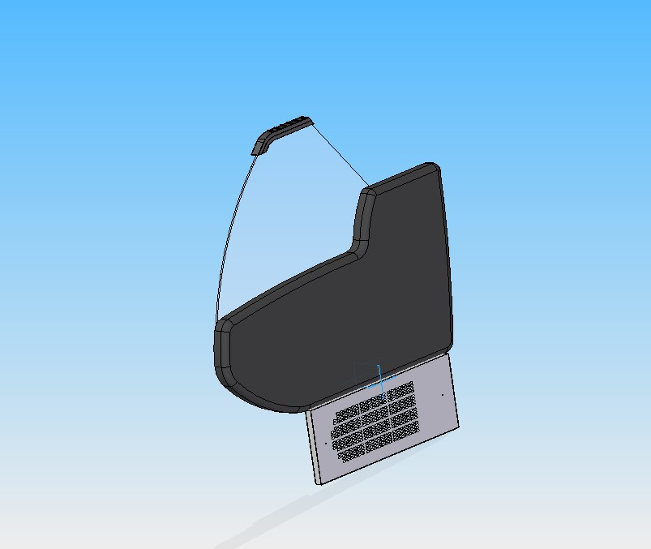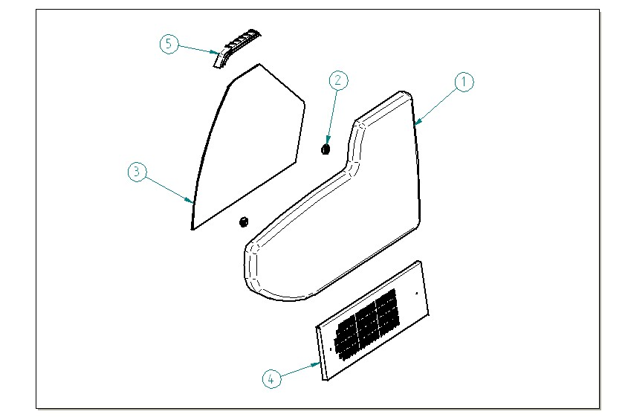

ITEM  NUMBER | DOCUMENT  NUMBER | TITLE | MATERIAL | PART NO. FOR EACH MODULE
 |  |  |  | 1190 | 1785
1 | ET0M 002 | END WALL | ABS | 4104006
2 |  | GLASS BLOCKING 1 | PVC | 4100313
3 | ET0M 001 | SIDE GLASS | FLOAT 6mm | 4190893
4 | ET0J 015 | LEFT SIDE DECORATION PANEL | PLAST. SHEET 6/10 | 2DV120070057
5 | RG 003 | TOP SIDE HEAD |  | 4105408

===========================================





Regione Gabannone, 4 – Zona Industriale
15030 TERRUGGIA (AL) ITALY
Tel. +39 0142 433711
Fax. +39 0142 433700

