

EXPLODED VIEW

VS-DELTA
FAN ASSISTED

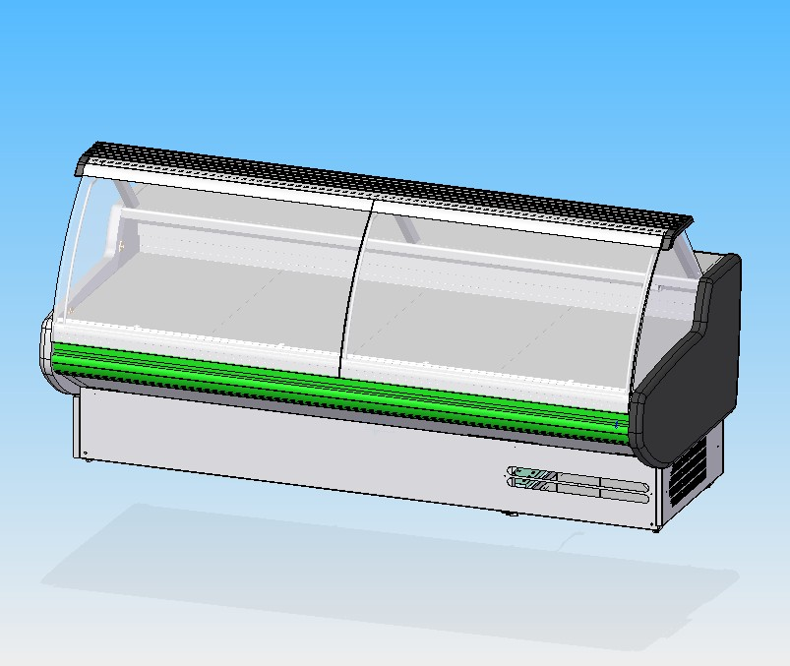

GENERAL SPLITTING UP

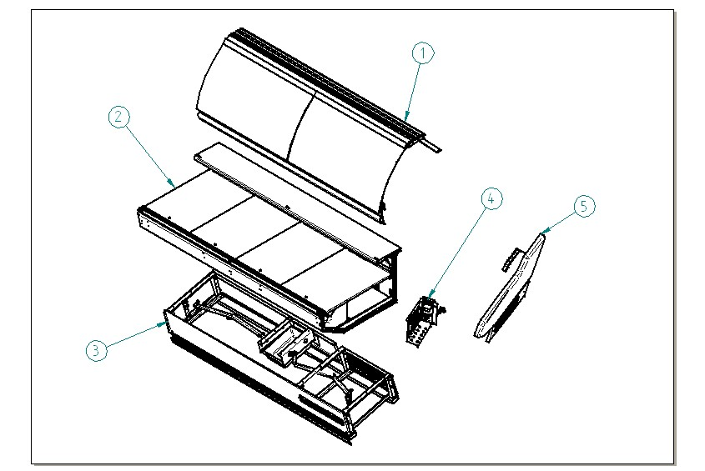

- GLASSES SUPERSTRUCTURE
- DISPLAY AREA INTERNAL FINISH
- FRONTAL DECORATION, FRAME, DRAIN
- CONTROL BOARD
- COMPLETE SIDE WALL

  - GLASSES SUPERSTRUCTURE

1.1 GLASS AND PROFILES
1.2 ALUMINIUM TOP AND LAMPS
1.3 GLASS UPRIGHT
1.4 BUMPER BAND

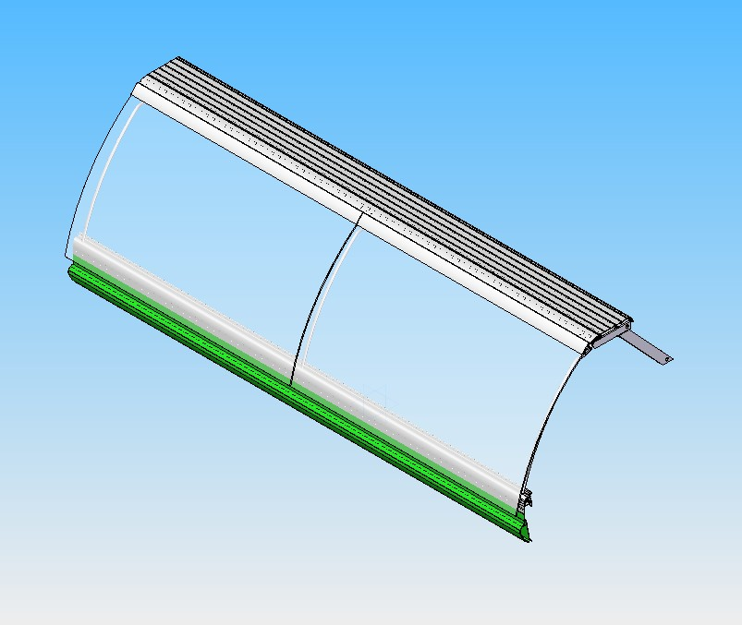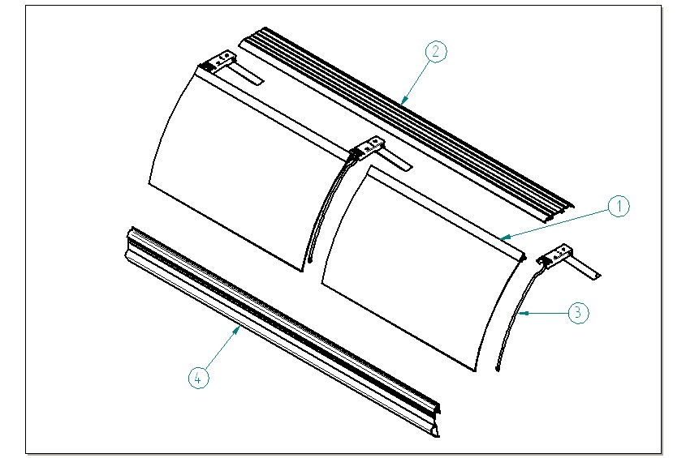

  - GLASS AND PROFILES

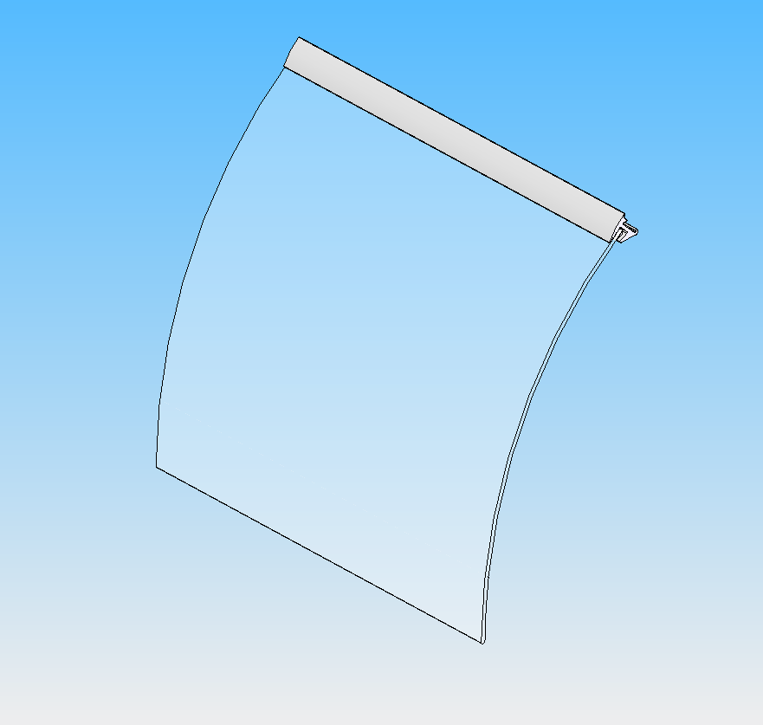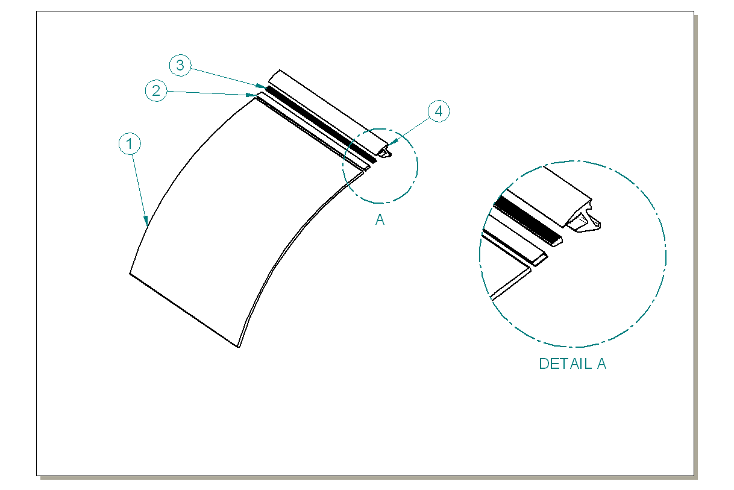

ITEM  NUMBER | DOCUMENT  NUMBER | TITLE | MATERIAL | PART NO. FOR EACH MODULE
 |  |  |  | 1190 | 1785 | 2380 | 2975 | 3570
1 | EEAV 106 | SILKSCREEN R1000 GLASS | FLOAT 6mm SILKSCREEN | 4191915 | 4191917 | 4191915 | 4191916 | 4191917
2 |  | GLASS GASKET PROFILE | PVC | 4180100
3 | DA0D 023 | JAW INSERT PROFILE CUT | ALUMINIUM PROFILE E5628A | 2PV120030006 | 2PV200030006 | 2PV120030006 | 2PV300030006 | 2PV200030006
4 | DA0D 015 | GLASSES JAW CUT AND DRILLING | ALUMINIUM | 2PV120030005 | 2PV200030005 | 2PV120030005 | 2PV300030005 | 2PV200030005

  - ALUMINIUM TOP AND LAMPS

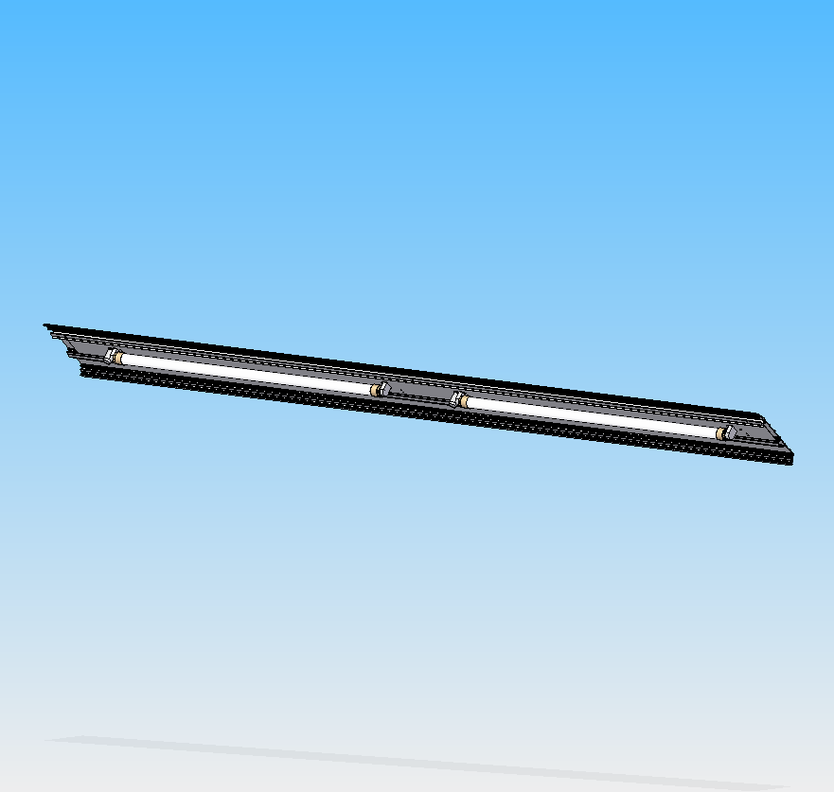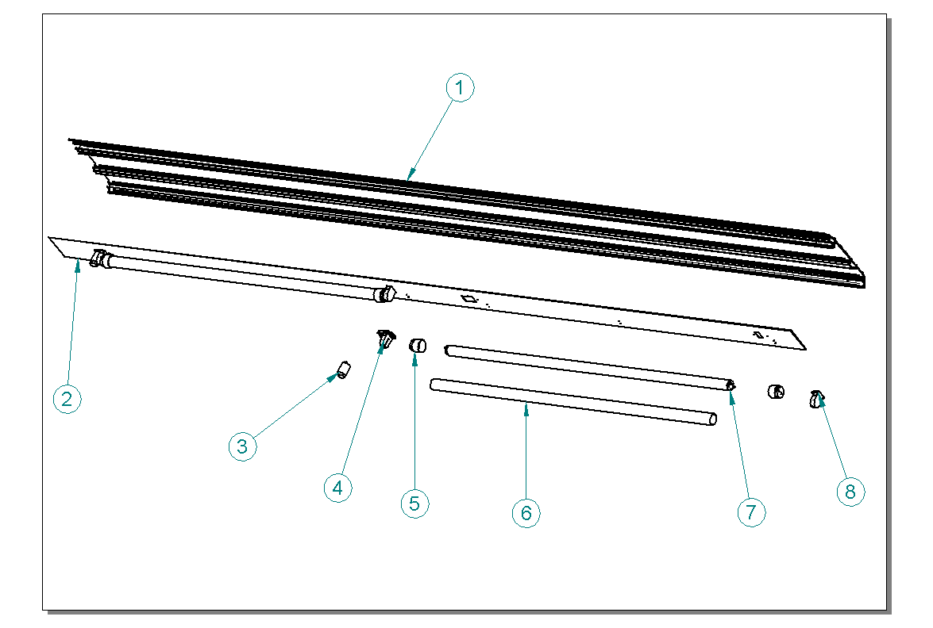

ITEM  NUMBER | DOCUMENT  NUMBER | TITLE | MATERIAL | PART NO. FOR EACH MODULE
 |  |  |  | 1190 | 1785 | 2380 | 2975 | 3570
1 | ET0D 002 | LINEAR MODULE TOP PROFILE MOD 2380 | ALUMINIUM PROFILE Q 1238 | 2BV120032003 | 2BV200032003 | 2BV250032003 | 2BV300032003 | 2BV360032003
2 | ET0E 001 | TOP LAMP-HOLDER MOD 250 | PLASTICIZED SHEET 8/10 | 6BV120022004 | 6BV200022004 | 6BV250022004 | 6BV300022004 | 6BV360022004
3 |  | STARTER OSAMA ST 111 |  | 4116001
4 |  | LAMP-HOLDER + STARTER-HOLDER 249 TCR "UL" | PVC | 4114726
5 |  | NEON CAP | PVC | 4114716 | 4114718 | 4114716 | 4114717 | 4114718
6 |  | NEON AKO PROTECTION TUBE | PVC | 4114716 | 4114718 | 4114716 | 4114717 | 4114718
7 |  | NEON |  | 30 Watt 4114510 | 58 Watt 4114511 | 30 Watt 4114510 | 36 Watt 4114512 | 58 Watt 4114511
8 |  | LAMP-HOLDER 249 TS "UL" | PVC | 4114727

1.3 CENTRAL UPRIGHT

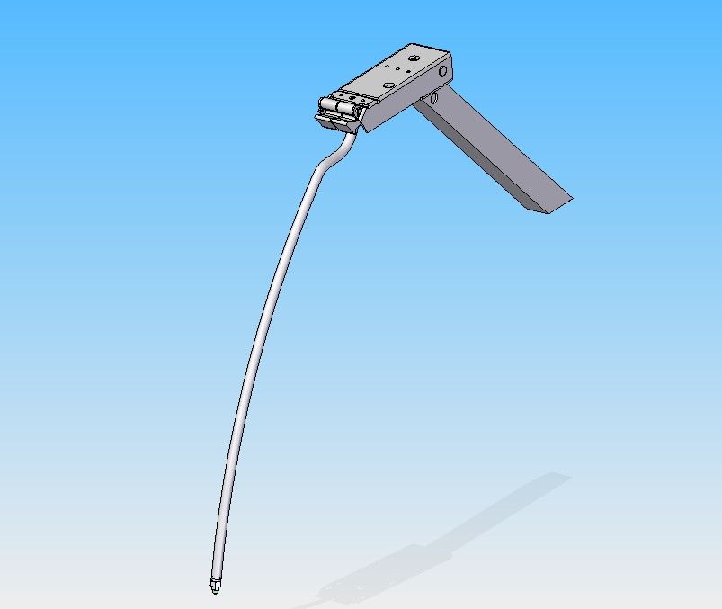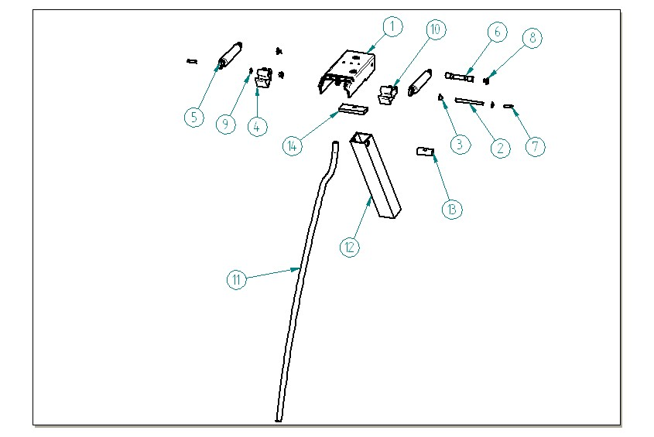

ITEM  NUMBER | DOCUMENT  NUMBER | TITLE | MATERIAL | MODULI/CODICI
 |  |  |  | 1190 | 1785 | 2380 | 2975 | 3570
1 | EEAV 104 | CENTRAL PLIERS CASING | SHEET 25/10 |  |  | 4140012
2 | EEAV 017 | ARM PIN | DRAWN GROUND D6 GALVANIZED
3 | EEAV 016 | PISTON NYLON BUSH | NYLON | 8291718
4 | EEAV 011 | RIGHT ROTATION LEVER | ALUMINIUM ALLOY | 4282113
5 |  | PISTON STROKE 60 | STEEL | 4145020 | 4145023 | 4145020 | 4145021 | 4145023
6 | EEAV 019 | PISTON BACK PIN | DRAWN IRON
7 | EEAV 018 | PISTON FRONT PIN | DRAWN GROUND GALVANIZED
8 | EEAV 086 | BOLT FOR BACK PIN | DRAWN IRON
9 |  | SEGGER 5 | GALVANIZED STEEL | 8298303
10 | EEAV 011 | LEFT ROTATION LEVER | ALUMINIUM ALLOY | 4282114
11 | EEAV 116 | FRONT UPRIGHT | TUBE 12X1.2 | 4283104
12 | ET0D 001 | BACK UPRIGHT WITHOUT HOLE | ALUMINIUM PROFILE PE3107 | 2BV120030352
13 | EEAV 001 | UPRIGHT BLOCK | GALVANIZED DRAWN
14 | EEAV 052 | PLIERS FIXING BLOCK 58 X 30 | ALUMINIUM PROFILE 30 X 6 | 4282002

1.3 RIGHT SIDE UPRIGHT

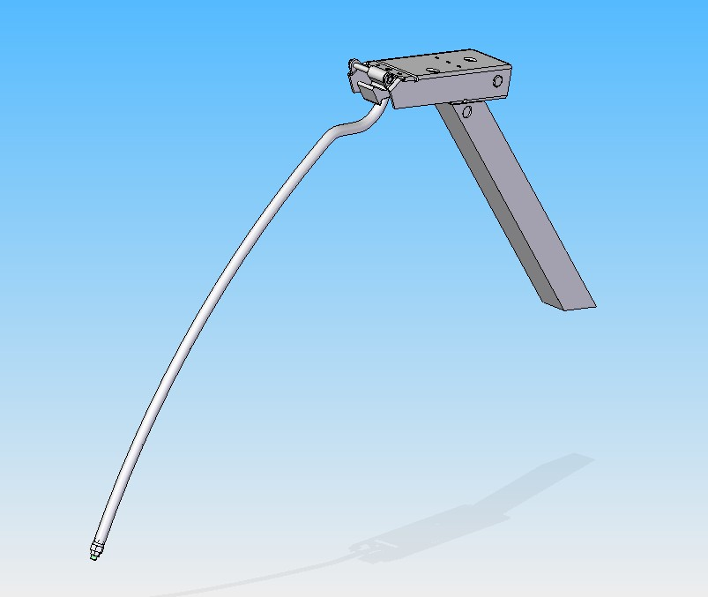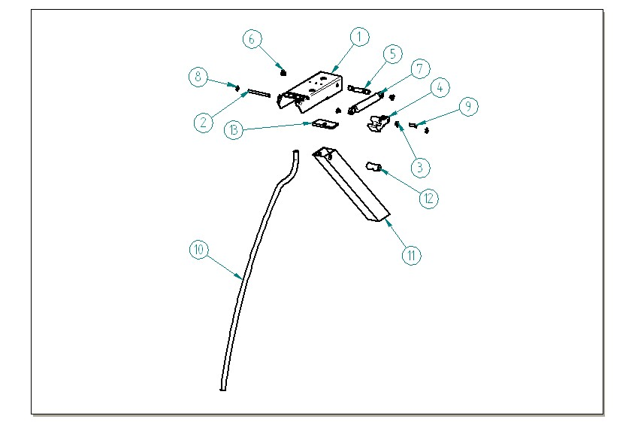

ITEM  NUMBER | DOCUMENT  NUMBER | TITLE | MATERIAL | PART NO. FOR EACH MODULE
 |  |  |  | 1190 | 1785
1 | EEAV 104 | PLIERS CASING | SHEET 25/10 | 4140010
2 | EEAV 017 | ARM PIN | DRAWN GROUND D6 GALVANIZED
3 | EEAV 016 | PISTON NYLON BUSH | NYLON | 8291718
4 | EEAV 011 | RIGHT ROTATION LEVER | ALUMINIUM ALLOY | 4282113
5 | EEAV 019 | PISTON BACK PIN | DRAWN IRON
6 | EEAV 086 | BOLT FOR BACK PIN | DRAWN IRON
7 |  | PISTON STROKE 60 | STEEL | 4145020 | 4145023
8 |  | SEGGER 5 | GALVANIZED STEEL | 8298303
9 | EEAV 018 | PISTON FRONT PIN | DROWN GROUND GALVANIZED
10 | EEAV 116 | FRONT UPRIGHT | TUBE 12X1.2 | 4283104
11 | ET0D 001 | BACK UPRIGHT WITHOUT HOLE | ALUMINIUM PROFILE PE3107 | 2BV120030352
12 | EEAV 001 | UPRIGHT BLOCK | GALVANIZED DRAWN
13 | EEAV 052 | PLIERS FIXING BLOCK 58 X 30 | ALUMINIUM PROFILE 30 X 6 | 4282002

1.4 BUMPER BAND

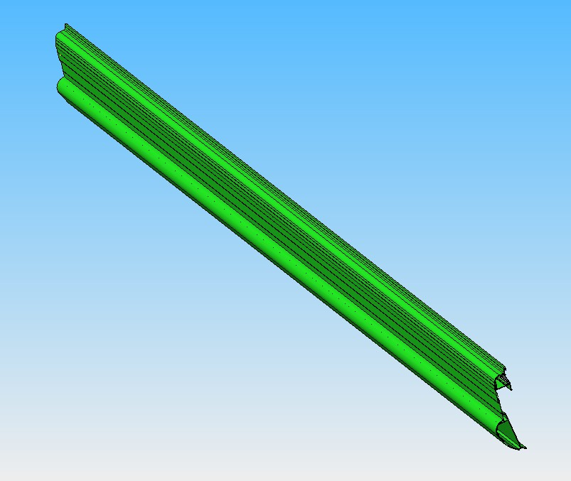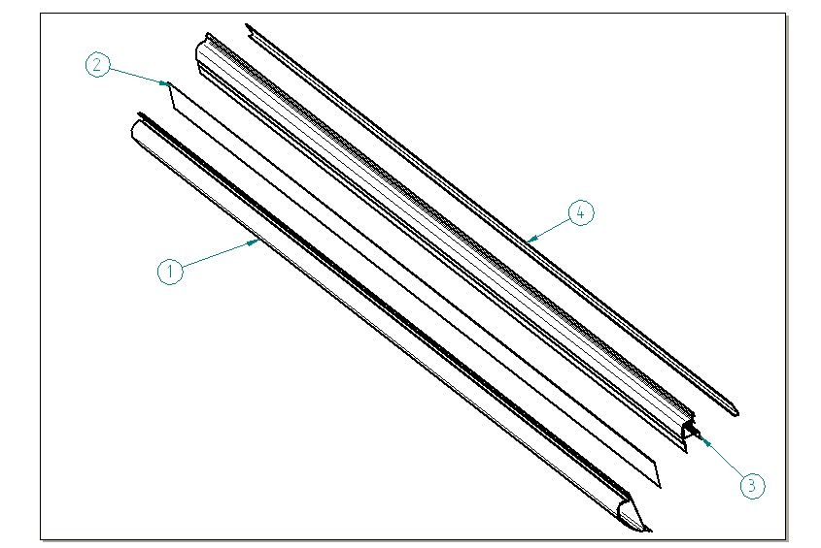

ITEM  NUMBER | DOCUMENT  NUMBER | TITLE | MATERIAL | PART NO. FOR EACH MODULE
 |  |  |  | 1190 | 1785 | 2380 | 2975 | 3570
1 | ET0J 004 | LINEAR FRONT PROFILE MOD 2380 | PVC PROFILE P1421 | 2DV1200F2001 | 2DV2000F2001 | 2DV2500F2001 | 2DV3000F2001 | 2DV3600F2001
2 | DEAV 503 | PAINTED FRONT STRIPE | PLAST. SHEET 5/10 | 6DV360070106 | 6DV360070106 | 6DV360070106 | 6DV360070106 | 6DV360070106
3 | ET0L 002 | ANTI-MIST BAND MOD 250 | ALUMINIUM PROFILE PE 3109
4 | EEAV 014 | ANTI-MIST HEATER PROTECTION | ALUMINIUM | 6DV120030058 | 6DV200030058 | 6DV250030058 | 6DV300030058 | 6DV360030058

  - INTERNAL FINISH

2.1 DISPLAY PLATE
2.2 UNDERSTORAGE DOOR
2.3 WORKING TABLE
2.4 EVAPORATOR
2.5 FANS-HOLDER
2.6 INTERNAL FINISH

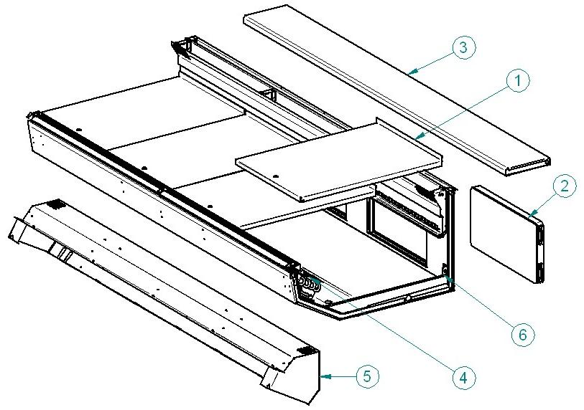

2.1 DISPLAY PLATE AND UNDERPLATE
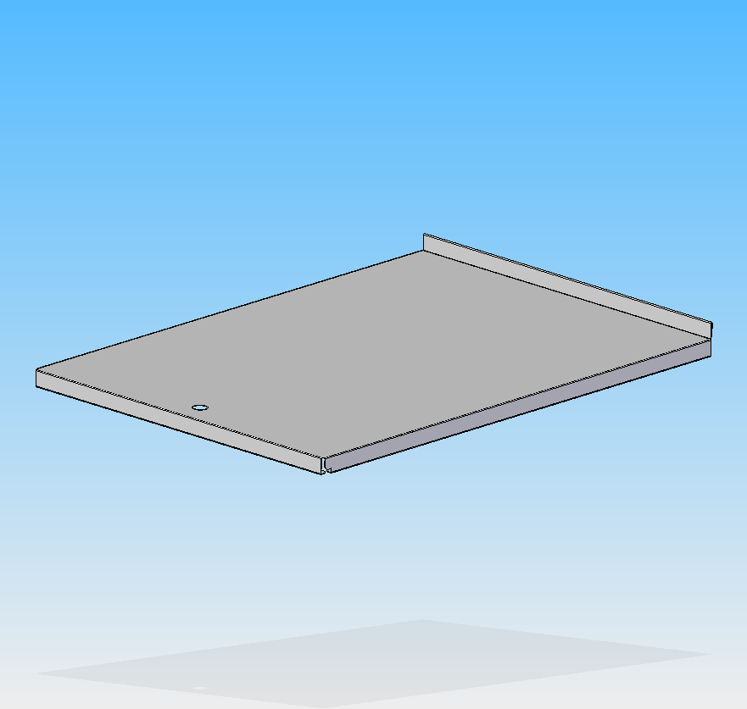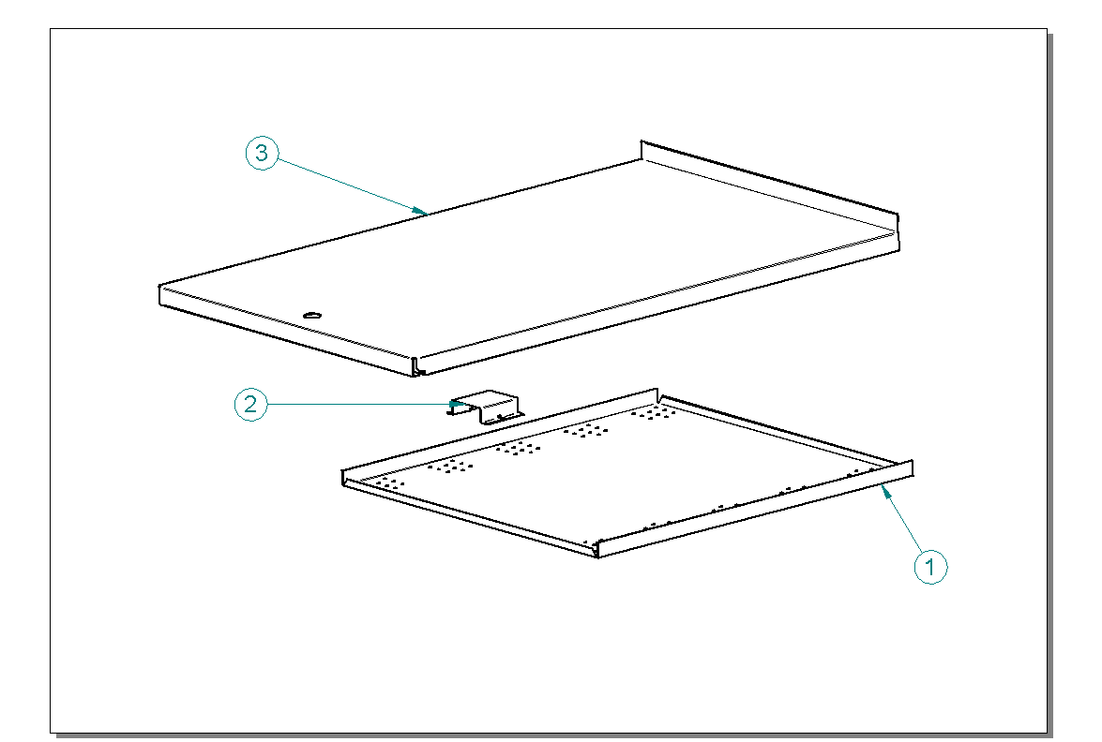

ITEM  NUMBER | DOCUMENT  NUMBER | TITLE | MATERIAL | PART NO. FOR EACH MODULE
 |  |  |  | 1190 | 1785 | 2380 | 2975 | 3570
1 | ET0K 002 | UNDERPLATE 591 | PLAST. SHEET 6/10 | 6BV1200A2003 | 6BV1200A2003 | 6BV1200A2003 | 6BV1200A2003 | 6BV1200A2003
2 | ET0K 008 | PLATE REINFORCEMENT | PLAST. SHEET 8/10 | 6BV1200A2004 | 6BV1200A2004 | 6BV1200A2004 | 6BV1200A2004 | 6BV1200A2004
3 | ET0K 007 | PLATE MOD. LOWE NSF | PLAST. SHEET 8/10 | 6DV1200A2301 | 6DV1200A2301 | 6DV1200A2301 | 6DV1200A2301 | 6DV1200A2301

2.2 UNDERSTORAGE DOOR AND HINGES

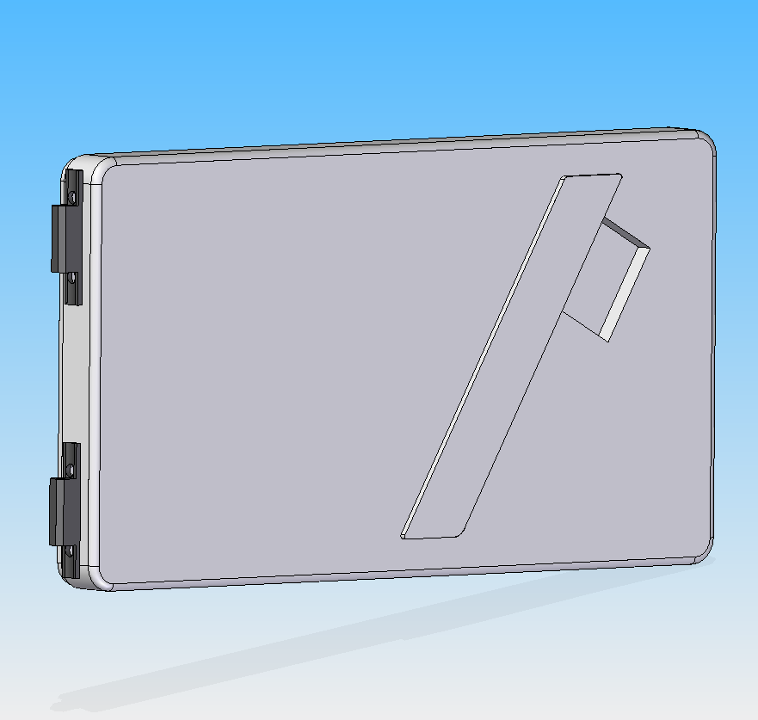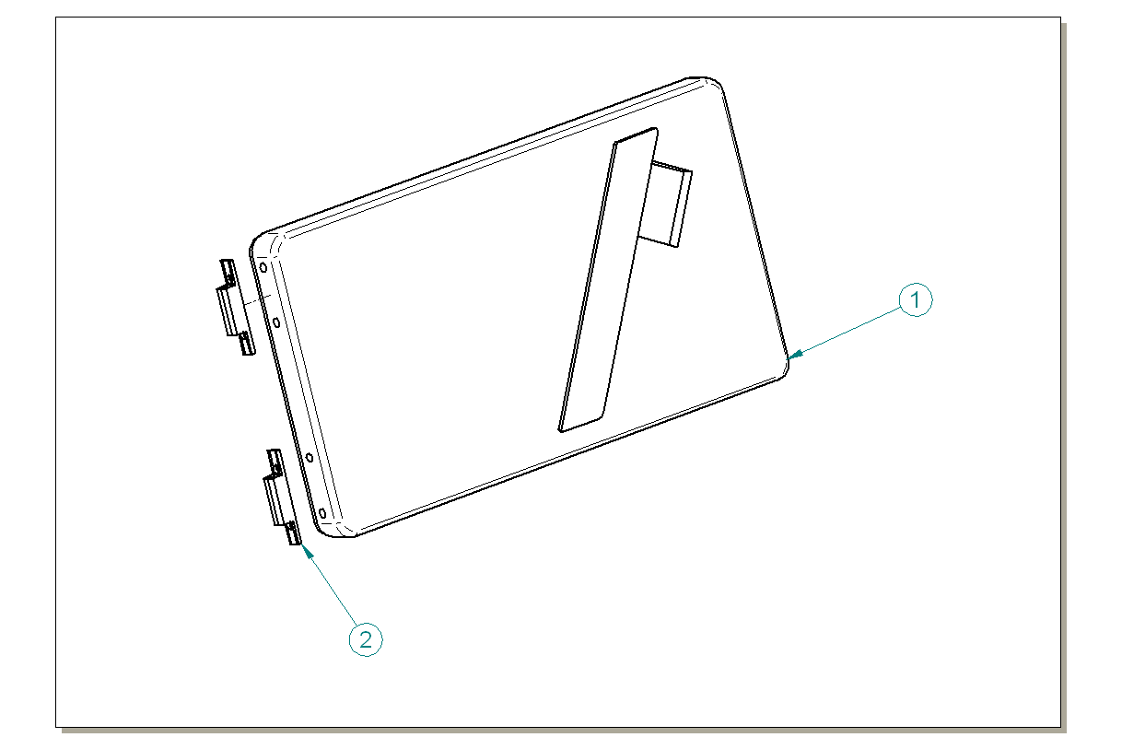

ITEM  NUMBER | DOCUMENT  NUMBER | TITLE | MATERIAL | PART NO. FOR EACH MODULE
 |  |  |  | 1190 | 1785 | 2380 | 2975 | 3570
1 | EEE0 100 | DOOR | PST | 4331806
2 |  | HINGE 1 | PVC | 4330902

2.3 WORKING TABLE

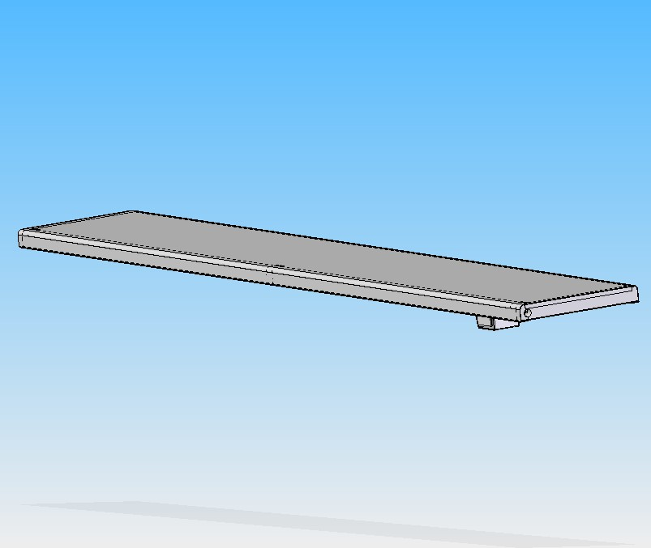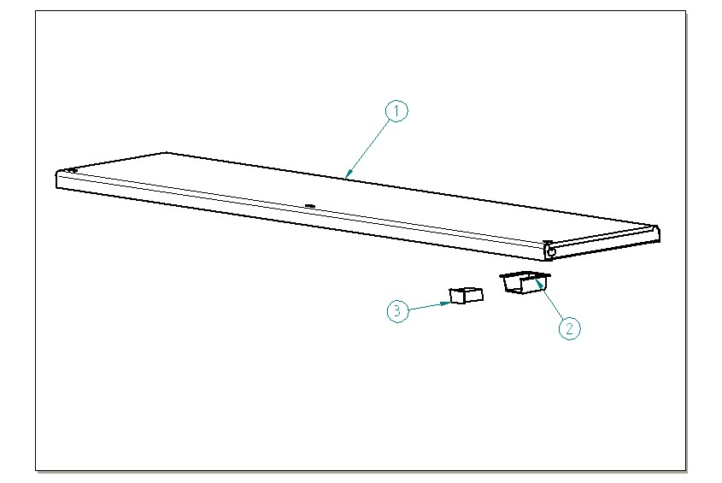

ITEM  NUMBER | DOCUMENT  NUMBER | TITLE | MATERIAL | PART NO. FOR EACH MODULE
 |  |  |  | 1190 | 1785 | 2380 | 2975 | 3570
1 | ET0H 006 | WORKING TABLE BV 250 |  | 2BV120012000 | 2BV200012000 | 2BV250012000 | 2BV300012000 | 2BV360012000
2 | ET0C 011 | THERMOMETER-HOLDER | PST PLATE | 4102114
3 |  | THERMOMETRO RECT.-40°+40°C°+ F°ROF88 |  | 4131300

2.4 EVAPORATOR

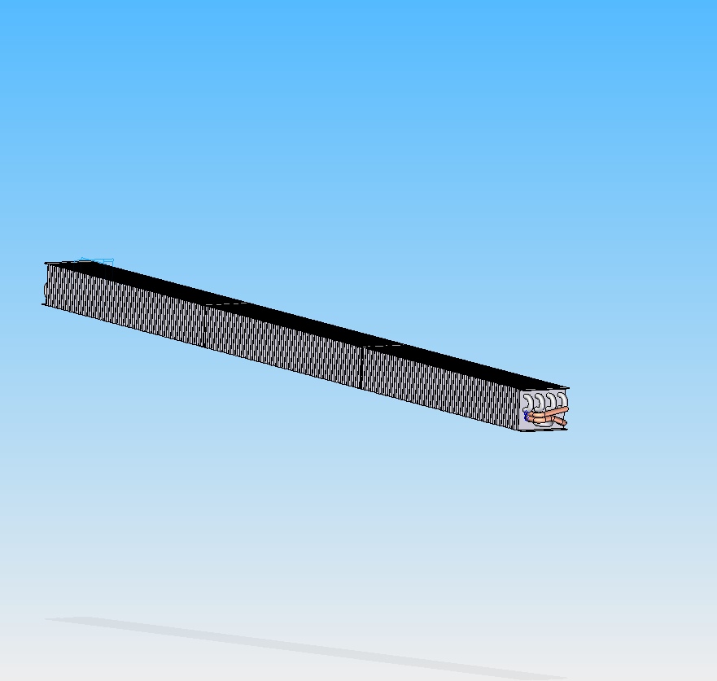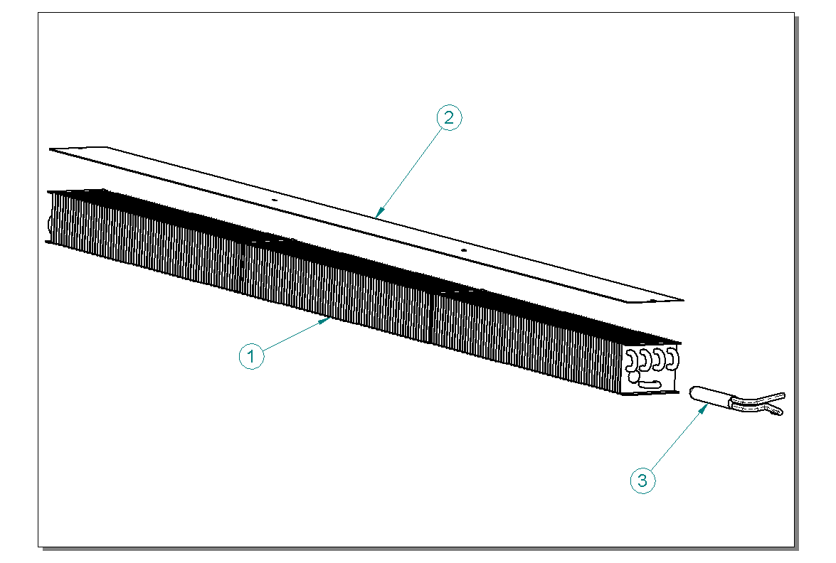

ITEM  NUMBER | DOCUMENT  NUMBER | TITLE | MATERIAL | PART NO. FOR EACH MODULE
 |  |  |  | 1190 | 1785 | 2380 | 2975 | 3570
1 | ET0F 001 | EVAPORATOR VS-V | TUBES COPPER-SHEET.ALU. | 4222110 | 4222111 | 4222112 | 4222113 | 4222114
2 | ET0F 004 | FAN ASSISTED EVAPORATOR CLOSURE | SHEET 5/10 | 6BV120042001 | 6BV200042001 | 6BV250042001 | 6BV300042001 | 6BV360042001
3 | ET0F 002 | EVAPORATOR LIQUID SEPARATOR | TUBES WORKED COPPER | 5025605

2.4.1 EVAPORATOR WITH VALVE POSITION
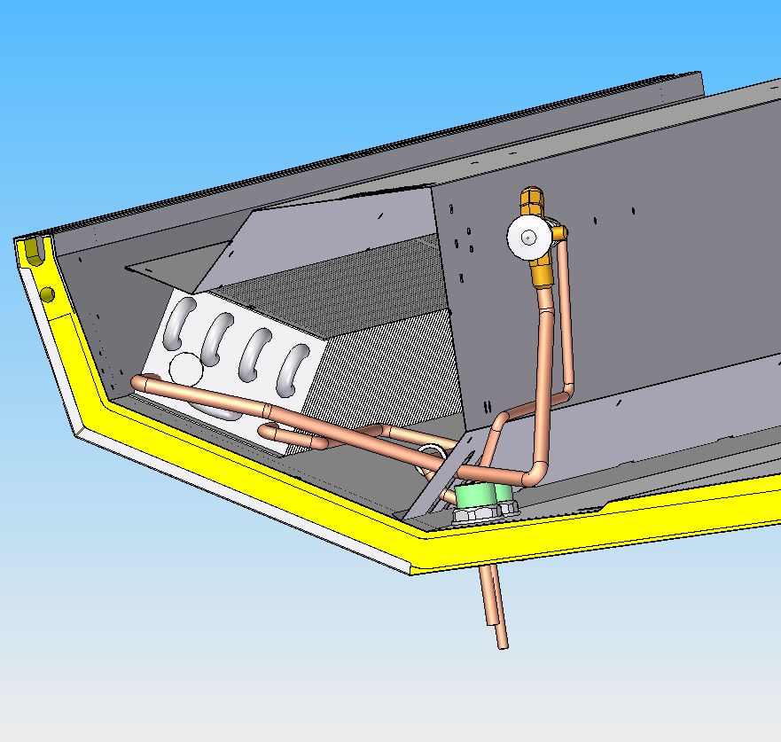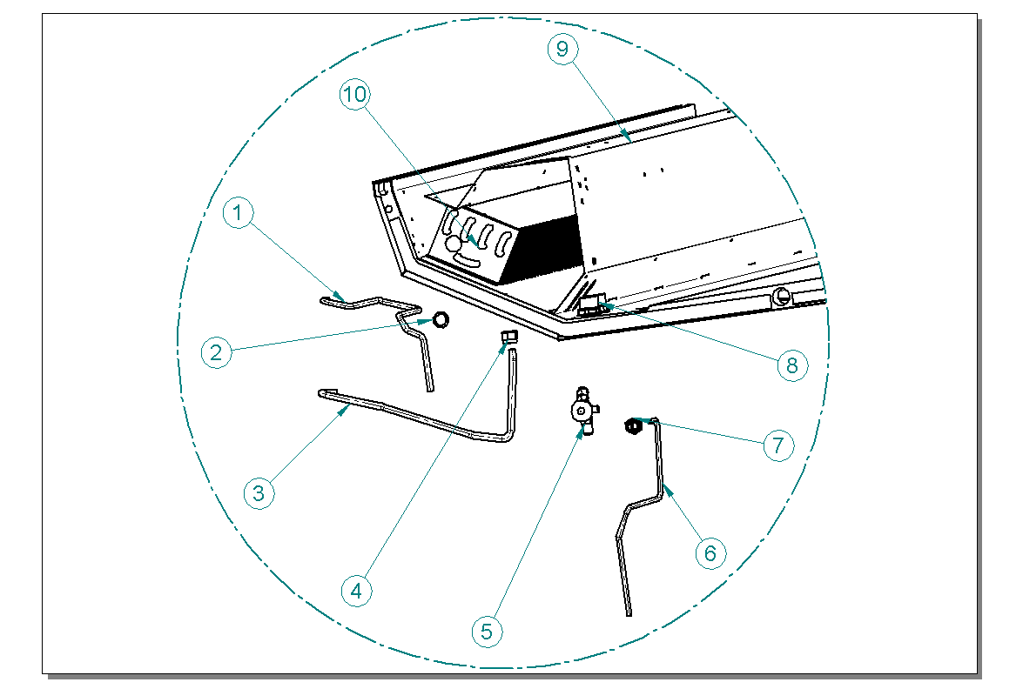

ITEM  NUMBER | DOCUMENT  NUMBER | TITLE | MATERIAL | PART NO. FOR EACH MODULE
 |  |  |  | 1190 | 1785 | 2380 | 2975 | 3570
1 | ET0F 010 | SUCTION TUBE FOR VALVE SYSTEM | COPPER TUBE Ø8×10 | 4272425
2 | ET0F 010 | FAIR-LEAD Ø22 |  | 4113102
3 | ET0F 009 | EVAPORATOR TUBE - VALVE | COPPER TUBE Ø10×12 | 4272420
4 | ET0F 009 | PIPE UNION 1/2 SAE Ø12 |  | 4272420
5 |  | VALVE |  | 4251312
6 | ET0F 008 | DELIVERY SIDE TUBE FOR VALVE SYSTEM | COPPER TUBE Ø6×8 | 4272415
7 |  | PIPE UNION 3/8SAE Ø8 |  | 4272415
8 |  | DRAIN d32 h60 | ABS | 4102125
9 | DA0G 020 | EVAPORATOR COVER | PLAST, SHEET 6/10 | 6PV120040008 | 6PV200040008 | 6PV250040008 | 6PV300040008 | 6PV360040008
10 | ET0F 001 | EVAPORATOR VS-V | TUBES COPPER-SHEET.ALU. | 4222110 | 4222111 | 4222112 | 4222113 | 4222114

2.4.2 EVAPORATOR POSITION ON MODULE WITH CAPILLARY SYSTEM

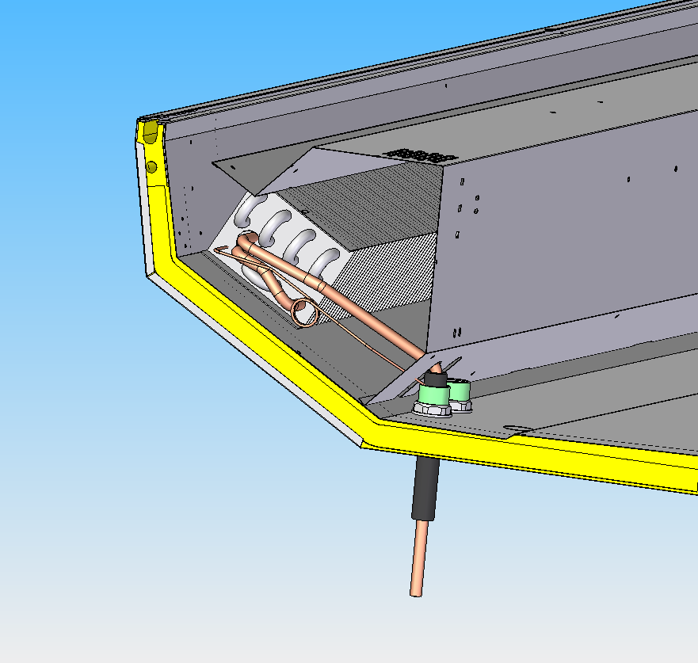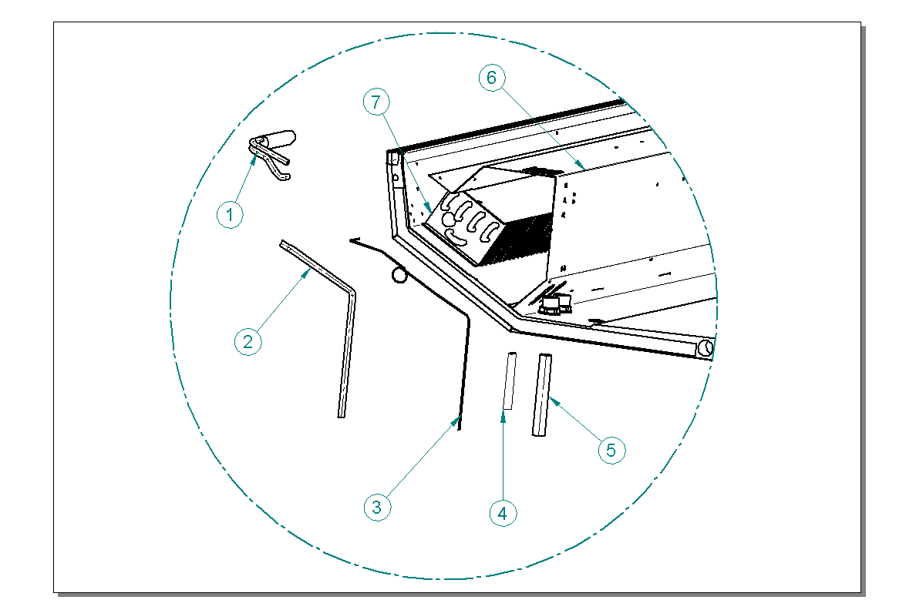

ITEM  NUMBER | DOCUMENT  NUMBER | TITLE | MATERIAL | PART NO. FOR EACH MODULE
 |  |  |  | 1190 | 1785 | 2380 | 2975 | 3570
1 | ET0F 002 | EVAPORATOR LIQUID SEPARATOR | WORKED COPPER TUBE | 5025605
2 | ET0F 003 | SUCTION TUBE |  | 4272425
3 | ET0F 003 | CAPILLARY TUBE | CAPILLARY | 4260203 (1.2x2.40)
 |  |  |  | 4260204 (1.4x2.60)
4 | ET0F 003 | TAPE 50×25 | ALU MONOADHESIVE | 8334325
5 | ET0F 003 | ANTICONDENSATE | INSULATING SPONGE | 4270502
6 | DA0G 020 | EVAPORATOR COVER | PLAST. SHEET 6/10 | 6PV120040008 | 6PV200040008 | 6PV250040008 | 6PV300040008 | 6PV360040008
7 | ET0F 001 | EVAPORATOR VS-V | TUBES COPPER-SHEET.ALU. | 4222110 | 4222111 | 4222112 | 4222113 | 4222114

2.5 FANS HOLDER
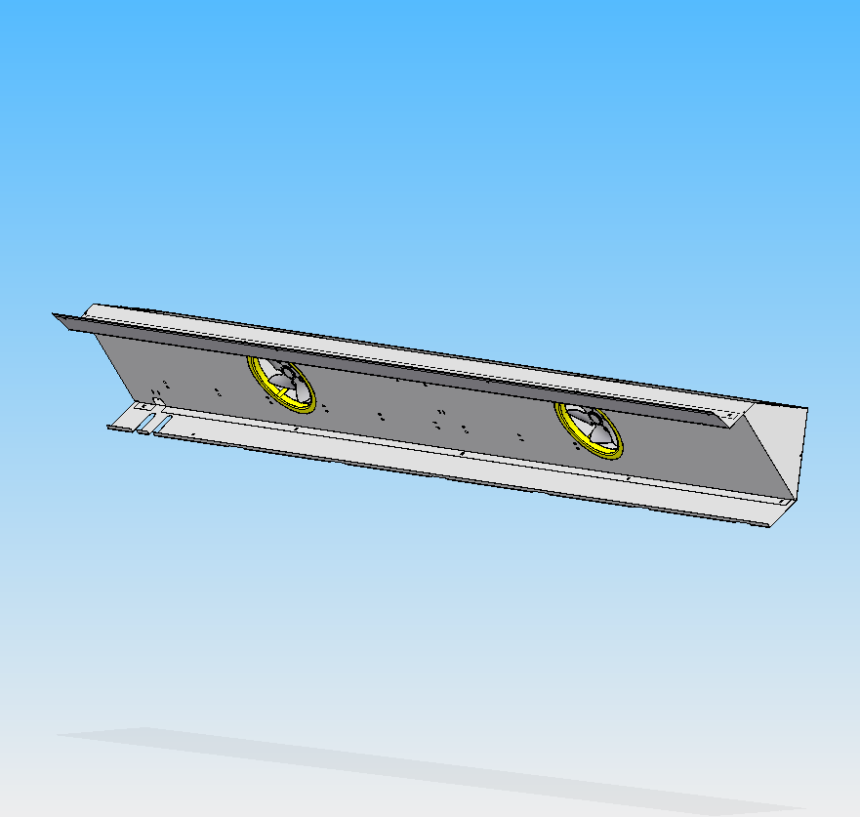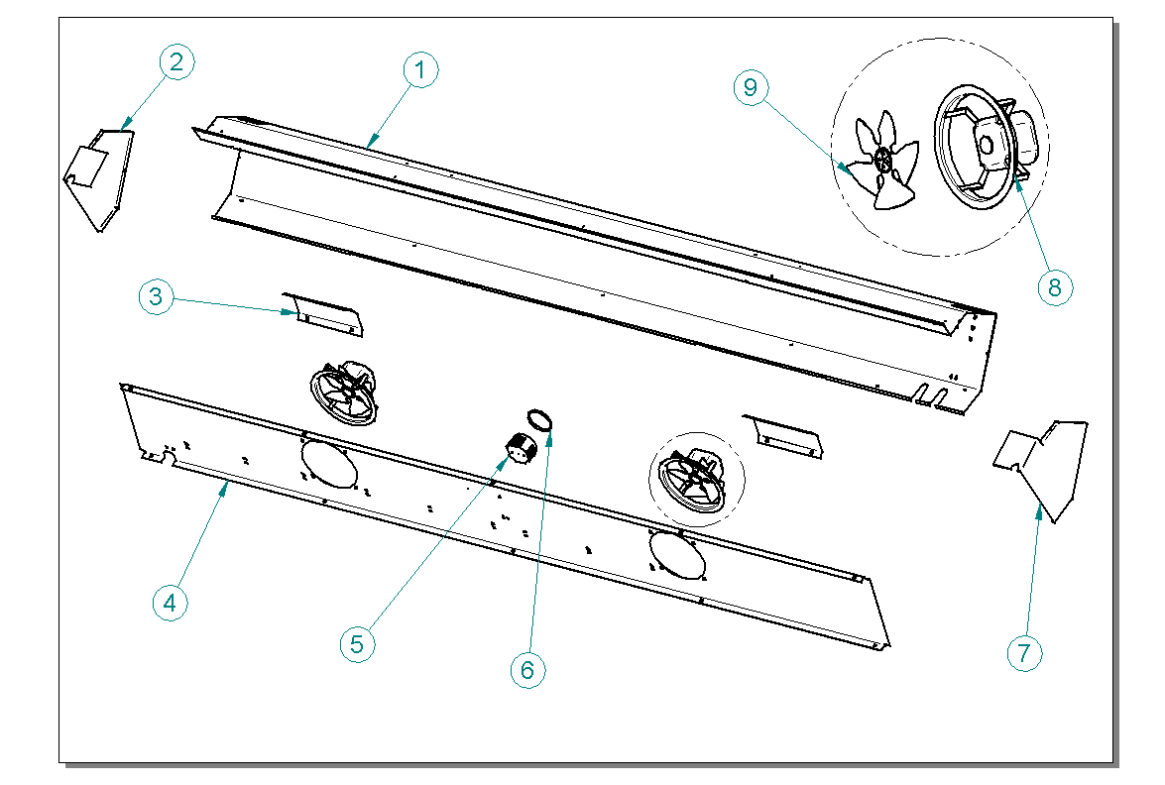

ITEM  NUMBER | DOCUMENT  NUMBER | TITLE | MATERIAL | PART NO. FOR EACH MODULE
 |  |  |  | 1190 | 1785 | 2380 | 2975 | 3570
1 | DA0G 020 | EVAPORATOR COVER | PLAST. SHEET 6/10 | 6PV120040008 | 6PV200040008 | 6PV250040008 | 6PV300040008 | 6PV360040008
2 | DA0G 017 | RIGHT STOPPER EVAPORATOR COVER | PLAST. SHEET 6/10 | 6PV120040006
3 | ET0G 011 | FANS COVER | SHEET 6/10 | 6BV120042012
4 | ET0G 008 | FANS HOLDER | SHEET 6/10 | 6BV120042011 | 6BV200042011 | 6BV250042011 | 6BV300042011 | 6BV360042011
5 |  | SHUNT BOX 70 mm | PLAST. INSULATING MAT. GW | 4115401
6 |  | SHUNT BOX COVER 70 mm | PLAST. INSULATING MAT. GW | 4115401
7 | DA0G 017 | LEFT STOPPER EVAPORATOR COVER SX | PLAST. SHEET 6/10 | 6PV120040007
8 |  | MOTORFAN |  | 4240501
9 |  | FAN |  | 4249926

2.6. INTERNAL FINISH

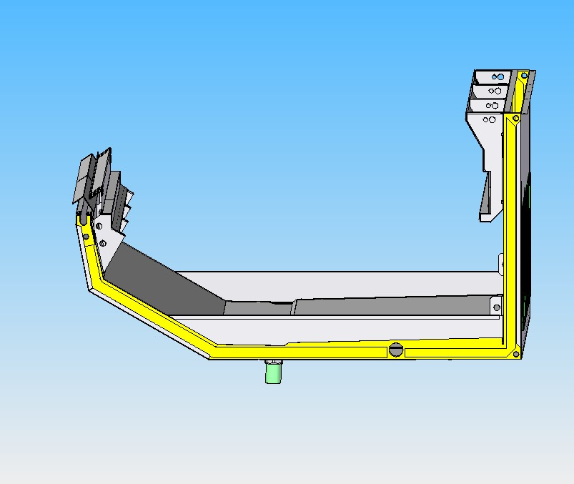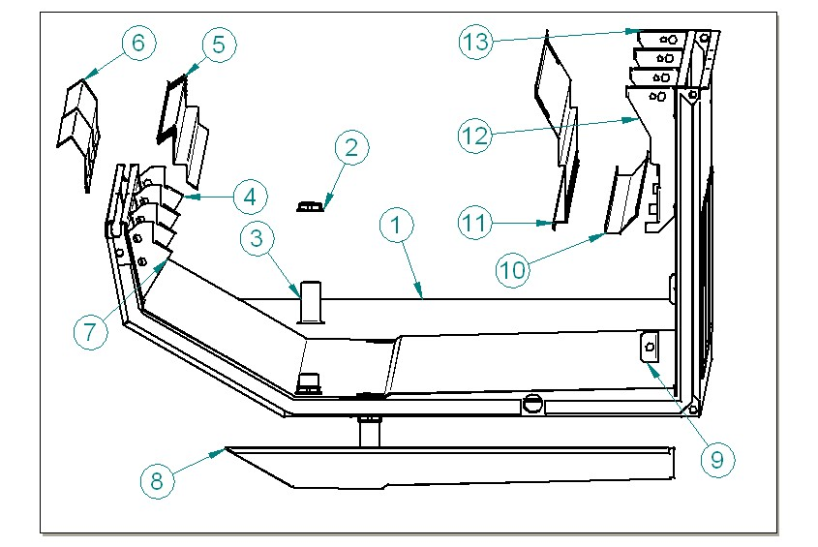

ITEM  NUMBER | DOCUMENT  NUMBER | TITLE | MATERIAL | PART NO. FOR EACH MODULE
 |  |  |  | 1190 | 1785 | 2380 | 2975 | 3570
1 | ET0A 042 | RIGHT BODY HEAD | PLAST. SHEET 6/10 | 6BV120042015
2 |  | DRAIN NUT d32 | ABS | 4102125
3 |  | DRAIN d32 | ABS | 4102125
4 | ET0G 001 | FRONT BRACKET – RIGHT FROM SERVICE SIDE | STAINLESS STEEL AISI 304 15/10 | 6BV120042002
5 | DA0G 001 | FRONT UPRIGHT SUCTION GRID | PLAST. SHEET 8/10
6 | DA0G 002 | SUCTION GRID CLOSURE | STAINLESS STEEL AISI 304 6/10 | 6PV120040004 | 6PV200040004 | 6PV250040004 | 6PV300040004 | 6PV360040004
7 | ET0G 001 | FRONT BRACKET – LEFT FROM SERVICE SIDE | STAINLESS STEEL AISI 304 15/10 | 6BV120042003
8 | ET0A 042 | LEFT BODY HEAD | PLAST. SHEET 6/10 | 6BV120042016
9 | ET0U 001 | MULTIPLEXING BRACKET | STAINLESS STEEL AISI 304 30/10 | 4282119
10 | ET0G 018 | AIR CHANNEL BAFFLE | PLAST. SHEET 6/10 | 6BV120042014 | 6BV200042014 | 6BV250042014 | 6BV300042014 | 6BV360042014
11 | DA0G 053 | AIR OUTLET GRID MOD. FAN ASSISTED | PLAST. SHEET 8/10 | 2PV120040005 | 2PV200040005 | 2PV250040005 | 2PV300040005 | 2PV360040005
12 | DA0G 052 | BACK BRACKET – LEFT FROM SERVICE SIDE | SHEET 15/10 | 6BV120042002
13 | DA0G 052 | BACK BRACKET – RIGHT FROM SERVICE SIDE | SHEET 15/10 | 6PV120040001

  - DECORATION – FRAME – DRAIN

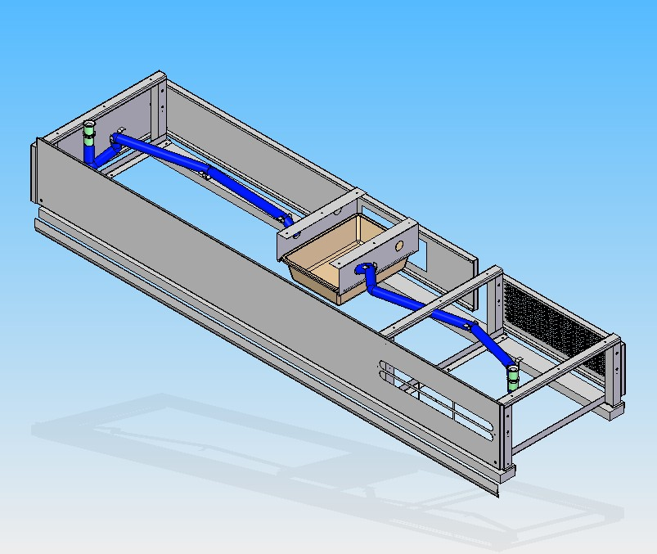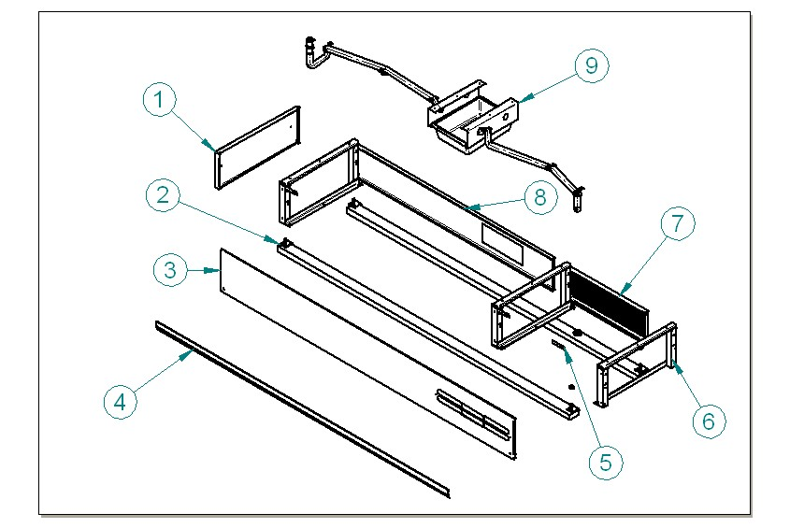

ITEM  NUMBER | DOCUMENT  NUMBER | TITLE | MATERIAL | PART NO. FOR EACH MODULE
 |  |  |  | 1190 | 1785 | 2380 | 2975 | 3570
1 | ET0J 015 | LEFT SIDE DECORATION PANEL | PLAST. SHEET 6/10 | 6DV120072058
2 | ET0B 007 | LOADING SLIDE LINEAR MOD. 250 | SPRUCE WOOD | 4321219 | 4321220 | 4321221 | 4321222 | 4321223
3 | DEF0 501 | FRONTAL PANEL MOD. 250 | PLAST. SHEET 8/10 | 6DV120070030 | 6DV200070030 | 6DV250070030 | 6DV300070030 | 6DV360070030
4 |  | MINIGONNA |  | 4161901 | 4161903 | 4161901 | 4161902 | 4161903
5 | DA0B 006 | LOADING SLIDE BLOCK ING BRACKET | SHEET 30/10 | 4282833
6 | ET0B 001 | FRAME | IRON 360 | 4280114
7 | ET0J 002 | SLOT PANEL FOR COMPRESSOR AREA | PLAST. SHEET 6/10 | 6BV120072010 | 6BV120072010 | 6BV120072010 | 6BV120072010 | 6BV120072010
8 | ET0J 003 | PIERCED BACK PANEL | PLAST. SHEET 6/10 | 6BV120072029 | 6BV200072029 | 6BV250072029 | 6BV300072029 | 6BV360072029
9 |  | DRAIN TUBE | PVC | 4180815

LOADING SLIDE

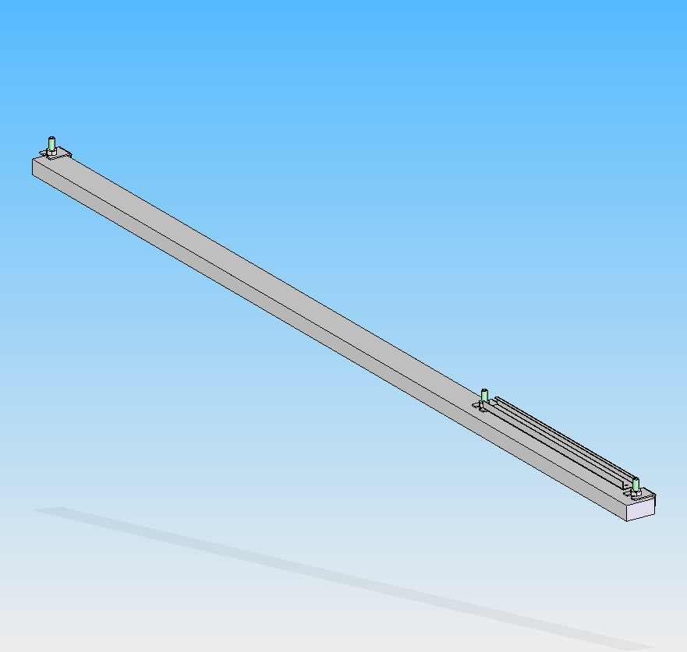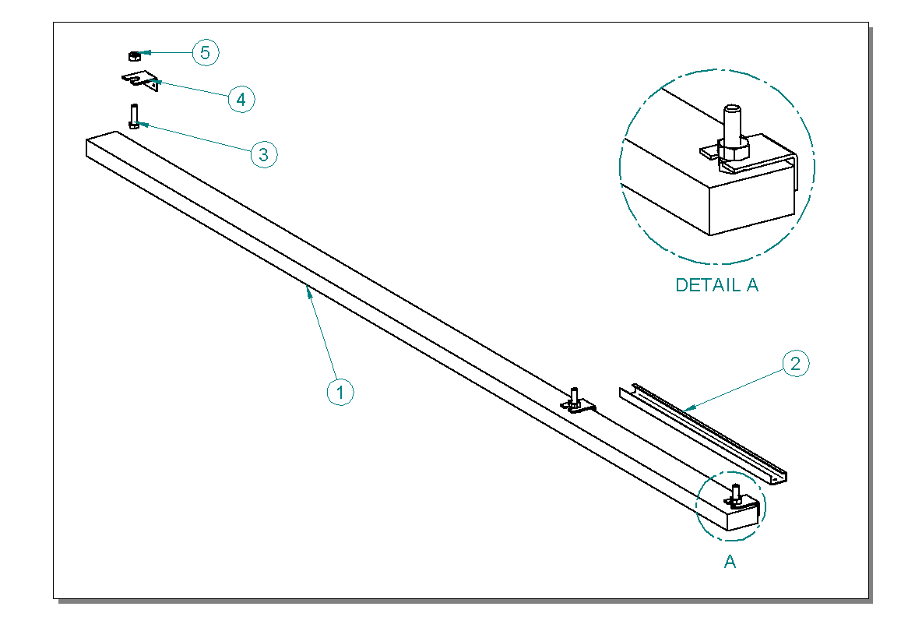

ITEM  NUMBER | DOCUMENT  NUMBER | TITLE | MATERIAL | PART NO. FOR EACH MODULE
 |  |  |  | 1190 | 1785 | 2380 | 2975 | 3570
1 | ET0B 007 | LOADING SLIDE LINEAR MOD. 250 | SPRUCE WOOD | 4321219 | 4321220 | 4321221 | 4321222 | 4321223
2 | ET0B 003 | SIDE MEMBER FOR COMPRESSOR AREA | SHEET 15/10 | 6BV120002016
3 |  | FEET BOLT M12 | GALVANIZED SHEET | 8293413
4 | DA0B 006 | LOADING SLIDE BLOCKING BRACKET | SHEET 30/10 | 4282833
5 |  | NUT M12 | GALVANIZED IRON | 8291073

DRAIN

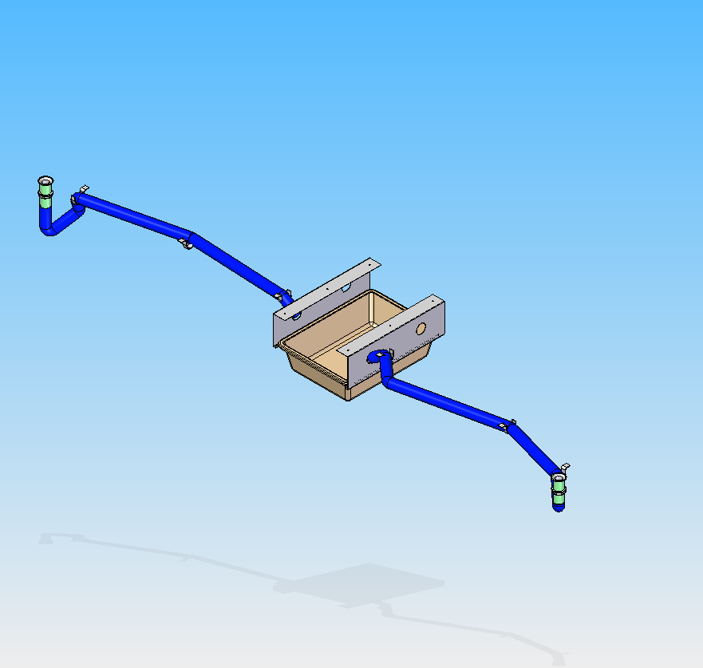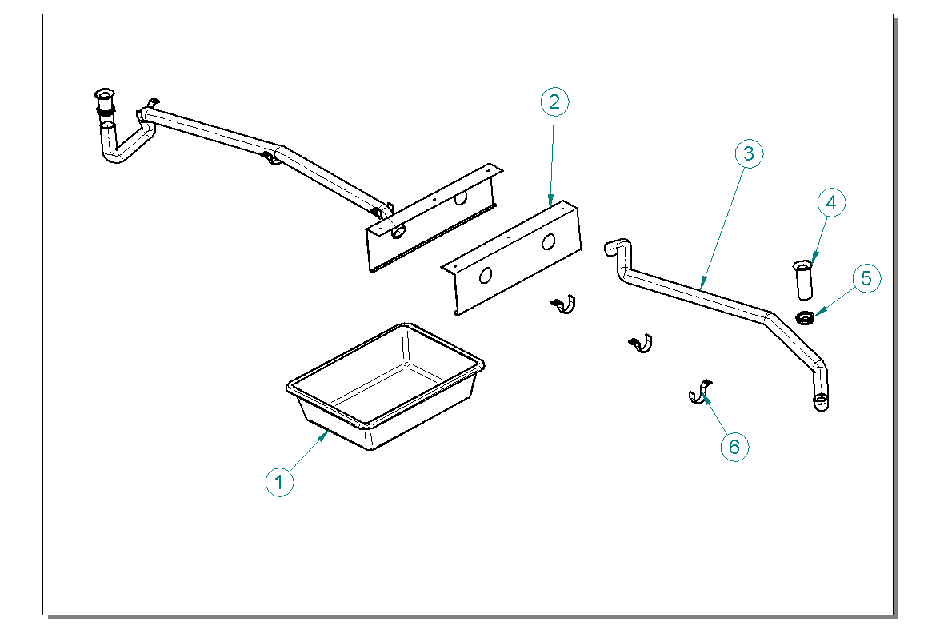

ITEM  NUMBER | DOCUMENT  NUMBER | TITLE | MATERIAL | PART NO. FOR EACH MODULE
 |  |  |  | 1190 | 1785 | 2380 | 2975 | 3570
1 |  | BASIN | PVC | 4100102 | 4100109
2 | ET0I 001 | DRAIN BASIN SUPPORT | SHEET 10/10 | 6BV120052001 | 6BV120052001 | 6BV120052001 | 6BV120052001 | 6BV120052001
3 |  | DRAIN TUBE | PVC | 4180815
4 |  | PIPE d32 | ABS | 4102125
5 |  | PIPE NUT d32 | ABS | 4102125
6 |  | METALLIC CLIP FOR TUBE d40 | GALVANIZED STEEL | 8298201

  - CONTROL BOARD
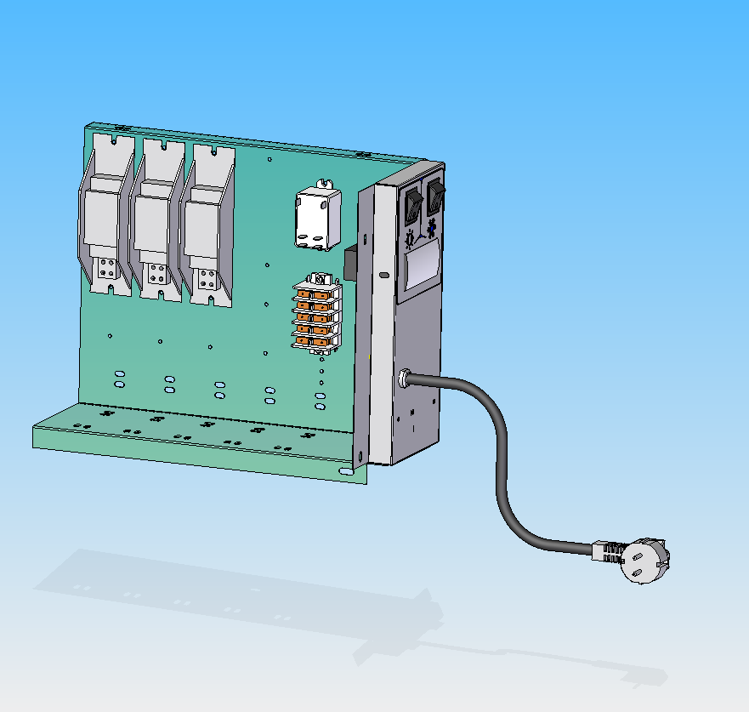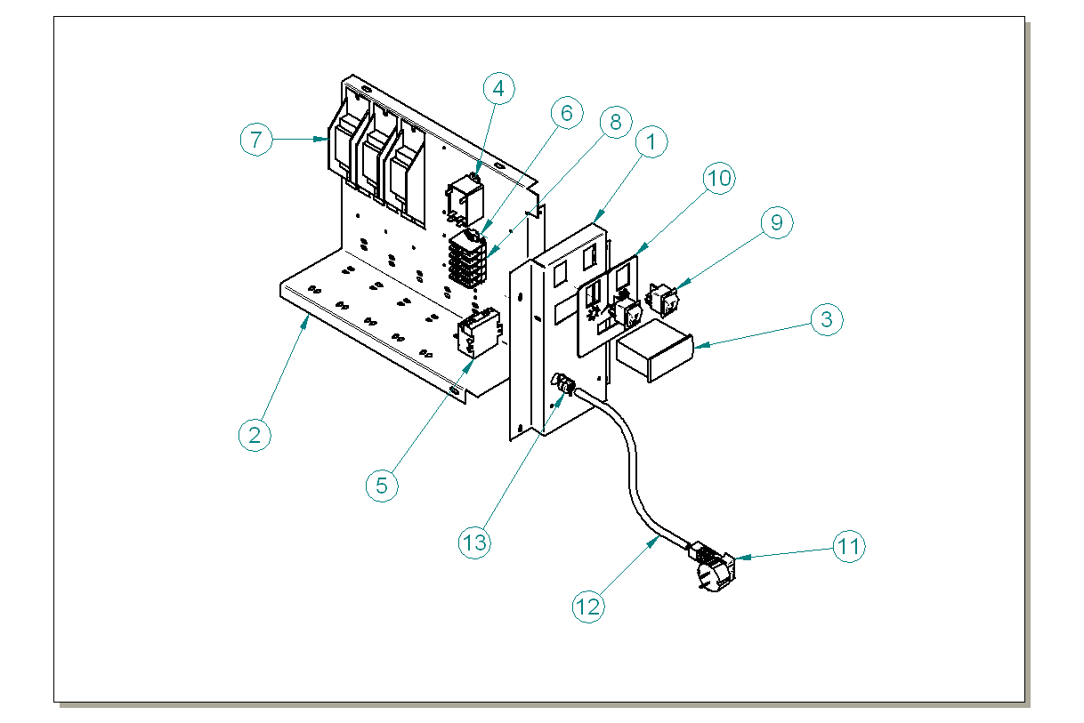

ITEM  NUMBER | DOCUMENT  NUMBER | TITLE | MATERIAL | PART NO. FOR EACH MODULE
 |  |  |  | 1190 | 1785 | 2380 | 2975 | 3570
1 | ET0C 003 | ELECTRONIC FRONT CONTROL PANEL | PLAST. SHEET 6/10 | 6BV120020118
2 | ET0C 001 | BALLAST HOLDER | SHEET 10/10 | 6BV120020182
3 |  | ELECTRONIC CONTROL ELIWELL |  | 4131712
4 |  | RELE FINDER 66.82.8.230.0300 |  | 4111012
5 |  | TRANSFORMER 12 V |  | 4131623
6 |  | PA81 |  | 4113703
7 |  | BALLAST |  | 15 W 4115106 | 30 W 4115103 | 58 - 65 W 4115105 | 30 W 4115103 | 36 - 40 W 4115104
8 |  | TERMINAL BOARD PA 80 |  | 4113702
9 |  | BIPOLAR SWITCH |  | 4113518
10 | ET0C 004 | CONTROL BOARD PLATE |  | 4335648
11 |  | PLUG
12 |  | FEED CABLE
13 | 8291719 | STOPPER FAIRLEAD HEYCO 6N3-4 | PVC | 8291719

  - COMPLETE SIDE WALL

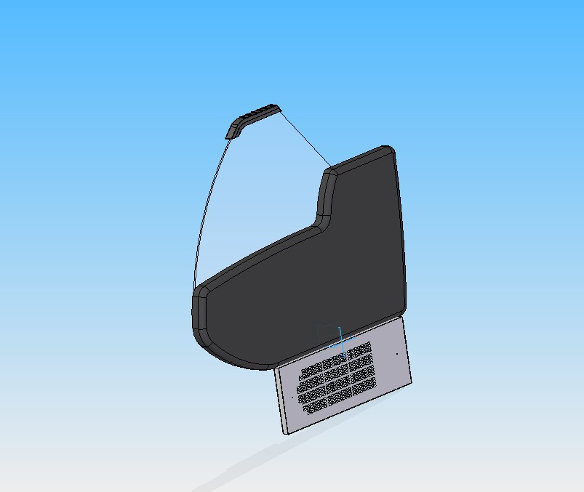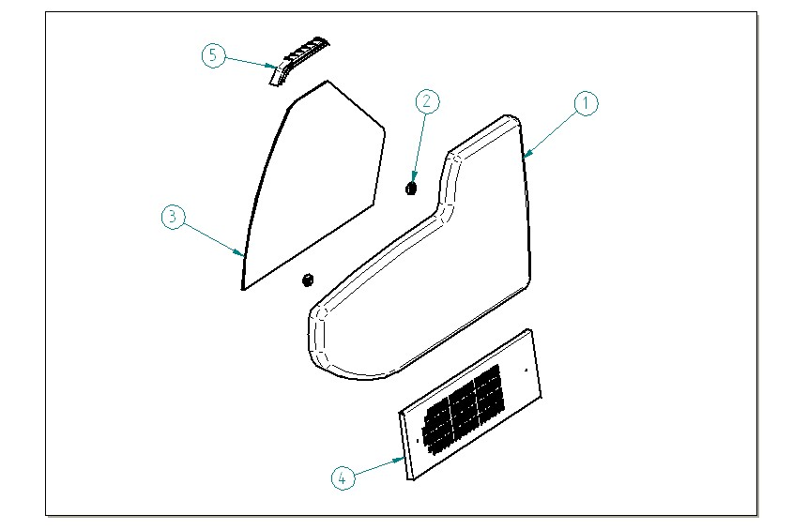

ITEM  NUMBER | DOCUMENT  NUMBER | TITLE | MATERIAL | PART NO. FOR EACH MODULE
 |  |  |  | 1190 | 1785 | 2380 | 2975 | 3570
1 | ET0M 002 | END WALL | ABS | 4104006
2 |  | GLASS BLOCKING 1 | PVC | 4100313
3 | ET0M 001 | SIDE GLASS | FLOAT 6mm | 4190893
4 | ET0J 015 | LEFT SIDE DECORATION PANEL | PLAST. SHEET 6/10 | 2DV120070057
5 | RG 003 | TOP SIDE HEAD |  | 4105408

===========================================





Regione Gabannone, 4 – Zona Industriale
15030 TERRUGGIA (AL) ITALY
Tel. +39 0142 433711
Fax. +39 0142 433700

