

EXPLODED VIEW

FIRENZE
90º INTERNAL CORNER

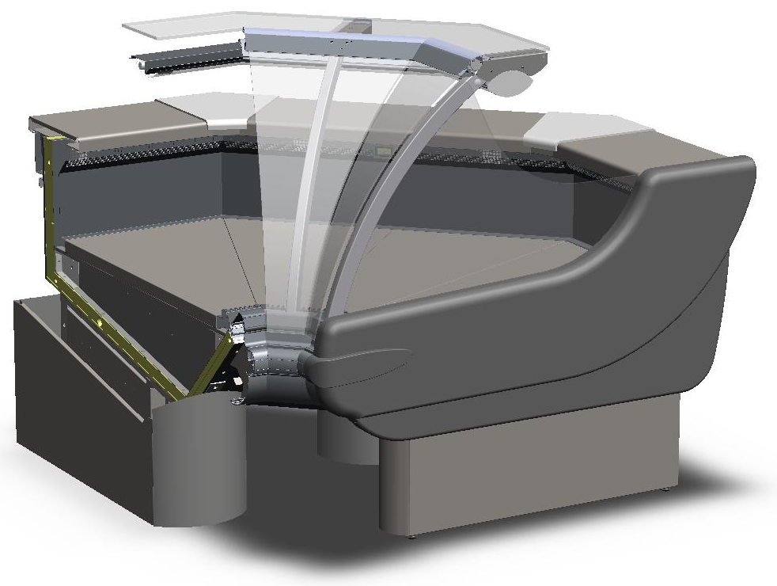

GENERAL SPLITTING UP
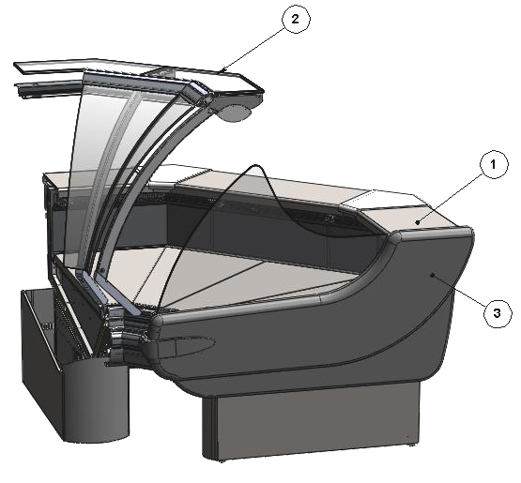
- INTERNAL FINISH, FRONTAL DECORATION
- GLASSES SUPERSTRUCTURE
- COMPLETE SIDE WALL

1. INTERNAL FINISH, FRONTAL DECORATION

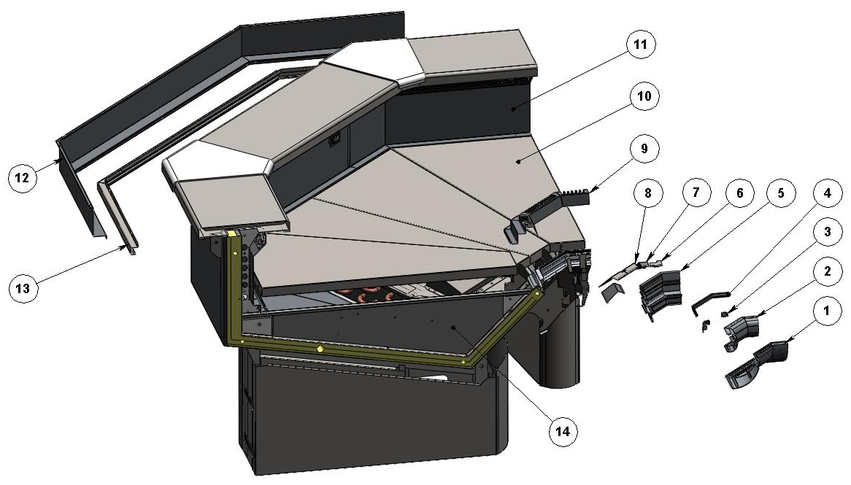

ITEM  NUMBER | DOCUMENT  NUMBER | TITLE | MATERIAL | PART NO. FOR MODULE
1. | TT0L014 | UPPER DECORATION PROFILE | ALUMINIUM | 2FI45I0F0031 (DX)
 |  |  |  | 2FI45I0F0051 (SX)
 |  |  |  | 2FI90I0F0011 (CX)
2. | TT0L012 | BUMPER RAIL PROFILE | PVC | 2FI45I0F0029 (DX)
 |  |  |  | 2FI45I0F0049 (SX)
 |  |  |  | 2FI90I0F0009 (CX)
3. | TT0L004 | BUMPER RAIL COUPLER BRACKET |  | 6FI1250F0008
4. |  | GLASS REBATE GUMMY PROFILE BETA BLACK P0391 | PVC | 4180403
5. | TT0L038 | GLASS REBATE PROFILE |  | 2FI45I0F0027 (DX)
 |  |  |  | 2FI45I0F0047 (SX)
 |  |  |  | 2FI90I0F0007 (CX)
6. | TT0G002 | LATERAL UPRIGHT STOPPER | GREY PLAST. N1 6/10 | 6FI1250F0003 (SX)
7. | TT0G023 | LATERAL UPRIGHT STOPPER | GREY PLAST. N1 6/10 | 6FI45I0F0002 (DX)
 |  |  |  | 6FI45I0F0003 (SX)
8. | TT0G023 | CENTRAL UPRIGHT STOPPER |  | 6FI90I0F0004 (DX)
 |  |  |  | 6FI90I0F0005 (SX)
9. | TT0G011 | SUCTION GRID |  | 6FI45I040031 (DX)
 |  |  |  | 6FI45I040051 (SX)
 |  |  |  | 6FI90I040011 (CX)
10. |  | REMOVABLE PLATE INTERNAL CORNER (ASSEMBLY) |  | 2FI45I040001 (DX)
 |  |  |  | 2FI45I040003 (SX)
11. | TT0G009 | AIR OUTLET GRID | STAINLESS STEEL AISI304 8/10 | 6FI45I040029 (DX)
 |  |  |  | 6FI45I040049 (SX)
 |  |  |  | 6FI90I040009 (CX)
12. | TT0H012 | BLIND WIREWAY | GREY PLAST. N1 6/10 | 6FI45I010027 (DX)
 |  |  |  | 6FI45I010047 (SX)
 |  |  |  | 6FI90I010007 (CX)
13. | PP102 | SLIDING FOR ACCESSORY | STAINLESS STEEL AISI304 8/10 | 6PP90I010009
14. |  | BASIN INTERNAL FINISH

1.1. BASIN INTERNAL FINISH
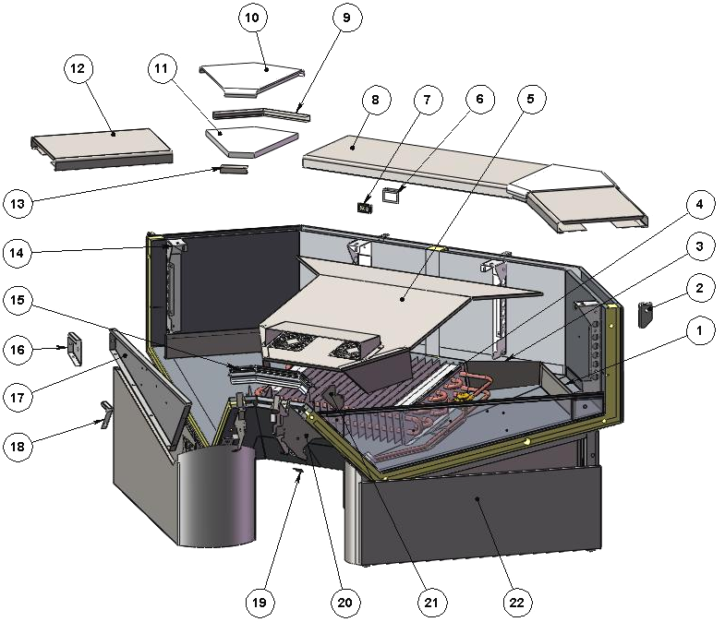

ITEM  NUMBER | DOCUMENT  NUMBER | TITLE | MATERIAL | PART NO. FOR MODULE
1. | PP180 | AIR OUTLET CHANNEL 90°I | PLAST. SHEET 6/10 | 6SV90I040017 (DX)
 |  |  |  | 6SV90I040018 (SX)
2. | TT0H004 | BACK LEVEL SURFACE SUPPORT | IRON SHEET 20/10 | 6FI125010011 (SX)
 |  |  |  | 6FI125010009 (DX)
3. | PP180 | BACK LATERAL EVAPORATOR COVER 90°I | PLAST. SHEET 6/10 | 6SV90I040008 (DX)
 |  |  |  | 6SV90I040015 (SX)
4. |  | EVAPORATOR
5. |  | FANS HOLDER
6. | TT0C002 | THERMOMETER HOLDER | STAINLESS STEEL AISI304 15/10 | 6FI125020007
7. |  | DIGITAL THERMOMETER |  | 4131307
8. | PP061 | STAINLESS STEEL PLAIN | STAINLESS STEEL AISI304 DEC9 BA + PRO + SAT80 H435X7/10 | 6PP90I010002
9. | PP211 | BACK PLAST. STAILESS STEEL CLOSURE 45E | STAINLESS STEEL AISI304 DEC9 BA + PRO + SAT80 H435X7/10 | 6PP45E010007
10. | PP062 | JUNCTION PLANES FOR CORNERS | POLYETHYLENE Thickness 25mm | 4081121
11. | PP210 | PLAST. STOPPER INT. CORNER ALPHA | POLYETHYLENE Thickness 18mm | 4081128
12. | PP061 | STAINLESS STEEL PLAIN | STAINLESS STEEL AISI304 DEC9 BA + PRO + SAT80 H435X7/10 | 6PP45I010002
13. | PP211 | FRONT PLAST. STAILESS STEEL CLOSURE 45E | STAINLESS STEEL AISI304 DEC9 BA + PRO + SAT80 H435X7/10 | 6PP45E010008
14. | TT0G006 | BACK GRID SUPPORT BRACKET | IRON SHEET 15/10 | 6FI125040113 (SX)
 |  |  |  | 2FI45I040027 (DX)
15. | TT0G015 | TOP DEFLECTOR PROFILE | ATOXIC PVC PROFILE GLASS DEFL.4400 0G 001 | 2FI45E040027 (DX)
 |  |  |  | 2FI45I040047 (SX)
 |  |  |  | 2FI90I040007 (CX)
16. | RG106 | BACK STOPPER BRACKET | IRON SHEET 15/10 | 6SV072040041 (SX)
 |  |  |  | 6SV072040040 (DX)
17. | PP013 | BASIN STOPPER | STAINLESS STEEL AISI304 5/10 | 6PP096040001 (SX)
 |  |  |  | 6PP096040000 (DX)
18. | RG034 | SIDE WALL FIXING BRACKET | IRON SHEET 15/10 | 6SV072040039 (SX)
 |  |  |  | 6SV072040038 (DX)
19. | TT0L022 | STOPPER SUPPORT PST | GALVANIZED SHEET SKIMPAS 7/10 | 6FI1250F0012
20. | TT0L001 | TOP PANEL SUPPORT BRACKET | GALVANIZED SHEET 15/10 | 6FI1250F0001
21. | TT0G007 | FRONT GRID SUPPORT BRACKET | STAINLESS STEEL AISI304 15/10 | 6FI125040014 (DX)
 |  |  |  | 6FI125040015 (SX)
22. |  | BOTTOM BASIN ASSEMBLY

    - FANS HOLDER. EVAPORATOR

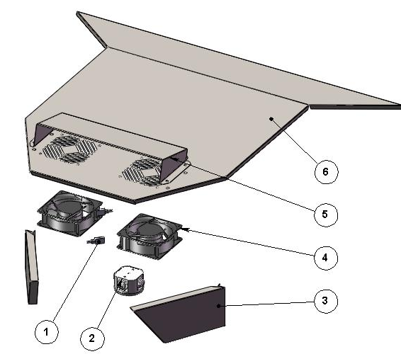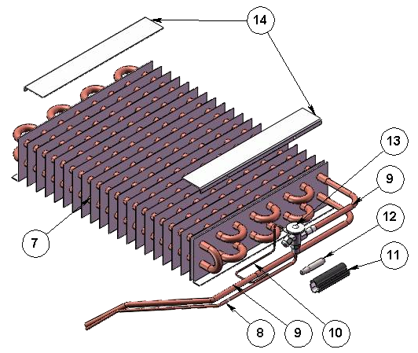

ITEM  NUMBER | DOCUMENT  NUMBER | TITLE | MATERIAL | PART NO. FOR MODULE
1. |  | CABLE CONNECTOR L. 1525 MM |  | 4110606
2. |  | SHUNT BOX D.65 GEWISS | PLAST INSULATING MAT. GW | 4115401
3. | PP180 | FRONT LATERAL EVAPORATOR COVER 90°I | PLAST. SHEET 6/10 | 6SV90I040006 (DX)
 |  |  |  | 6SV90I040016 (SX)
4. |  | MOTORFAN “PP” 4715 MS23TB10 A00 |  | 4241007
5. | PP183 | FANS COVER 90°INT CORNER | STAINLESS STEEL AISI 304 6/10 | 6SV90I040012
6. | TT0F026 | EVAPORATOR COVER 90°I P | STAINLESS STEEL AISI 304 6/10 | 6FI90I040005
7. |  | EVAPORATOR 720 KING V. COATED 520 | COOPER TUBES - ALUMINIUM SHEETS | 4220301
8. | PP441 | TUBE FOR VALVE, EXTERNAL EQUALIZATION | COOPER TUBES D.4 X 6 | 4272414
9. | PP440 | TUBE FOR VALVE, LIQUID LINE | COOPER TUBES D.6 X 8 | 4272415
10. |  | CAPILLARY TUBE | COOPER TUBES 1.8X3 | 4260206
11. |  | ANTICONDENSATE TUBE | INSULATING SPONGE 6 X 22 | 4270505
12. |  | VALVE BULB
13. |  | WELDED VALVE THERMOSTAT.R404 TES/2 |  | 4251311
14. | CC0F012 | EVAPORATOR COVER SUPPORT BRACKET | SILVER PLATED +PLASTICIZED ALUMINIUM 20/10 | 6PP096040036

    - BOTTOM BASIN ASSEMBLY
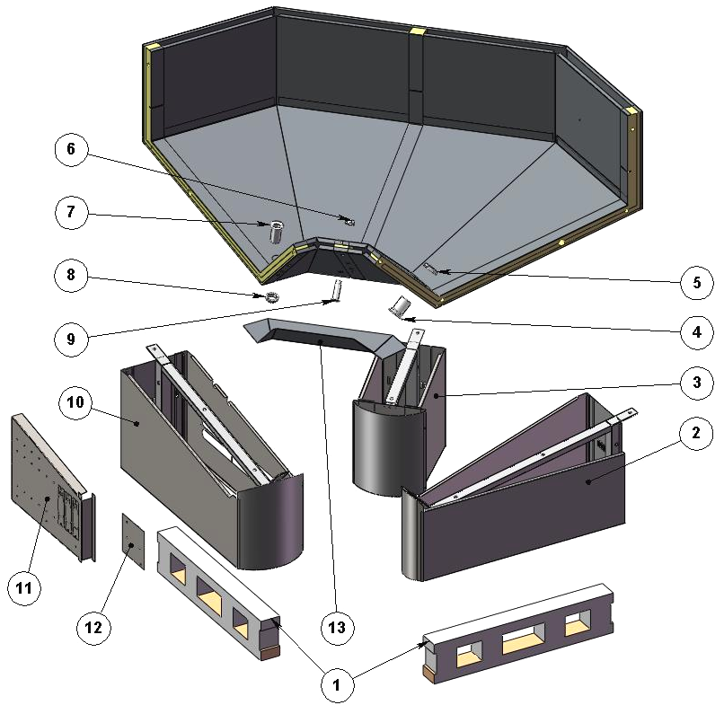

ITEM  NUMBER | DOCUMENT  NUMBER | TITLE | MATERIAL | PART NO. FOR MODULE
1. | PP178 | WOOD SLIDE ”ALPHA” H80 L. 720 | SPRUCE WOOD | 4321310
2. |  | LEFT FRAME
3. |  | CENTRAL FRAME
4. |  | DRAIN D. 44 | ABS | 4102106
5. |  | DRAIN NUT D. 44 | ABS | 4102106
6. |  | DRAIN NUT D. 35 | ABS
7. |  | DRAIN 10124 1’1/2 GAS L.75 MM | ABS | 4102132
8. |  | DRAIN NUT 1’’1/2 | ABS
9. |  | DRAIN D. 35 | ABS
10. |  | RIGHT FRAME
11. |  | BALLASTS HOLDER PANEL
12. | RGSD016 | SUPPORT FOR BALLASTS PANEL TERMINAL BOARD | GALVANIZED SHEET 10/10 | 6SV072090010
13. | TT0J046 | BASIN COVER PANNEL | PLAST. SHEET N12SM 6/10 | 6FI45I070005 (DX)
 |  |  |  | 6FI45I070006 (SX)
 |  |  |  | 6FI90I070007 (CX)

1.1.2.1. BALLASTS HOLDER PANEL

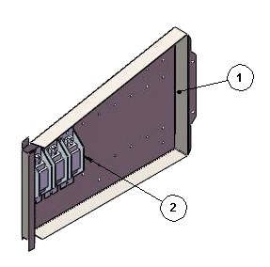

ITEM  NUMBER | DOCUMENT  NUMBER | TITLE | MATERIAL | PART NO. FOR MODULE
1. | TT0C001 | BALLASTS HOLDER | IRON SHEET 10/10 | 6FI125090108
2. |  | BALLAST |  | 18 – 20 W | 15 W
 |  |  |  | 4115102 | 4115106

1.1.2.2. FRAME

LEFT | RIGHT | CENTRAL
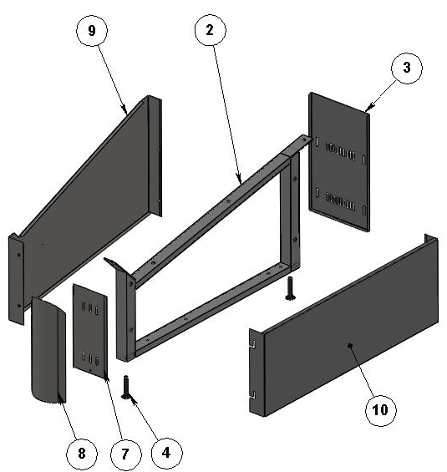 | 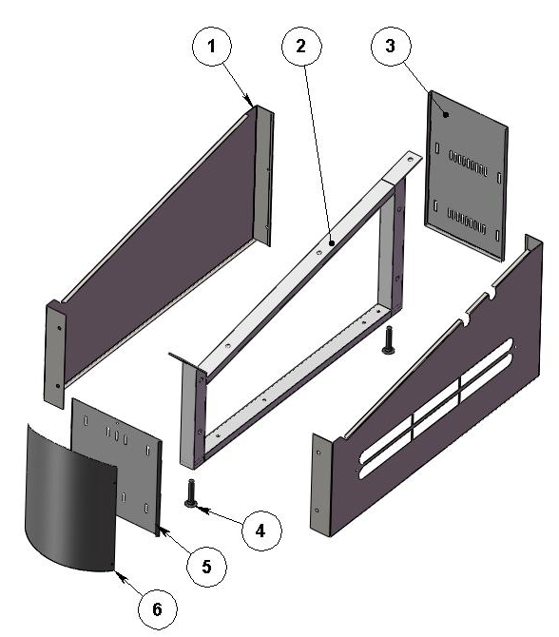 | 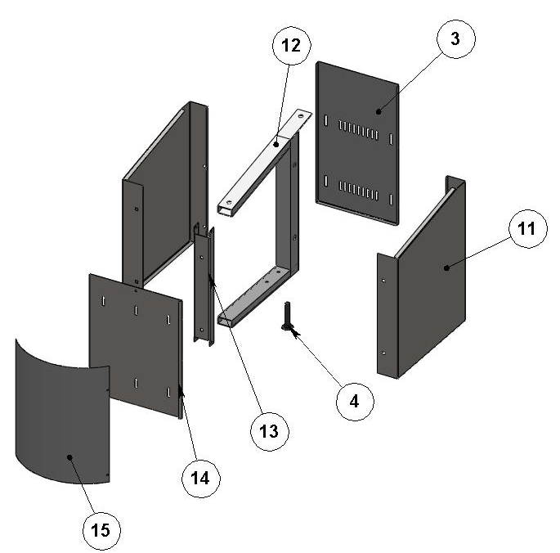

ITEM  NUMBER | DOCUMENT  NUMBER | TITLE | MATERIAL | PART NO. FOR MODULE
1. | TT0J003 | UNDER BASIN DECORATION | PLASTICIZED SHEET 8/10 | 6FI125070004 (SX)
 |  |  |  | 6FI125070003 (DX)
2. | TT0B006 | FRAME | IRON TUBE | 2FI125060001
3. | TT0J007 | LEG BACK CLOSURE (P) | GREY PLASTICIZED SHEET 6/10 | 6FI125060002
4. |  | BOLT M12X45 | GALVANIZED STEEL
5. | TT0J005 | FRONT DECORATION SUPPORT ANTHRAC. | PLASTICIZED SHEET 8/10 | 6FI125070002
6. | TT0J001 | CAMBERED ANTHRAC. FRONT DECORATION | PLASTICIZED SHEET 8/10 | 6FI125070001
7. | TT0J053 | DECORATION SUPPORT 45I SIDE WALL TERM. | PLASTICIZED SHEET 8/10 | -
8. | TT0J052 | CAMBERED FRONT DECORATION 45I SIDE WALL TERM. | PLASTICIZED SHEET 8/10 | -
9. | TT0J054 | UNDER BASIN DECORATION INTERNAL CORNER SIDE WALL TERM. | PLASTICIZED SHEET 8/10 | -
10. | TT0J002 | UNDER SIDE WALL DECORATION | PLASTICIZED SHEET 8/10 | 6FI125080012 (DX)
 |  |  |  | 6FI125080013 (SX)
11. | TT0J049 | UNDER BASIN DECORATION INTERNAL CORNER | GREY PLASTICIZED SHEET 8/10 | 6FI90I070003 (DX)
 |  |  |  | 6FI90I070004 (SX)
12. | TT0B023 | FRAME | IRON TUBE | 2FI90I060001
13. | TT0B024 | FRAME SUPPORT FOR 90°INTERNAL CORNER | GALVANIZED SHEET15/10 | 6FI90I060005
14. | TT0J050 | FRONT DECORATION SUPPORT ANTHRAC. INTERNAL CORNER | GREY PLASTICIZED SHEET 8/10 | 6FI90I070002
15. | TT0J051 | CAMBERED ANTHRAC. FRONT DECORATION INTERNAL CORNER | GREY PLASTICIZED SHEET 8/10 | 6FI90I070001

2. GLASSES SUPERSTRUCTURE
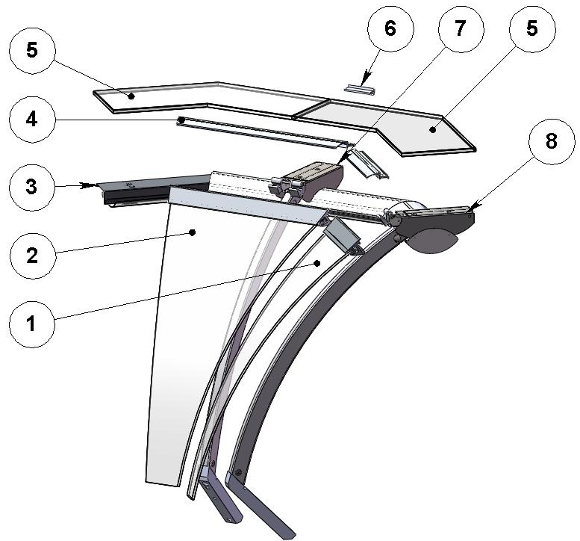

ITEM  NUMBER | DOCUMENT  NUMBER | TITLE | MATERIAL | PART NO. FOR MODULE
1. |  | LEFT GLASS ASSEMBLY
2. |  | CENTRAL GLASS ASSEMBLY |  | 2SV90I030008
3. |  | UPPER CEILING LAMP FI 90°I C.T.M. |  | 2FI90I030009
4. | TT0D023 | COVER PROFILE | ALUMINIUM PROFILE | 2FI90I030005 (CX)
 |  |  |  | (SX)
5. | TT0D021 | HEAD GLASS FI 135°I |  | 4199913
6. | TT0D010 | CENTRAL TOP GLASS STOP | TOP GLASS STOP PROFILE | 2FI187030004
7. |  | CENTRAL UPRIGHT |  | 2FI125030002
8. |  | LATERAL UPRIGHT

2.1. CEILING LAMP
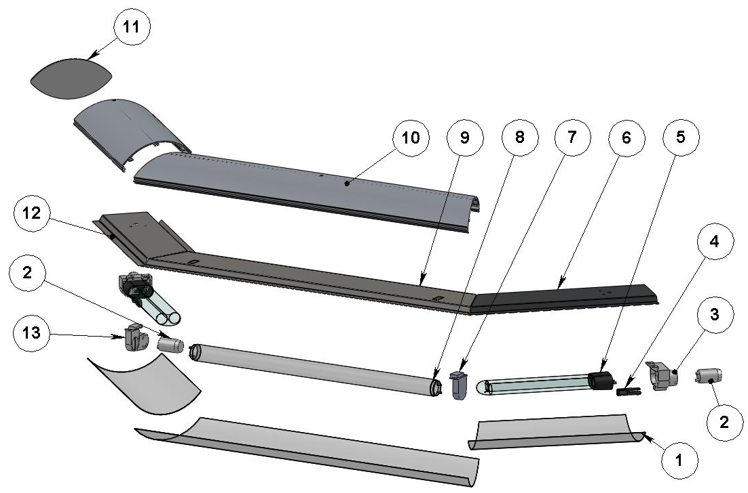

ITEM  NUMBER | DOCUMENT  NUMBER | TITLE | MATERIAL | PART NO. FOR MODULE
1. | TT0E029 | CEILING LAMP SHIELD POLYCARBONATE | POLYC. PLEX. LEXAN PC 2050X1250X0,75 | 6FI45I030032 (DX)
 |  |  |  | 6FI45I030052 (SX)
 |  |  |  | 6FI90I030012 (CX)
2. |  | UNIVERSAL STARTER FS 11 |  | 4116001
3. |  | LAMPS HOLDER + STARTERS HOLDER 441/V-16 |  | 4114712
4. |  | LAMP STOP DEVICE "120" |  | 4114713
5. |  | COMPACT LAMP DULUX L18W/76 |  | 4113623
6. | TT0E005 | RIGHT TOP CEILING LAMP 45°I | PLASTICIZED SHEET 8/10 | 6FI45I030031 (DX)
 |  |  |  | 6FI45I030051 (SX)
7. |  | LAMP HOLDER STUCCHI 255/S 2° 250V |  | 4114709
8. |  | NEON 15 W/76 D.26 L 438 |  | 4114514
9. | TT0E006 | CENTRAL TOP CEILING LAMP 90°I | PLASTICIZED SHEET 8/10 | 6FI90I030011
10. | TT0E008 | CEILING LAMP PROFILE INTERNAL CORNER | ALUMINIUM PROFILE | 2FI90I030010 (CX)
 |  |  |  | 2FI90I030010 (DX)
11. | CC0D023.1 | CEILING LAMP HEAD | OPAL GLASS | 4082305
12. | TT0E005 | TOP LAMPS HOLDER 45°I FOR CORNER ENDED WITH SIDE WALL | PLASTICIZED SHEET 8/10 | 6FI45I030031 (DX)
13. |  | LAMPS HOLDER + STARTERS HOLDER STUCCHI 255/C | PVC | 4114710

2.2. UPRIGHT

LATERAL | CENTRAL
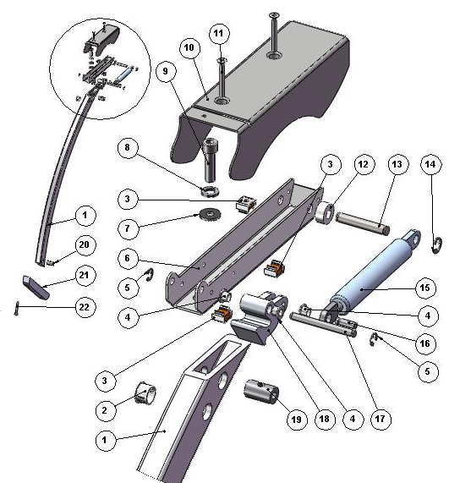 | 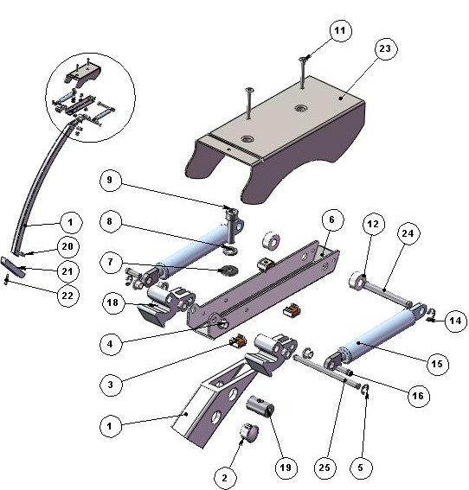

ITEM  NUMBER | DOCUMENT  NUMBER | TITLE | MATERIAL | PART NO. FOR MODULE
1. | TT0D002 | CURVED FRONT UPRIGHT FIR. | ALLOY 6060 T5 | 4351209
2. |  | WHITE STOPPER DP500 | PLASTIC | 4333114
3. |  | CAGE NUT M5
4. | ECAV 016 | PISTON BUSH | NYLON | 8291718
5. |  | SEGGER 5 | GALVANIZED STEEL | 8298303
6. | TT 0D001 | LEVER SUPPORT | IRON SHEET 20/10 | 2FI125030013
7. |  | PLAIN WASHER 8X24 | GALVANIZED STEEL
8. |  | GROWER M8
9. |  | BOLT TCEI M8X30 | GALVANIZED STEEL
10. | TT0D007 | LEVER COVER | IRON SHEET 15/10 | 2FI125030016 (SX)
11. |  | BOLT TS+ M5X35 | STAINLESS STEEL
12. |  | SPACER WITH HOLE DCS79B 6R | NYLON
13. | TT0D005 | LATERAL BACK PIN | GROUND DRAWN STEEL Ø8 | 4140086
14. |  | SEGGER 7 | GALVANIZED STEEL | 8298304
15. |  | PISTON VS-SV R 1000 | STAINLESS STEEL | 4145020
16. | ECAV018 | PISTON FRONT PIN | GROUND DRAWN STEEL Ø6
17. | TT0D003 | LATERAL FRONT PIN | GROUND DRAWN STEEL Ø6 | 4140085
18. | AV011 | ROTATION LEVER PRESSOFUS | ALUMINIUM ALLOY | 4282114 (SX)
 |  |  |  | 4282113 (DX)
19. | TT0D013 | GLASS UPRIGHT PIN | STEEL BAR Ø15 | 4140088
20. | RG072 | BACK GLASS UPRIGHT PIN "SIGMA" GALVANIZED | STEEL BAR Ø15 | 4140070
21. | CC0D010 | GLASS UPRIGHT SUPPORT KREA | ALUMINIUM ALLOY 6060 (FLAT PROFILE 30X30) | 4282116
22. |  | BOLT TCEI M8X50 | GALVANIZED STEEL
23. | TT0D008 | CENTRAL LEVER COVER | IRON SHEET 15/10 | 2FI125030017 (CX)
24. | TT0D006 | CENTRAL BACK PIN | GROUND DRAWN STEEL Ø8 | 4140087
25. | TT0D004 | CENTRAL FRONT PIN | GROUND DRAWN STEEL Ø6 | 4140084

2.3. GLASS ASSEMBLY

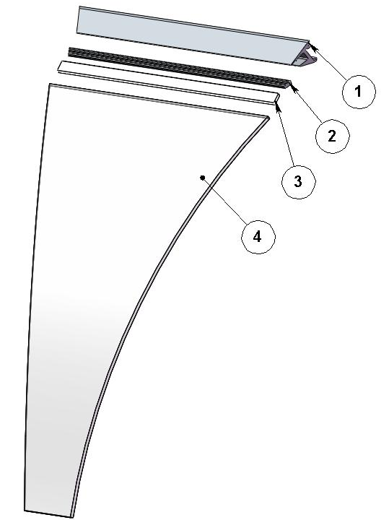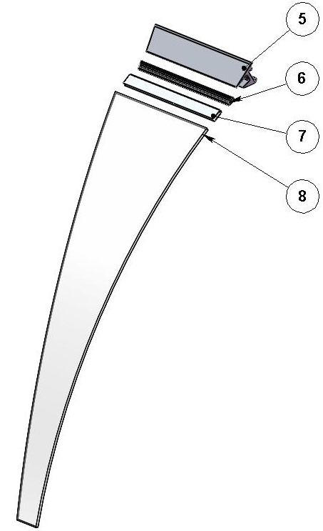
ITEM  NUMBER | DOCUMENT  NUMBER | TITLE | MATERIAL | PART NO. FOR MODULE
1. | RG061 | CENTRAL JAW PROFILE SV 90°I | JAW ALUMINIUM PROFILE | 2SV90I030009
2. |  | GLASS GASKET PROFILE | PVC | 4180100
3. |  | CENTRAL JAW INSERT PROFILE SV 90°I | ALUMINIUM PROFILE E5628A | 2SV90I030011
4. | RG046 | CENTRAL CURVED GLASS 90° INT. CORNER 760X 438 | FLOAT 6 mm | 4191473
5. | RG061.1 | JAW PROFILE 45I | ALUMINIUM PROFILE
6. |  | GLASS GASKET PROFILE | PVC | 4180100
7. | TT0D031 | JAW INSERT PROFILE | ALUMINIUM PROFILE E5628A
8. | RG045 | GLASS 45I | FLOAT 6mm | 4191472 (SX)

3. COMPLETE SIDE WALL
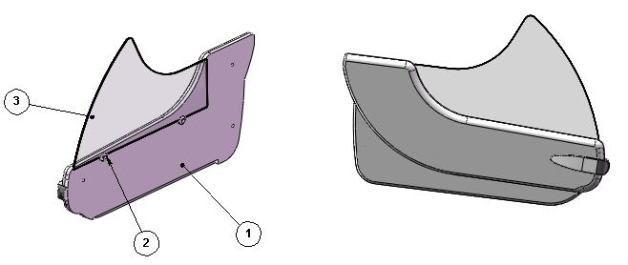

ITEM  NUMBER | DOCUMENT  NUMBER | TITLE | MATERIAL | PART NO. FOR MODULE
1. | TT0M001 | SIDE WALL | POLYURETHANE Thickness 50mm | (SX)
 |  |  |  | (DX)
2. |  | LATERAL GLASS BLOCK | PVC | 4100313
3. | TT0M009 | SIDE GLASS FIRENZE | FLOAT 6 mm | 4190150

==========================================





Regione Gabannone, 4 – Zona Industriale
15030 TERRUGGIA (AL) ITALY
Tel. +39 0142 433711
Fax. +39 0142 433700

