

EXPLODED VIEW

FIRENZE SELF SERVICE

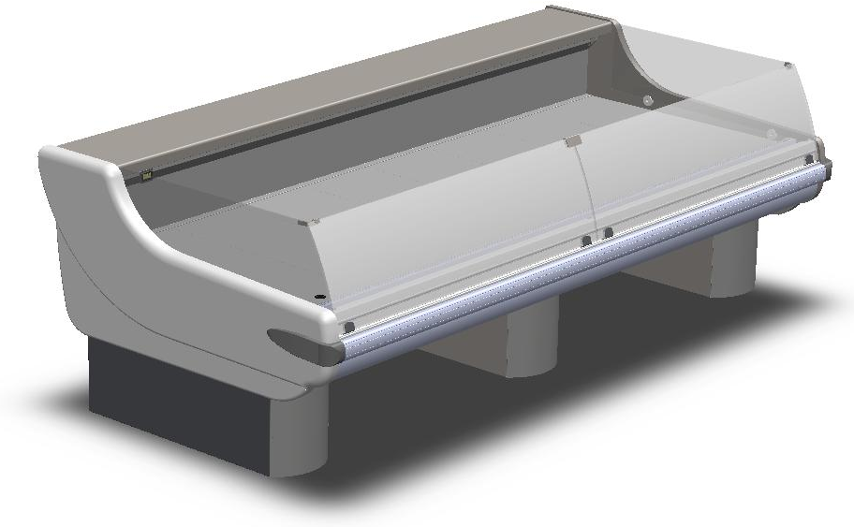

GENERAL SPLITTING UP

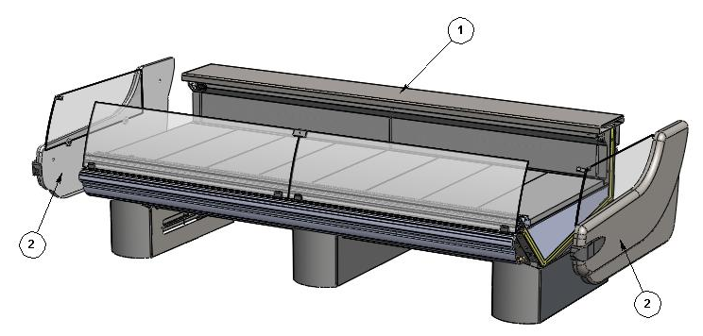

- INTERNAL FINISH, FRONTAL DECORATION
- LATERAL SIDE WALL

1. INTERNAL FINISH, FRONTAL DECORATION

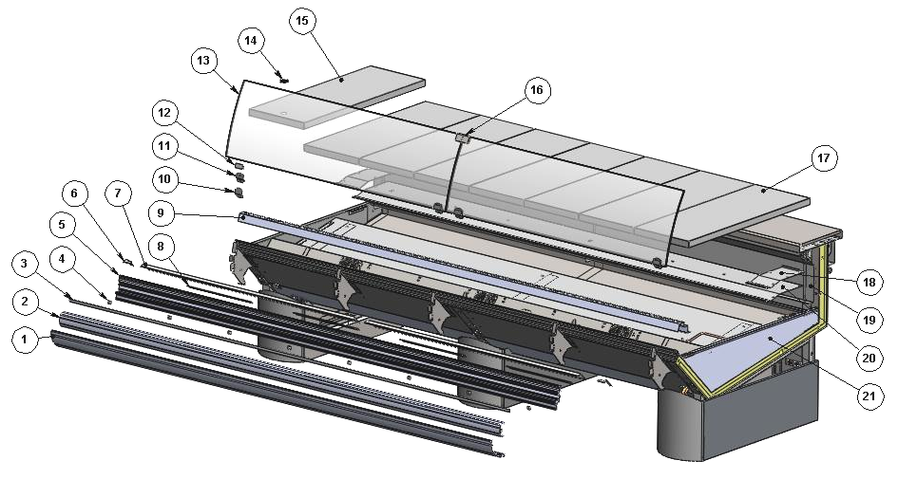

ITEM  NUMBER | DOCUMENT  NUMBER | TITLE | MATERIAL | PART NO. FOR EACH MODULE
 |  |  |  | 937 | 1250 | 1875 | 2500 | 3125 | 3750
1. | TT0L003 | TOP DECORATION PROFIL | ALUMINIUM | 2FI1250F0011
2. | TT0L002 | BUMPER PROFIL | PVC | 2FI1250F0009
3. |  | LITTLE RUBBER INSERT PROFIL | PVC | 4180409
4. | TT0L004 | COUPLING BUMPER BRACKET |  | 6FI1250F0008
5. | TT0L039 | GLASS REBATE PROFIL |  | 2FI1250F0007
6. | TT0G002 | LATERAL UPRIGHT STOPPER | PLASTICIZED SHEET 6/10 | 6FI1250F0003 (SX)
 |  |  |  | 6FI1250F0002 (DX)
7. | TT0G003 | CENTRAL UPRIGHT STOPPER | PLASTICIZED SHEET 6/10 | 6FI1250F0004 |  | 6FI1870F0006(SX)
 |  |  |  | - |  | 6FI1870F0005 (DX)
 |  |  |  | - |  | - | - | 6FI3750F0004 (CX)
8. | TT0L022 | PST STOPPER SUPPORT | GALVANIZED SHEET 7/10 | 6FI1250F0012
9. | TT0G005 | SUCTION GRID WITH BAFFLE LINEAR MODULES | STAINLESS STEEL AISI304 SB 8/10 | 6FI093040011 | 6FI125040011 | 6FI187040011 | 6FI250040011 | 6FI312040011 | 6FI375040011
10. | RG126 | BACK GLASS FIXING BRACKET S/S | STAINLESS STEEL AISI304 2B 15/10 | 6SV072030403
11. | RG126 | FRONT GLASS FIXING BRACKET S/S | STAINLESS STEEL AISI304 2B 15/10 | 6SV072030402
12. |  | GLASS GASKET PVC PROFIL U ART.P0 924 | PVC | 4180100
13. | TT0D055 | FRONT GLASS SELF SERVICE |  | 4191586 | 4191587 | 4191586 | 4191587 | 4191586 | 4191587
 |  |  |  |  |  |  |  | 4191587 | 4191587
14. |  | FAIR LEAD LITTLE RUBBER D25 |  | 4113102
15. | TT0K001 | REMOVABLE DISPLAY PLATE WITH HOLE | STAINLESS STEEL AISI304 8/10 | 6FI125040004
16. |  | GLASS STOP MANOR SS POLYCARBONATE MP160 |  | 4081335
17. | TT0K001 | REMOVABLE DISPLAY PLATE WITHOUT HOLE | STAINLESS STEEL AISI304 8/10 | 6FI125040002
18. | TT0F016 | BOTTOM CLOSURE EVAPORATOR STOPPER | STAINLESS STEEL AISI304 8/10 | 6FI125040022
19. | TT0G004 | AIR OUTLET GRID FOR FRONT UPRIGHT | STAINLESS STEEL AISI304 8/10 | 6FI093040009 | 6FI125040009 | 6FI187040009 | 6FI250040009 | 6FI312040009 | 6FI375040009
20. | TT0F006 | BACK CLOSURE EVAPORATOR | STAINLESS STEEL AISI304 8/10 | 6FI093040020 | 6FI125040020 | 6FI187040020 | 6FI250040020 | 6FI312040020 | 6FI375040020
21. |  | BASIN INTERNAL FINISH

1.1. BASIN INTERNAL FINISH

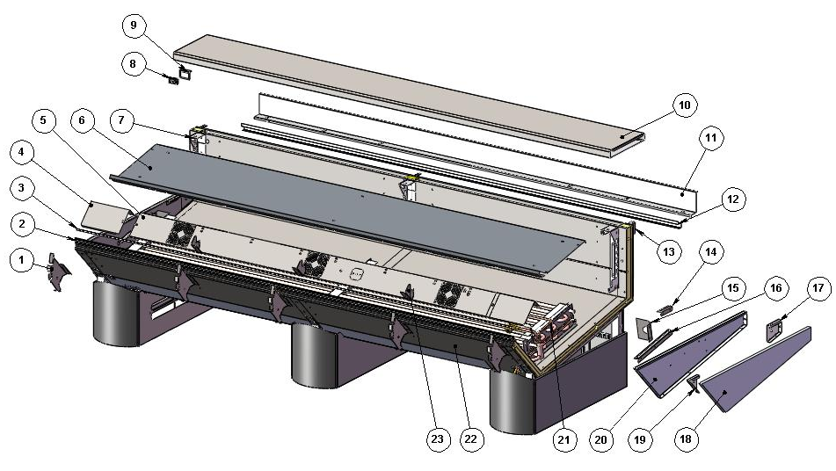

ITEM  NUMBER | DOCUMENT  NUMBER | TITLE | MATERIAL | PART NO. FOR EACH MODULE
 |  |  |  | 937 | 1250 |  | 1875 |  | 2500 | 3125 | 3750
1. | TT0L001 | PANEL SUPPORT TOP BRACKET | GALVANIZED SHEET 15/10 | 6FI1250F0001
2. | TT0G013 | BAFFLE SUPPORT PROFIL | ATOXIC GLASS BAFFLE PVC PROFILE 4400 | 2FI093040007 | 2FI125040007 |  | 2FI187040007 |  | 2FI250040007 | 2FI312540007 | 2FI375040007
3. |  | LITTLE RUBBER INSERT PROFILE |  | 4180409
4. | TT0F003 | DRAIN INSPECTION COMPARTMENT | STAINLESS STEEL AISI304 6/10 | 6FI125040124 (SX)
 |  |  |  | 6FI125040123 (DX)
5. |  | FANS HOLDER ASSEMBLY |  | 2FI093040017 |  | 2FI125040117 |  | 2FI187040117 | 2FI250040117 | 2FI312040117 | 2FI375040117
6. | TT0F001 | EVAPORATOR COVER | STAINLESS STEEL AISI304 8/10 | 6FI093040016 |  | 6FI125040116 |  | 6FI187040116 | 6FI250040116 | 6FI312040116 | 6FI375040116
7. | TT0G006 | BACK GRID SUPPORT BRACKET | IRON SHEET 15/10 | 6FI125040113(SX)
 |  |  |  | 6FI125040112(DX)
8. |  | DIGITAL THERMOMETER |  | 4131307
9. | TT0C002 | THERMOMETER HOLDER | STAINLESS STEEL AISI304 15/10 | 6FI125020007
10. |  | WORKING TABLE |  | 2FI093010000 | 2FI125010000 |  | 2FI187010000 |  | 2FI250010000 | 2FI312010000 | 2FI375010000
11. | TT0H013 | BLIND WIREWAY | PLASTICIZED SHEET 6/10 | 6FI093010007 | 6FI125010007 |  | 6FI187510007 |  | 6FI250010007 | 6FI312010007 | 6FI375010007
12. | TT0H014 | SLIDING GUIDE FOR ACCESSORIES | STAINLESS STEEL AISI304 8/10 | 6FI093010028 | 6FI125010028 |  | 6FI187510028 |  | 6FI250010028 | 6FI312010028 | 6FI375010028
13. | TT0H004 | BACK PLATFORM SUPPORT | IRON SHEET 20/10 | 6FI125010009(DX)
 |  |  |  | 6FI125010011(SX)
14. | TT0F 007 | BACK CLOSURE SUPPORT | STAINLESS STEEL AISI304 5/10 | 6FI125040121
15. | TT0F 005 | LATERAL CLOSURE EVAPORATOR | STAINLESS STEEL AISI304 6/10 | 6FI125040119
16. | PP 379 | EVAPORATOR COVER SUPPORT | STAINLESS STEEL AISI304 6/10 | 6PP096040006
17. | RG106 | BACK STOPPER BRACKET | IRON SHEET 15/10 | 6SV072040041(SX)
 |  |  |  | 6SV072040040(DX)
18. | PP042 | BASIN INSULATING STOPPER | POLYSTYRENE D.30 | 2PP096040006
19. | RG 034 | SIDE WALL FIXING BRACKET | IRON SHEET 15/10 | 6SV072040039(SX)
 |  |  |  | 6SV072040038(DX)
20. | PP013 | BASIN STOPPER | STAINLESS STEEL AISI304 5/10 | 6PP096040001(SX)
 |  |  |  | 6PP096040000(DX)
21. |  | EVAPORATOR |  | 2FI093150001 | 2FI125150001 |  | 2FI187153001 |  | 2FI250150001 | 2FI312150001 | 2FI312153001
22. |  | BOTTOM BASIN ASSEMBLY
23. | TT0G007 | FRONT GRID SUPPORT BRACKET | STAINLESS STEEL AISI304 5/10 | 6FI125040015

1.1.1. FANS HOLDER. EVAPORATOR

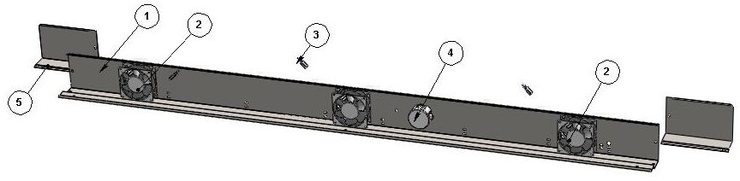

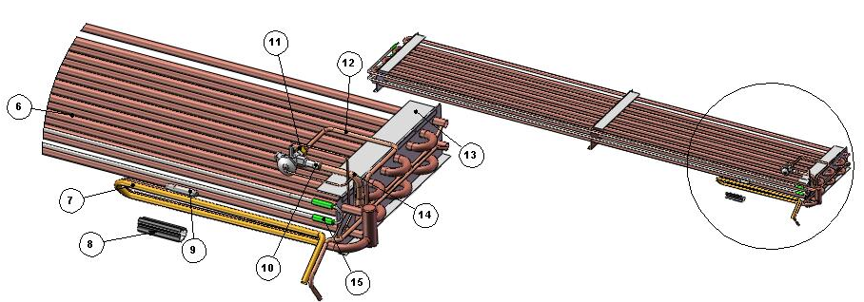

ITEM  NUMBER | DOCUMENT  NUMBER | TITLE | MATERIAL | PART NO. FOR EACH MODULE
 |  |  |  | 937 | 1250 | 1875 | 2500 | 3125 | 3750
1. | TT0F002 | FANS HOLDER | STAINLESS STEEL AISI304 6/10 | 6FI093040018 | 6FI125040118 | 6FI187040118 | 6FI250040118 | 6FI312040118 | 6FI375040118
2. |  | MOTORFAN |  | 4241007
3. |  | CABLE CONNECTOR L. 1525 MM |  | 4110606
4. |  | SHUNT BOX D.65 GEWISS | PLAST INSULATING MAT. GW | 4115401
5. | TT0F003 | DRAIN INSPECTION COMPARTMENT REMOVABLE PLATE | STAINLESS STEEL AISI304 6/10 | 6FI125040023 (DX)
 |  |  |  | 6FI125040024 (SX)
6. | RG215 | EVAPORATOR | COOPER TUBES -ALUMINIUM SHEETS | 4220342 | 4220343 | - | - | - | -
6. | RG216 | EVAPORATOR | COOPER TUBES -ALUMINIUM SHEETS | - | - | 4220344 | 4220345 | 4220309 | 4220346
7. | TT0F008 | SUCTION TUBE | COOPER TUBES 10X12 | 4260104
8. |  | ANTICONDENSATE TUBE | INSULATING SPONGE 6X22 | 4270505
9. |  | VALVE BULB
10. |  | WELDED VALVE THERMOSTAT.R404 TES/2 |  | 4251311
11. |  | PIPE UNION 3/8SAE Ø 8 |  | 4272415
12. | PP303.1 | EVAPORATOR DELIVERY SIDE TUBE | COOPER TUBES Ø8 | 4271314
13. | CC0F012 | EVAPORATOR COVER SUPPORT BRACKET | SILVER PLATED +PLASTICIZED ALUMINIUM 20/10 | 6PP096040036
14. | PP293.1 | VALVE - EVAPORATOR TUBE WITH LIQUID DISTRIBUTOR | COOPER TUBES Ø12 – Ø6 | 4271313
15. | TT0F023 | DEFROSTING RESISTOR | STAINLESS STEEL AISI304 | 4122102 |  | 4122103 | 4122104 | 4122105 | 4122106

1.1.2. BOTTOM BASIN ASSEMBLY

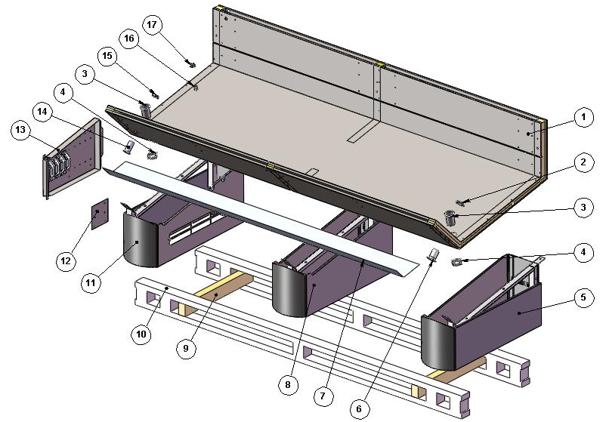

ITEM  NUMBER | DOCUMENT  NUMBER | TITLE | MATERIAL | PART NO. FOR EACH MODULE
 |  |  |  | 937 | 1250 |  | 1875 |  | 2500 |  |  | 3125 |  | 3750
1. | TT0A001 | FOAMED BODY E(P)+I(P) |  | 2FI093000001 | 2FI125000001 |  | 2FI187000001 |  | 2FI250000001 |  |  | 2FI312000001 |  | 2FI375000001
2. |  | DRAIN NUT D. 44 | ABS | 4102106
3. |  | DRAIN 10124 1'1/2 GAS L.75 MM | ABS | 4102132
4. |  | DRAIN NUT 1” 1/2 GAS | ABS | 4102132
5. |  | LEFT FRAME
6. |  | DRAIN D. 44 | ABS | 4102106
7. | TT0J006 | BASIN COVER PANEL | PLASTICIZED SHEET 8/10 | 6FI093070005 |  | 6FI125070005 |  | 6FI187070005 |  | 6FI250070005 | 6FI312070005 |  | 6FI312070005
8. |  | CENTRAL FRAME
9. |  | SPLINE | WOOD 80X50X630 | 4321248
10. | TT0B014 | LOADING SLIDE | SPRUCE WOOD | 4321345
11. |  | RIGHT FRAME
12. | RGSD.016 | SUPPORT FOR BALLASTS PANEL TERMINAL BOARD | GALVANIZED SHEET 10/10 | 6SV072090010
13. |  | BALLASTS HOLDER PANEL |  | 2FI125090107
14. |  | DRAIN EXCELLEN. H90 D32-10106 | ABS | 4102125
15. |  | DRAIN NUT D32 | ABS
16. |  | DRAIN D. 20 | ABS | 4102101
17. |  | DRAIN NUT D. 20 | ABS | 4102101

1.1.2.1. BALLASTS HOLDER PANEL

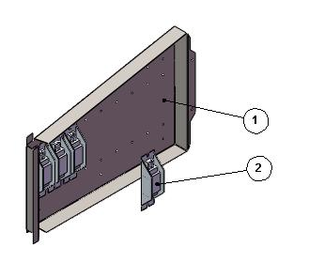

ITEM  NUMBER | DOCUMENT  NUMBER | TITLE | MATERIAL | PART NO. FOR EACH MODULE
 |  |  |  | 937 | 1250 | 1875 | 2500 | 3125 | 3750
1. | TT0C001 | BALLASTS HOLDER | IRON SHEET 10/10 | 6FI125090108
2. |  | BALLAST |  | 30W
 |  |  |  | 4115103

1.1.2.2. CENTRAL AND LEFT FRAME

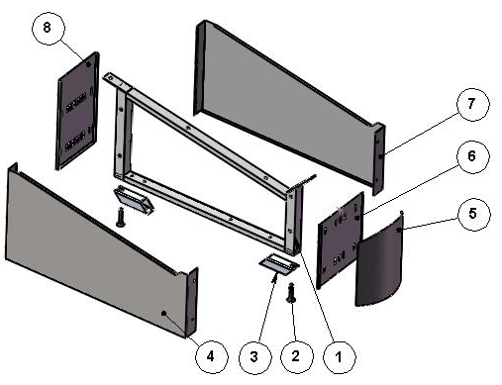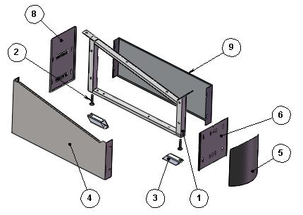
ITEM  NUMBER | DOCUMENT  NUMBER | TITLE | MATERIAL | PART NO. FOR EACH MODULE
 |  |  |  | 937 | 1250 | 1875 | 2500 | 3125 | 3750
1. | VLTT0B006 | FRAME | ALUMINIUM ALLOY | 2FI125060001
2. |  | BOLT M12X45 | GALVANIZED STEEL
3. | TT0B020 | SLIDE COUPLER BRACKET | IRON
4. | TT0J003 | RIGHT BLIND PAINTED UNDER BASIN DECORATION | PLASTICIZED SHEET 8/10 | 6FI125070003
5. | TT0J001 | PAINTED CAMBERED FRONT DECORATION | PLASTICIZED SHEET 8/10 | 6FI125070001
6. | TT0J005 | PAINTED FRONT DECORATION SUPPORT | PLASTICIZED SHEET 8/10 | 6FI125070002
7. | TT0J003 | LEFT BLIND PAINTED UNDER BASIN DECORATION | PLASTICIZED SHEET 8/10 | 6FI125070004
8. | TT0J007 | LEG BACK CLOSURE (P) | GREY PLASTICIZED SHEET 6/10 | 6FI125060002
9. | TT0J002 | LEFT UNDER SIDE WALL DECORATION WITH CAMBERED FRONT | PLASTICIZED SHEET 8/10 | 6FI125080013 (SX)
 |  |  |  | 6FI125080012 (DX)

2. LATERAL SIDE WALL

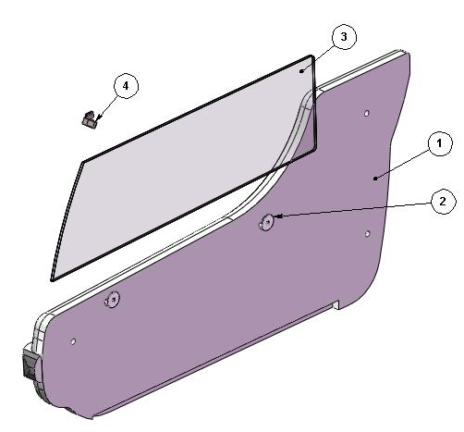
ITEM  NUMBER | DOCUMENT  NUMBER | TITLE | MATERIAL | PART NO. FOR EACH MODULE
 |  |  |  | 937 | 1250 | 1875 | 2500 | 3125 | 3750
1. | TT0M001 | SIDE WALL | POLYURETHANE Thickness 50mm | (SX)
 |  |  |  | (DX)
2. |  | LATERAL GLASS BLOCK | PVC | 4100313
3. | TT0M008 | SIDE GLASS FIRENZE | FLOAT 6 mm | 4190307
4. | ETOM004 | SIDE WALL FRONT GLASS SS BRACKET | STAINLESS STEEL AISI304 15/10 | 6DV120032001 (DX)
 |  |  |  | 6DV120032002 (SX)

===========================================





Regione Gabannone, 4 – Zona Industriale
15030 TERRUGGIA (AL) ITALY
Tel. +39 0142 433711
Fax. +39 0142 433700

