

EXPLODED VIEW

FIRENZE HOT SECTION

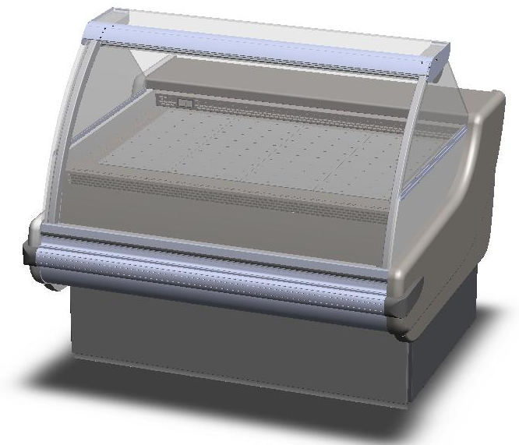

GENERAL SPLITTING UP

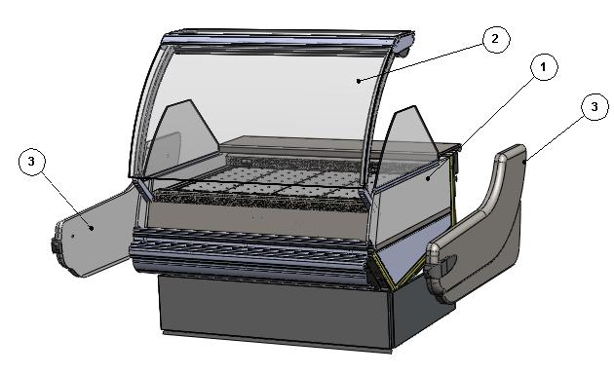

- INTERNAL FINISH, FRONTAL DECORATION
- GLASSES SUPERSTRUCTURE
- LATERAL SIDE WALL

1. INTERNAL FINISH, FRONTAL DECORATION
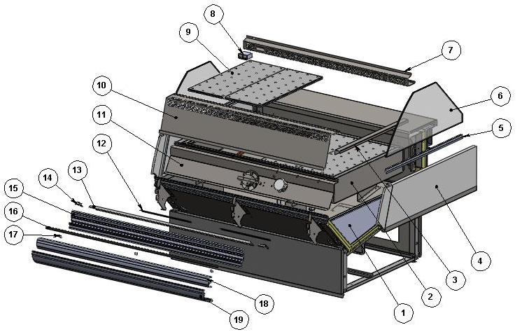

ITEM  NUMBER | DOCUMENT  NUMBER | TITLE | MATERIAL | PART NO. FOR EACH MODULE
 |  |  |  | 937 | 1250
1. |  | BASIN INTERNAL FINISH
2. |  | BAIN-MARIE BASIN ASSEMBLY 1200
3. | TT2G004 | BASIN COMPENSATION BM 1250 | STAINLESS STEEL AISI304 SB+PRO, 10/10 | 6FI12504T006
4. |  | HOT SECTION FIXED DIVIDER |  | 2FI12504T004 (DX)
 |  |  |  | 2FI12504T005 (SX)
5. | TT0U018 | GLASS HANDLE | ALUMINIUM PROFILE
6. | TT0U015 | HIGH GLASS ON FIXED DIVIDER FOR FIRENZE / A | FLOAT 6mm TRANSPARENT | 4191393
7. | TT2G006 | BACK GRID BM | STAINLESS STEEL AISI304 SB+PRO, 8/10 | 6FI09304T001 | 6FI12504T001
8. |  | THERMOMETER 0/120°C C°+ F°RO-88 BLACK |  | 4131306
9. | VLTC037 | BORED SHELFS | STAINLESS STEEL AISI304 SB+PRO, 8/10 | 6PP09604T029
10. | TT2G003 | FRONT GRID BM | STAINLESS STEEL AISI304 SB+PRO, 8/10 | 6FI09304T002 | 6FI12504T002
11. |  | HOT SECTION FANS HOLDER |  | 2PP09604T004 | 2FI12504T007
12. | VLTT0L022 | STOPPER SUPPORT PST | GALVANIZED SHEET 7/10 | 6FI1250F0012
13. | TT0G003 | CENTRAL UPRIGHT STOPPER | PLASTICIZED SHEET 6/10 | 6FI1250F0004
14. | VLTT0G 002 | LATERAL UPRIGHT STOPPER | PLASTICIZED SHEET 6/10 | 6FI1250F0003 (SX)
 |  |  |  | 6FI1250F0002 (DX)
15. | VLTT0L039 | GLASS REBATE PROFILE |  | 2FI0930F0007 | 2FI1250F0007
16. |  | GUMMY INSERT PROFILE | PVC | 4180409
17. | VLTT0L004 | BUMPER RAIL COUPLER BRACKET |  | 6FI1250F0008
18. | VLTT0L002 | BUMPER RAIL PROFILE | PVC | 2FI0930F0009 | 2FI1250F0009
19. | VLTT0L003 | UPPER DECORATION PROFILE | ALUMINIUM | 2FI0930F0011 | 2FI1250F0011

1.1. FANS HOLDER
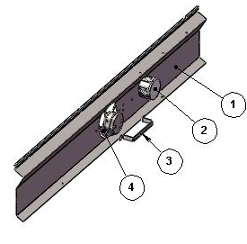

ITEM  NUMBER | DOCUMENT  NUMBER | TITLE | MATERIAL | PART NO. FOR EACH MODULE
 |  |  |  | 937 | 1250
1. | TT2G001 | FANS HOLDER | STAINLESS STEEL AISI304 1F/2B-2F/S4, 6/10 | 6PP09604T026 | 6FI12504T008
2. |  | SHUNT BOX D.65 GEWISS | PLAST INSULATING MAT. GW | 4115401
3. | VLTC020 | SUPPORT FOR MNB FAN |  | 6PP09604T021
4. |  | MOTORFAN A12W23 HWBRF0 IP55 |  | 4240308

1.2. BAIN MARIE BASIN ASSEMBLY 1200
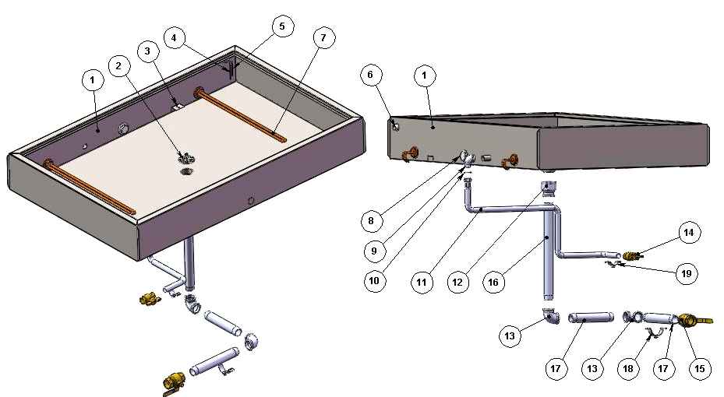

ITEM  NUMBER | DOCUMENT  NUMBER | TITLE | MATERIAL | PART NO. FOR EACH MODULE
 |  |  |  | 937 | 1250
1. | VLTC003 | BAIN MARIE BASIN 1200 |  | 4335761 | 4335762
2. | VSTC021 | GRID FOR BAIN MARIE TC BASIN | STAINLESS STEEL AISI304 1F/2B-2F/S4, 6/10 | 2BV12004T012
3. | CC2G014 | BRACKET TO FIX BULB THERMOSTAT | STAINLESS STEEL AISI304 SB+PRO, 10/10 | 6PP09604T035
4. | 2G012 | MINIMUM LEVEL SENSOR TC. | STAINLESS STEEL WIRE D.2 | 2BV12005T004
5. | 2G012 | MINIMUM LEVEL SENSOR TC. | STAINLESS STEEL WIRE D.2 | 2BV12005T005
6. |  | THREADED SCREW TAP STOPPER ½” | PVC | 4401208
7. | KTC040 | HOT SECTION RESISTOR L.470 1000W |  | 4121408
8. |  | COLLETTOR STOPPER.1” RG92 BRASS TC |  | 4401249
9. |  | CHROMATED 90° STREET ELBOW ½” |  | 4401224
10. |  | GASKET TUBE ½” |  | 4401233
11. |  | ANTIVIBRATION HOSE ½” MALE / FEMALE ,  -5 + 110° C,L = 1000 mm |  | 4401251
12. |  | FEMALE THREADED COUPLING 1” ½” GAS |  | 4401271
13. |  | STREET ELBOW 90° 1 ½” |  | 4401346
14. |  | BALL VALVE ½” |  | 4401261
15. |  | BALL VALVE 1 ½” |  | 4401302
16. |  | MALE – MALE COUPLING 1 ½” L.360 | ZINC | 4333515
17. |  | MALE – MALE COUPLING 1 ½” L.218 | ZINC | 4333514
18. |  | TAP BLOCKING OMEGA 1 1/2”
19. |  | TAP BLOCKING OMEGA 3/4”

1.3. BASIN INTERNAL FINISH

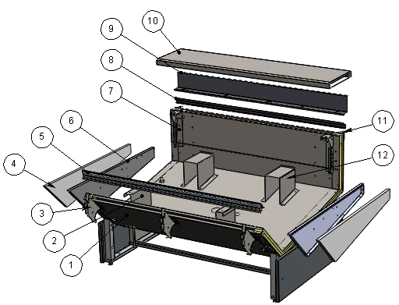

ITEM  NUMBER | DOCUMENT  NUMBER | TITLE | MATERIAL | PART NO. FOR EACH MODULE
 |  |  |  | 937 | 1250
1. |  | BOTTOM BASIN ASSEMBLY
2. | TT2G009 | BASIN FRONT SUPPORT OMEGA | STAINLESS STEEL AISI304 2B, 15/10 | 6FI12504T011 (DX)
 |  |  |  | 6FI12504T012 (SX)
3. | VLTT 0L001 | TOP PANEL SUPPORT BRACKET | GALVANIZED SHEET 15/10 | 6FI1250F0001
4. | PP042 | BASIN STOPPER INSULATION | POLYSTYRENE D.30 | 2PP096040006
5. | TT0G013 | TOP BAFFLE PROFILE | PVC | 2FI093040007 | 2FI125040007
6. | PP013 | BASIN STOPPER |  | 6PP096040000 (DX)
 |  |  |  | 6PP096040001 (SX)
7. | RG110.2 | PLATFORM SUPPORT AND AIR OUTLET GRID | STAINLESS STEEL AISI304 15/10 | 4281936 (DX)
 |  |  |  | 4282029 (SX)
8. | TT0H014 | GUIDE FOR SLIDING ACCESORIES | STAINLESS STEEL AISI304 8/10 | 6FI125010028
9. | TT0H013 | BLIND WIREWAY | PLASTICIZED SHEET 8/10 | 6FI125010007
10. |  | WORKING TABLE FIRENZE |  | 2FI09301T001 | 2FI12501T001
11. | TT0H004 | BACK PLATFORM SUPPORT | IRON SHEET 20/10 | 6FI125010011(SX)
 |  |  |  | 6FI125010009(DX)
12. | TT2G008 | BASIN BACK SUPPORT OMEGA | STAINLESS STEEL AISI304 2B, 15/10 | 6FI12504T010

1.3.1. BOTTOM BASIN ASSEMBLY
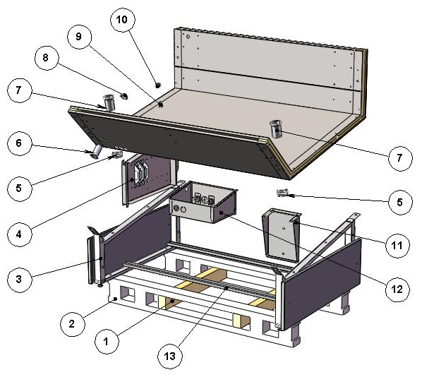

ITEM  NUMBER | DOCUMENT  NUMBER | TITLE | MATERIAL | PART NO. FOR EACH MODULE
 |  |  |  | 937 |  | 1250
1. |  | SPLINE | WOOD 80 X 50 X 630
2. | TT0B014 | LOADING SLIDE | SPRUCE WOOD | 4321345
3. |  | LATERAL FRAME
4. |  | BALLASTS HOLDER PANEL
5. |  | DRAIN NUT 1” 1/2 GAS | ABS | 4102132
6. |  | NUT EXCELLEN. H90 D32-10106 | ABS | 4102125
7. |  | NUT 10124 1'1/2 GAS L.75 MM | ABS | 4102132
8. |  | DRAIN NUT D32 | ABS
9. |  | NUT D. 20 | ABS | 4102101
10. |  | DRAIN NUT D. 20 | ABS | 4102101
11. | VLTC040 | DRAIN – LOAD SUPPORT BOARD | GALVANIZED SHEET 15/10 | 6PP09604T031 |  | 2PP09604T011
12. |  | CONTROL BOARD TC + IL.S.O I. |  | 2FI12502T000
13. | TT0B001 | TRESTLE GIRT | GALVANIZED SHEET 15/10 | 6FI093060202 | 6FI125060202

1.3.1.1. LATERAL FRAME
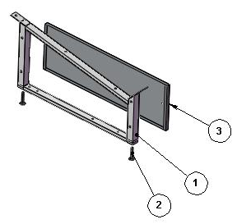

ITEM  NUMBER | DOCUMENT  NUMBER | TITLE | MATERIAL | PART NO. FOR EACH MODULE
 |  |  |  | 937 | 1250
1. | VLTT0B006 | FRAME | ALUMINIUM ALLOY | 2FI125060001
2. |  | BOLT M12X45 | GALVANIZED STEEL
3. | TT0J010 | UNDER SIDE WALL DECORATION WITH FRONT PLANE | PLASTICIZED SHEET 8/10 | 6FI125080113 (SX)
 |  |  |  | 6FI125080112 (DX)

1.3.1.2. BALLASTS HOLDER PANEL AND CONTROL BOARD HOT SECTION
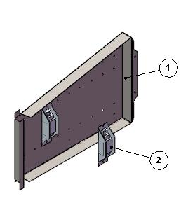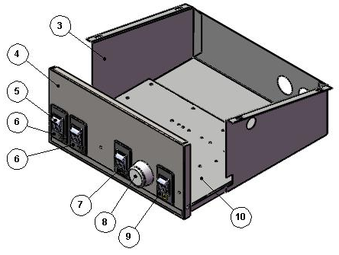

ITEM  NUMBER | DOCUMENT  NUMBER | TITLE | MATERIAL | PART NO. FOR EACH MODULE
 |  |  |  | 937 | 1250
1. |  | BALLASTS PANEL | IRON SHEET 10/10 | 2PP09609TR07
2. |  | BALLAST |  | 30W
 |  |  |  | 4115103
3. | RG053 | ELECTRICAL COMPONENT COMPARTIMENT (310X230) | GALVANIZED SHEET SKIMPAS, 7/10 | 6SV096020002
4. | VLTC068Q | FRONT CONTROL BAIN MARIE R.I. | PLASTICIZED SHEET N38PP, 6/10 | 6KV000000284
5. |  | BLACK BIPOLAR SWITCH R515KKFTOFA BOARD |  | 4113524
6. | RG040 | ADHESIVE LIGHT PLATE "SIGMA" |  | 4335638
7. | RG058 | RESISTOR PLATE
8. |  | THERMOSTAT TR/86 30900-05 +30°+90° |  | 4130107
9. | RG059 | FANS PLATE |  | 4335640
10. | RG054 | ELECTRICAL COMPONENTS SUPPORT (BOARD HOLDER ) | GALVANIZED SHEET 10/10 | 6SV096020003

2. GLASSES SUPERSTRUCTURE

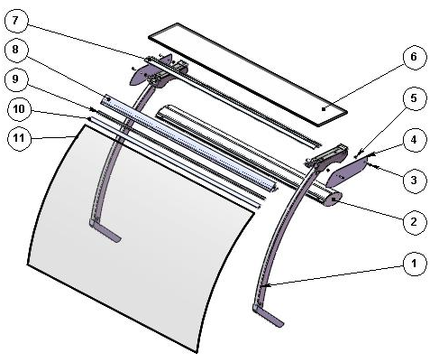

ITEM  NUMBER | DOCUMENT  NUMBER | TITLE | MATERIAL | PART NO. FOR EACH MODULE
 |  |  |  | 937 | 1250
1. |  | LATERAL UPRIGHT
2. |  | TOP CEILING LAMP FI |  | 2FI093030009 | 2FI125030009
3. |  | BURNISHED SELF-TAPPING SCREW TC 5X20 |  | 8292707
4. | TT0M003-2 | TOP SIDE GLASS | IRON SHEET 3/10 | 2FI125080008
5. |  | CYLINDRICAL SPACER WITH FEED-THROUGH HOLE DCK 86 CE |  | 8291721
6. | TT0D019 | HEAD GLASS | FLOAT 10mm | 4199901 | 4199900
7. | TT0D012 | COVER PROFILE | ALUMINIUM PROFILE PE3110 | 2FI093030005 | 2FI125030005
8. | TT0D031 | JAW INSERT PROFILE | ALUMINIUM PROFILE E5628A | 2FI187030008 | 2FI125030008
9. | TT0D011 | JAW PROFILE | JAW ALUMINIUM PROFILE | 2FI187030007 | 2FI125030007
10. |  | GLASS GASKET PROFILE | PVC | 4180100
11. | RG004.1 | CURVED GLASS R1000, L.1250 | FLOAT 6 mm | 4190738 | 4190739

2.1. LATERAL UPRIGHT
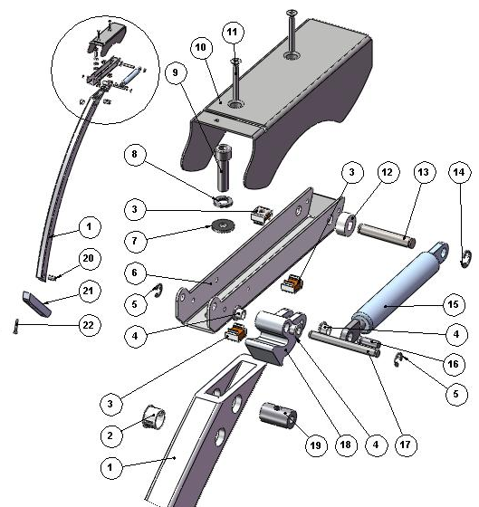

ITEM  NUMBER | DOCUMENT  NUMBER | TITLE | MATERIAL | PART NO. FOR EACH MODULE
 |  |  |  | 937 | 1250
1. | TT0D002 | CURVED FRONT UPRIGHT | ALLOY 6060 T5 | 4351209
2. |  | WHITE STOPPER DP500 | PLASTIC | 4333114
3. |  | CAGE NUT M5
4. | ECAV 016 | PISTON BUSH | NYLON | 8291718
5. |  | SEGGER 5 | GALVANIZED STEEL | 8298303
6. | TT 0D001 | LEVER SUPPORT | IRON SHEET 20/10 | 2FI125030013
7. |  | PLAIN WASHER 8X24 | GALVANIZED STEEL
8. |  | GROWER M8
9. |  | BOLT TCEI M8X30 | GALVANIZED STEEL
10. | TT0D007 | LEVER COVER | IRON SHEET 15/10 | 2FI125030015 (DX)
 |  |  |  | 2FI125030016 (SX)
11. |  | BOLT TS+ M5X35 | STAINLESS STEEL
12. |  | SPACER WITH HOLE DCS79B 6R ELECTROZUB | NYLON
13. | TT0D005 | LATERAL BACK PIN | GROUND DRAWN STEEL Ø8 | 4140086
14. |  | SEGGER 7 | GALVANIZED STEEL | 8298304
15. |  | PISTON VS-SV R 1000 084034 700 N | STEEL | 4145022
16. | ECAV018 | PISTON FRONT PIN | GROUND DRAWN STEEL Ø6
17. | TT0D003 | LATERAL FRONT PIN | GROUND DRAWN STEEL Ø6 | 4140085
18. | AV011 | ROTATION LEVER PRESSOFUS. | ALUMINIUM ALLOY | 4282114 (SX)
 |  |  |  | 4282113 (DX)
19. | TT0D013 | GLASS UPRIGHT PIN | STEEL BAR Ø15 | 4140088
20. | RG072 | BACK GLASS UPRIGHT PIN | STEEL BAR Ø15 | 4140070
21. | CC0D010 | GLASS UPRIGHT SUPPORT KREA | ALUMINIUM ALLOY 6060  (FLAT PROFILE 30X30) | 4282116
22. |  | BOLT TCEI M8X50 | GALVANIZED STEEL

2.3. CEILING LAMP

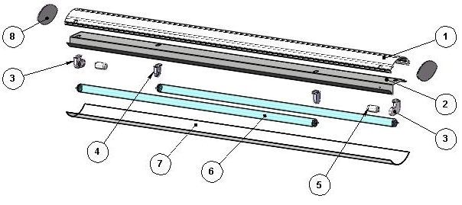

ITEM  NUMBER | DOCUMENT  NUMBER | TITLE | MATERIAL | PART NO. FOR EACH MODULE
 |  |  |  | 937 | 1250
1. | TT0E002 | CEILING LAMP PROFILE | ANODIZED ALUMINIUM | 2FI093030010 | 2FI125030010
2. | TT0E014 | TOP LAMPS HOLDER | PLASTICIZED SHEET 8/10 | 6FI187030011 | 6FI125030011
3. |  | LAMPS HOLDER + STARTERS HOLDER STUCCHI 255/C | PVC | 4114710
4. |  | LAMP HOLDER STUCCHI 255/S 2A 250V | PVC | 4114709
5. |  | UNIVERSAL STARTER FS 11 |  | 4116001
6. |  | NEON |  | 4114513 | 4114510
 |  |  |  | 18W | 30W
7. | TT0E015 | TOP POLYCARBONATE CEILING LAMP | POLYCARBONATE 7/10 | 6FI093030012 | 6FI125030012
8. | CC0D023.1 | PLEXIGLAS FOR CEILING LAMP | OPAL GLASS 3mm |  | 4082305

3. LATERAL SIDE WALL

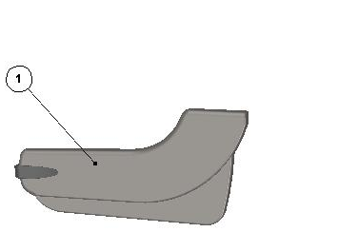

ITEM  NUMBER | DOCUMENT  NUMBER | TITLE | MATERIAL | PART NO. FOR EACH MODULE
 |  |  |  | 937 | 1250
1. | TT0M001 | SIDE WALL | POLYURETHANE Thickness 50mm | (SX)
 |  |  |  | (DX)

===========================================





Regione Gabannone, 4 – Zona Industriale
15030 TERRUGGIA (AL) ITALY
Tel. +39 0142 433711
Fax. +39 0142 433700

