

EXPLODED VIEW

SYNUS 90 eXternAL CORNER

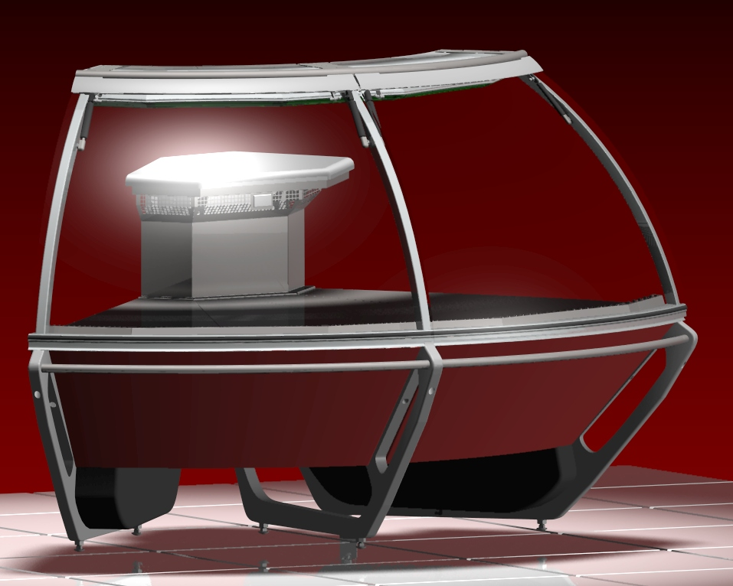

GENERAL SPLITTING UP
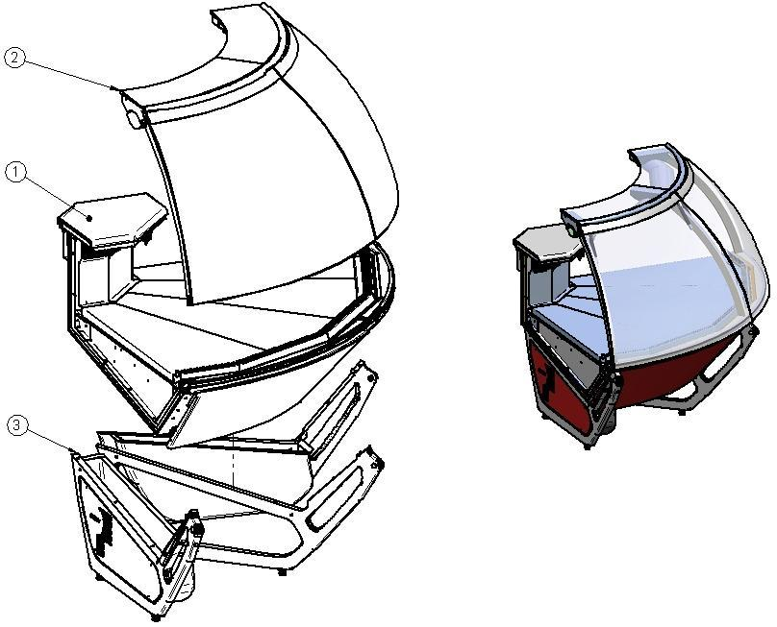

- INTERNAL FINISH, FRONTAL DECORATION
- GLASSES SUPERSTRUCTURE
- FRAME – LOADING SLIDE – BALLAST HOLDER PANEL

1. INTERNAL FINISH, FRONTAL DECORATION
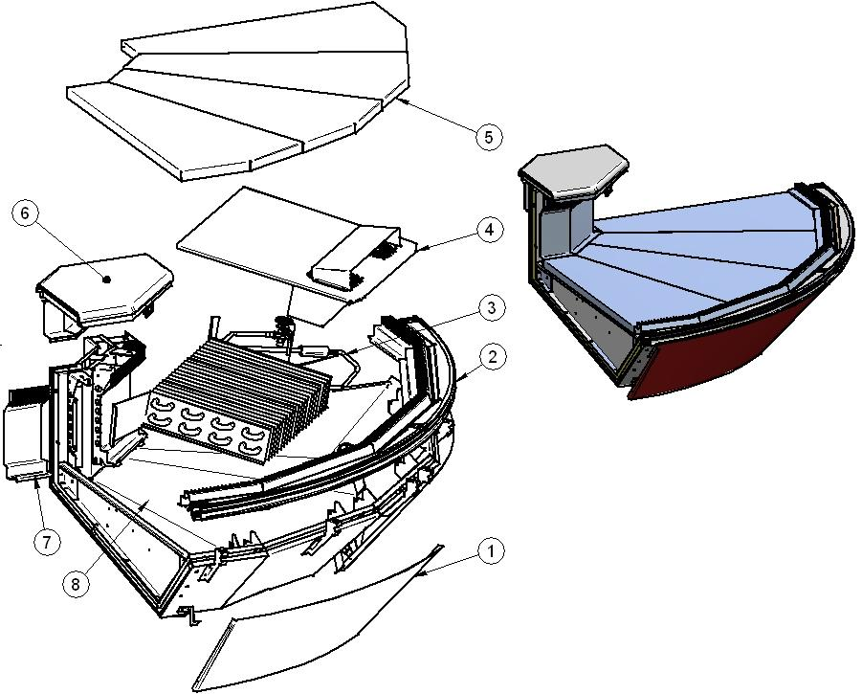

ITEM  NUMBER | DOCUMENT  NUMBER | TITLE | MATERIAL | PART NO. FOR MODULE
1. | SF0J 003-2 | FRONTAL PANEL | GALVANIZED SHEET 7/10 | 2IV90E070001
2. |  | FRONT FINISH
3. |  | EVAPORATOR |  | 2SV90E140001
4. |  | FANS HOLDER
5. |  | REMOVABLE PLATE EXTERNAL CORNER |  | 2IV45E040003 (DX)
 |  |  |  | 2IV45E040005 (SX)
6. |  | WORKING TABLE |  | 2FI90E010000
7. | TT0G008 | AIR OUTLET GRID | STAINLESS STEEL AISI304 SB+PRO 8/10 | 6FI45E040029 (DX)
 |  |  |  | 6FI90E040009 (CX)
 |  |  |  | 6FI45E040049 (SX)
8. |  | BASIN INTERNAL FINISH

1.1. BASIN INTERNAL FINISH

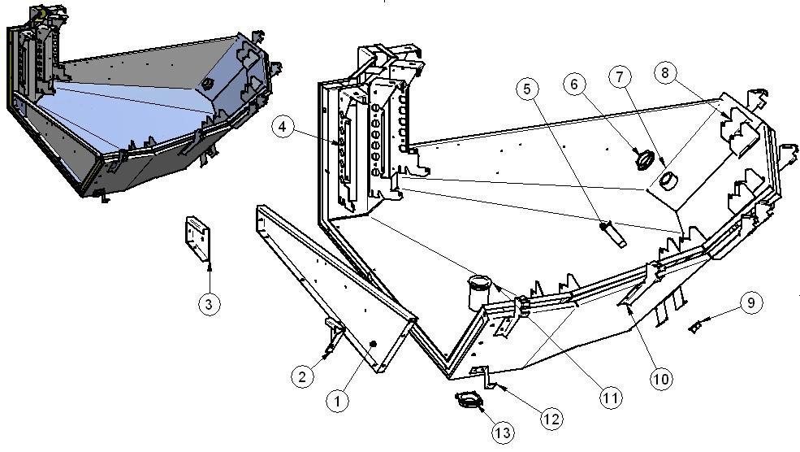

ITEM  NUMBER | DOCUMENT  NUMBER | TITLE | MATERIAL | PART NO. FOR MODULE
1. | PP013 | BASIN STOPPER | STAINLESS STEEL AISI304 5/10 | 6PP096040001(SX)
 |  |  |  | 6PP096040000(DX)
2. | RG034 | SIDE WALL FIXING BRACKET | IRON SHEET 15/10 | 6SV072040039(SX)
 |  |  |  | 6SV072040038(DX)
3. | RG106 | BACK STOPPER BRACKET | IRON SHEET 15/10 | 6SV072040041(SX)
 |  |  |  | 6SV072040040(DX)
4. | TT0G 006 | BACK GRID SUPPORT BRACKET | IRON SHEET 15/10 | 6FI125040113(SX)
 |  |  |  | 6FI125040112(DX)
5. |  | DRAIN Ø20 | ABS | 4102101
6. |  | DRAIN NUT Ø44 | ABS | 4102106
7. |  | DRAIN Ø44 | ABS | 4102106
8. | TT0G 007 | FRONT GRID SUPPORT BRACKET | IRON SHEET 15/10 | 6FI125040115 (SX)
 |  |  |  | 6FI125040114 (DX)
9. |  | DRAIN NUT Ø20 | ABS | 4102101
10. | SFOL 002 | GLASS REBATE PROFILE SUPPORT BRACKET | GALVANIZED SHEET 15/10 | 6IV1250F0002(SX)
 |  |  |  | 6IV1250F0001(DX)
11. |  | DRAIN 10124 1'1/2 GAS L.75 MM | ABS | 4102132
12. | SF0J005 | FRONT PANEL SUPPORT | GALVANIZED SHEET 15/10 | 6IV45E070017 (SX)
 |  |  |  | 6IV45E070018 (DX)
13. |  | DRAIN NUT 1'’1/2 | ABS

1.2. FANS HOLDER

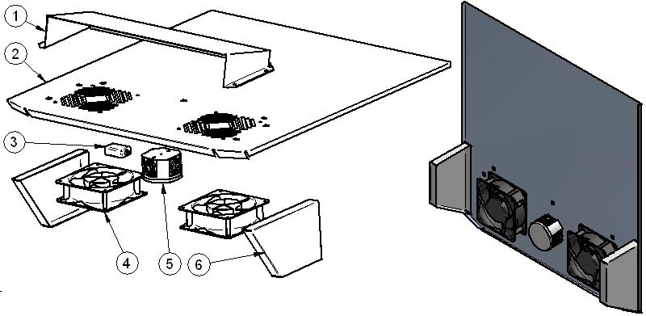

ITEM  NUMBER | DOCUMENT  NUMBER | TITLE | MATERIAL | PART NO. FOR MODULE
1. | PP183 | FANS COVER 90° EXT. CORNER | STAINLESS STEEL AISI304 1F/2B-2F/S4 6/10 | 6PP90E040012
2. | SF0F001 | EVAPORATOR COVER 90° EXT. CORNER | STAINLESS STEEL AISI304 1F/2B-2F/S4 6/10 | 6IV90E040018
3. |  | CABLE CONNECTOR L. 1525 MM |  | 4110606
4. |  | MOTORFAN |  | 4241007
5. |  | SHUNT BOX D.65 GEWISS | PLAST INSULATING MAT. GW | 4115401
6. | SF0F001 | FRONT LATERAL EVAPORATOR COVER | STAINLESS STEEL AISI304 1F/2B-2F/S4 6/10 | 6IV90E040039 (SX)
 |  |  |  | 6IV90E040019 (DX)

1.3. EVAPORATOR
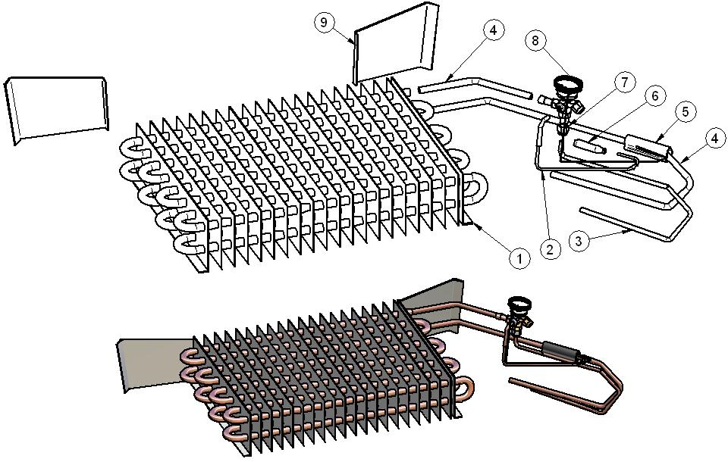

ITEM  NUMBER | DOCUMENT  NUMBER | TITLE | MATERIAL | PART NO. FOR MODULE
1. |  | EVAPORATOR 720 KING V.VERN. 520 | COOPER TUBES - ALUMINIUM SHEETS | 4220301
2. |  | CAPILLARY TUBE | COOPER TUBES 1.8X3 | 4260206
3. | PP441 | COOPER D.4X6 L.75 | COOPER TUBES D.4 X 6 | 4272414
4. | PP440 | COOPER D.6 X 8 L1400 | COOPER TUBES D.6 X 8 | 4272415
5. |  | ANTICONDENSATE TUBE | INSULATING SPONGE 6 X 22 | 4270505
6. |  | VALVE BULB
7. |  | PIPE UNION 3/8SAE Ø8 |  | 4272415
8. |  | WELDED VALVE THERMOSTAT.R404 TES/2 |  | 4251311
9. | SF0F001 | BACK LATERAL EVAPORATOR COVER 90° EXT. CORNER | SILVER PLATED +PLASTICIZED ALUMINIUM 20/10 | 6IV90E040021 (DX)
 |  |  |  | 6IV90E040041 (SX)

1.4. WORKING TABLE
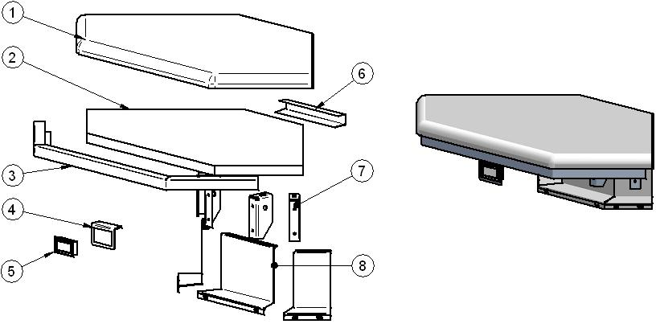

ITEM  NUMBER | DOCUMENT  NUMBER | TITLE | MATERIAL | PART NO. FOR MODULE
1. | PP062 | WHITE PLAST. CM2,5 "PP "90° CORNER | POLYETHYLENE Th. 25mm | 4081120
2. | PP210 | PLAST. STOPPER EXTERNAL CORNER | POLYETHYLENE Th. 18mm | 4081129
3. | PP212 | FRONT CLOSURE | STAINLESS STEEL AISI304 DEC9 BA + PRO + SATIN FINISHED 80 H435X7/10 | 6PP90E010008
4. | TT0C002 | THERMOMETER HOLDER | STAINLESS STEEL AISI304 15/10 | 6FI125020007
5. |  | DIGITAL THERMOMETER |  | 4131307
6. | PP212 | BACK CLOSURE | STAINLESS STEEL AISI304 DEC9 BA + PRO + SATIN FINISHED 80 H435X7/10 | 6PP90E010007
7. | TT0H004 | BACK LEVEL SURFACE SUPPORT | IRON SHEET 20/10 | 6FI125010011 (SX)  6FI125010009 (DX)
8. | TT0H011 | BLIND WIREWAY | GREY PLAST. N1 6/10 | 6FI45E010027 (DX)
 |  |  |  | 6FI90E010007 (CX)
 |  |  |  | 6FI45E010047 (SX)

1.5. FRONT FINISH
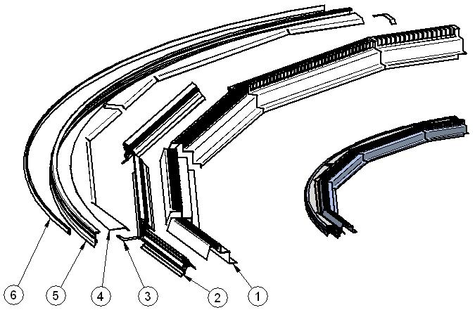

ITEM  NUMBER | DOCUMENT  NUMBER | TITLE | MATERIAL | PART NO. FOR MODULE
1. | SF0G009 | SUCTION GRID | STAINLESS STEEL AISI304 8/10 | 6IV45E040022 (DX)
 |  |  |  | 6IV45E040002 (CX)
 |  |  |  | 6IV45E040042 (SX)
2. | SF0G003 | TOP BAFFLE PROFILE | PVC | 2IV45E040021 (DX)
 |  |  |  | 2IV45E040001 (CX)
 |  |  |  | 2IV45E040041 (SX)
3. | SF0G012 | LATERAL UPRIGHT STOPPER | GREY PLAST. N1 6/10 | 6IV1250F0006 (DX)
 |  |  |  | 6IV1250F0007 (SX)
4. | SF0G002 | UPRIGHT STOPPER | GREY PLAST. N1 6/10 | 6IV90E0F0008 (DX)
 |  |  |  | 6IV90E0F0009 (SX)
5. | SF0L 009 | FRONT PROFILE | ALUMINIUM | 2IV90E0F0003
6. |  | GUMMY INSERT PROFILE | PVC | 4180409

1.6. REMOVABLE PLATE EXTERNAL CORNER

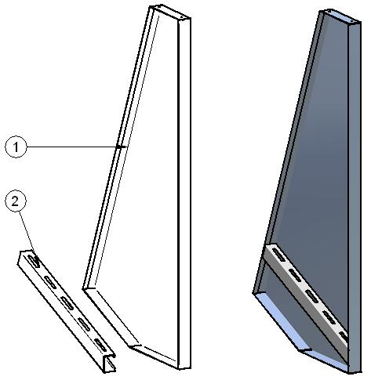

ITEM  NUMBER | DOCUMENT  NUMBER | TITLE | MATERIAL | PART NO. FOR MODULE
1. | SF0K003 | REMOVABLE PLATE 135° EXTERNAL CORNER | STAINLESS STEEL AISI304 SB+PRO 8/10 | 6IV45E040004 (DX)
 |  |  |  | 6IV45E040006 (SX)
2. | CC0K006 | UNDERPLATE CLOSURE EXTERNAL CORNER | STAINLESS STEEL AISI304 1F/2B-2F/S4 5/10 | 6KV45E040005 (DX)
 |  |  |  | 6KV45E040006 (SX)

2. GLASSES SUPERSTRUCTURE

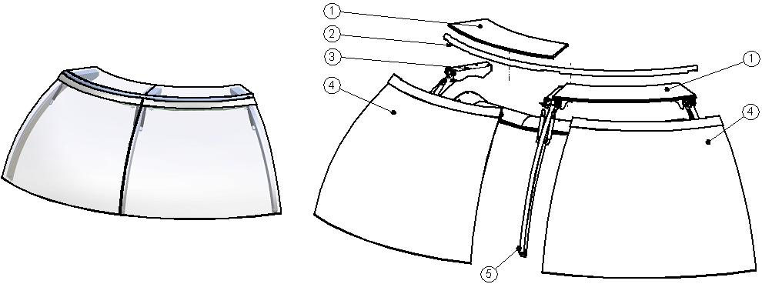

ITEM  NUMBER | DOCUMENT  NUMBER | TITLE | MATERIAL | PART NO. FOR MODULE
1. | SF0D015 | HEAD GLASS | FLOAT 10 mm | 4199916
2. | SF0D024 | LEVER CLOSURE TUBE | ALUMINIUM TUBE Ø28 Th. 1.5 | 2IV90E030006
3. |  | LATERAL UPRIGHT
4. |  | GLASS FIXING PANES CLAMP |  | 2IV90E030007
5. |  | CENTRAL UPRIGHT

2.1. LATERAL GLASS UPRIGHT
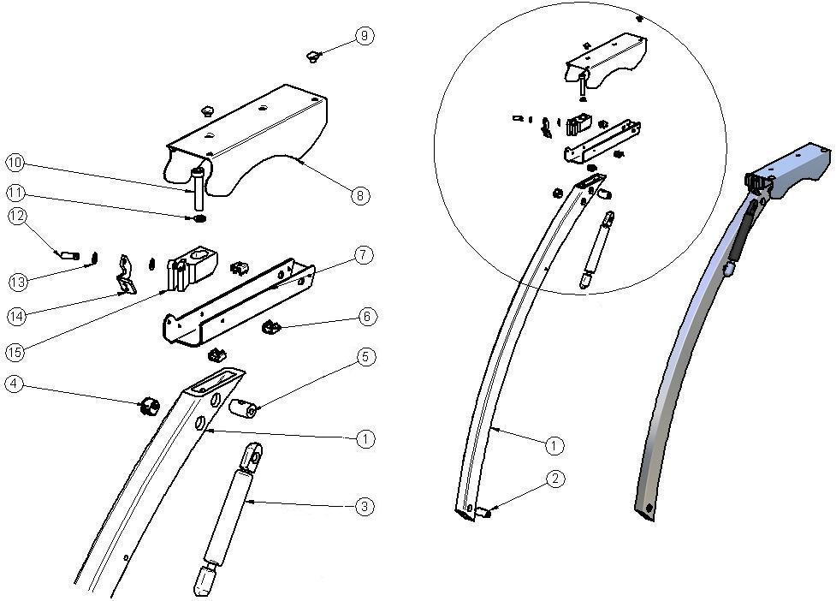

ITEM  NUMBER | DOCUMENT  NUMBER | TITLE | MATERIAL | PART NO. FOR MODULE
1. | TT0D002 | CURVED FRONT UPRIGHT | ALLOY 6060 T5 | 4351209
2. | RG072 | BACK GLASS UPRIGHT PIN | STEEL BAR Ø15 | 4140070
3. |  | PISTON 2 SNODI LIFT-O-MAT 5425VA 400N |  | 4144069
4. |  | WHITE STOPPER DP500 | PLASTIC | 4333114
5. | TT0D 013 | GLASS UPRIGHT PIN | STEEL BAR Ø15 | 4140088
6. |  | CAGE NUT M4
7. | SF0D022 | COVER SUPPORT, PAINTED | GALVANIZED SHEET 20/10 | 2IV45E030003 (DX)
 |  |  |  | 2IV45E030004 (SX)
8. | SF0D017 | LEVER COVER PAINTED 7035 | GALVANIZED SHEET 15/10 | 2IV125030003 (DX)
 |  |  |  | 2IV125030004 (SX)
9. |  | RUBBER BUFFER |  | 4332602
10. |  | BOLT TCEI M8X30 | GALVANIZED STEEL
11. |  | GROWER M8
12. | ECAV 018 | PISTON FRONT PIN | STAINLESS STEEL | 4140054
13. |  | BUSH
14. | SF0D011 | LEVER FOR EXTERNAL CORNER | IRON SHEET 30/10 | 4282824 (DX)
 |  |  |  | 4282825 (SX)
15. | SF0D019 | LEVER SUPPORT EXTERNAL CORNER |  | 4282829 (DX)
 |  |  |  | 4282830 (SX)

2.2. CENTRAL GLASS UPRIGHT

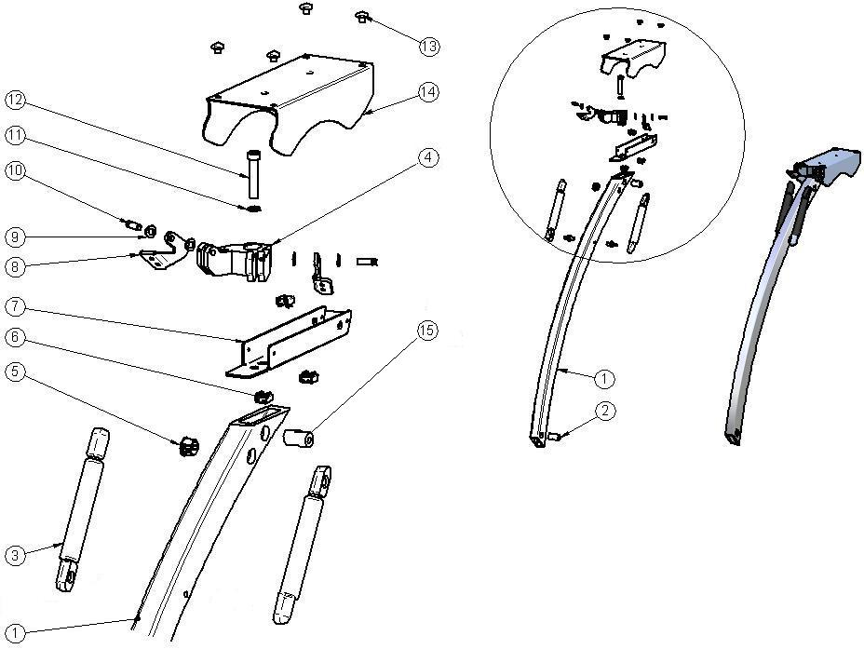

ITEM  NUMBER | DOCUMENT  NUMBER | TITLE | MATERIAL | PART NO. FOR MODULE
1. | TT0D002 | CURVED FRONT UPRIGHT | ALLOY 6060 T5 | 4351209
2. | RG072 | BACK GLASS UPRIGHT PIN | STEEL BAR Ø15 | 4140070
3. |  | PISTON 2 SNODI LIFT-O-MAT 5425VA 400N |  | 4144069
4. | SF0D020 | CENTRAL LEVER SUPPORT 90º EXT. CORNER | ALLOY 6060 T5 | 4282831
5. |  | WHITE STOPPER DP500 | PLASTIC | 4333114
6. |  | CAGE NUT M4
7. | SF0D023 | CENTRAL LEVER COVER SUPPORT 90º EXT. CORNER | GALVANIZED SHEET 20/10 | 2IV90E030016
8. | SF0D011 | LEVER FOR EXTERNAL CORNER | IRON SHEET 30/10 | 4282824 (DX)
 |  |  |  | 4282830 (SX)
9. |  | BUSH
10. | ECAV018 | PISTON FRONT PIN | STAINLESS STEEL | 4140054
11. |  | GROWER M8
12. |  | BOLT TCEI M8X30 | GALVANIZED STEEL
13. |  | RUBBER BUFFER |  | 4332602
14. | SF0D018 | LEVER COVER PAINTED 7035 | GALVANIZED SHEET 15/10 | 2IV187030005
15. | TT0D013 | GLASS UPRIGHT PIN | STEEL BAR Ø15 | 4140088

2.3. CEILING LAMP
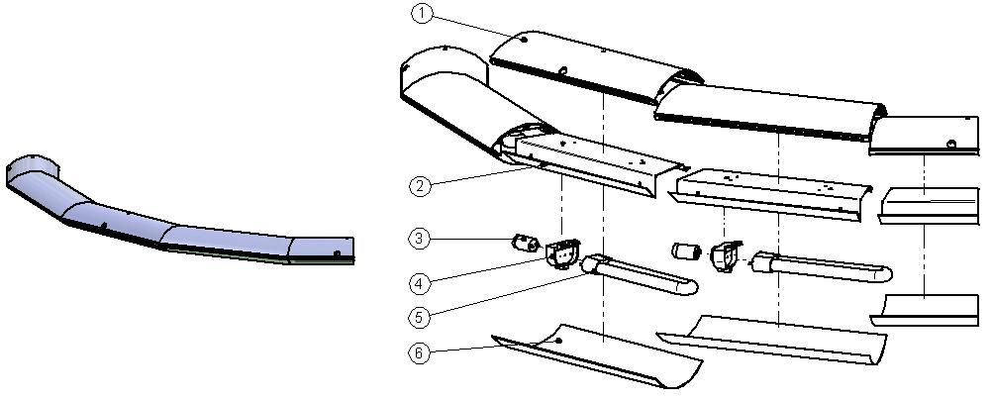
ITEM  NUMBER | DOCUMENT  NUMBER | TITLE | MATERIAL | PART NO. FOR MODULE
1. | SF0E001 | CEILING LAMP PROFILE | CEILING LAMP PROFILE SILVER PLATED 0E 001 L.6100 | 2IV45E030033 (DX)
 |  |  |  | 2IV45E030013 (CX)
 |  |  |  | 2IV45E030053 (SX)
2. | SF0E003 | TOP LAMPS HOLDER | WHITE PALST. A1SA 8/10 | 6IV45E030034 (DX)
 |  |  |  | 6IV45E030014 (CX)
 |  |  |  | 6IV45E030054 (SX)
3. |  | UNIVERSAL STARTER FS 11 |  | 4116001
4. |  | LAMPS HOLDER + STARTERS HOLDER 441/V-16 |  | 4114712
5. |  | COMPACT LAMP DULUX L18W/76 |  | 4113623
6. | SF0E005 | TOP CEILING LAMP | POLYCARBONATE 7/10 | 6IV45E030035 (DX)
 |  |  |  | 6IV45E030015 (CX)
 |  |  |  | 6IV45E030055 (SX)

2.4. GLASS FIXING PANES CLAMP
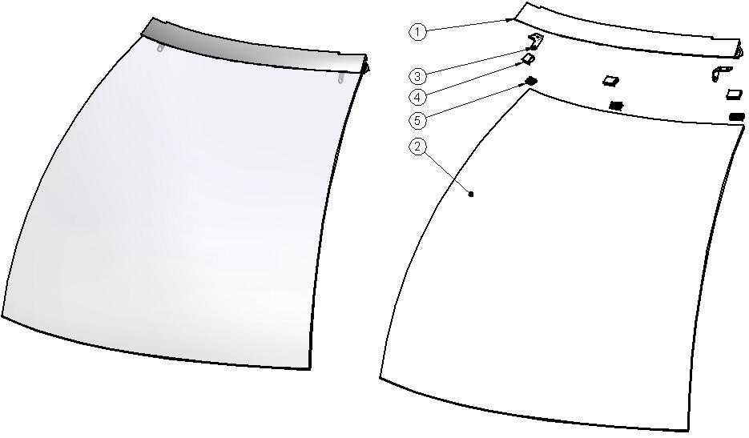
ITEM  NUMBER | DOCUMENT  NUMBER | TITLE | MATERIAL | PART NO. FOR MODULE
1. | SF0D003 | JAW PROFILE | JAW ALUMINIUM PROFILE | 2IV45E030008
2. | SF0D001 | SPHERIC GLASS EXT. | FLOAT 6MM TRANSPARENTE | 4191626
3. | SF0D012 | PISTON SUPPORT EXTERNAL CORNER | GALVANIZED SHEET 15/10 | 2IV45E030010 (DX)
 |  |  |  | 2IV45E030011 (SX)
4. |  | GLASS GASKET PROFILE | PVC | 4180100
5. | SF0D004 | JAW INSERT PROFILE | ALUMINIUM PROFILE E5628A | 2IV45E030009

3. FRAME – LOADING SLIDE – BALLAST HOLDER PANEL

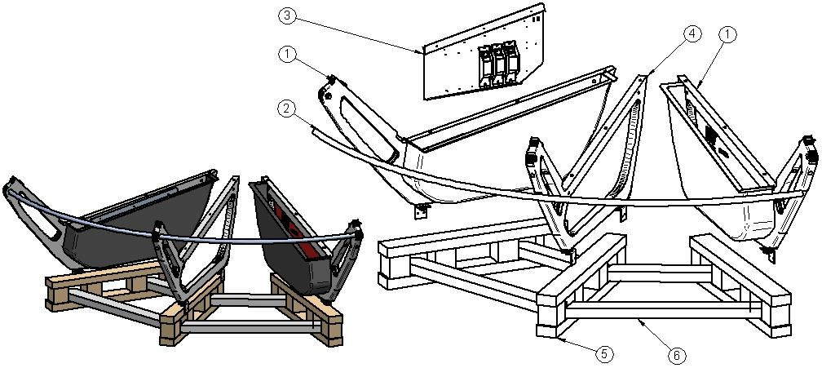

ITEM  NUMBER | DOCUMENT  NUMBER | TITLE | MATERIAL | PART NO. FOR MODULE
1. |  | LATERAL FRAME ASSEMBLY
2. | SF0L004 | TROLLEY STOPPER TUBE | ROUND STAINLESS STEEL TUBE PROFILE 22X1,5 L.6000
3. |  | BALLAST HOLDER PANEL
4. |  | CENTRAL FRAME ASSEMBLY
5. | PP178 | SLIDE “ALPHA” H80 L. 720 | SPRUCE WOOD | 4321310
6. | 0B 007 | LOADING SLIDE EE 3565 | SPRUCE WOOD 75X38 | 4321223

3.1. LATERAL FRAME ASSEMBLY

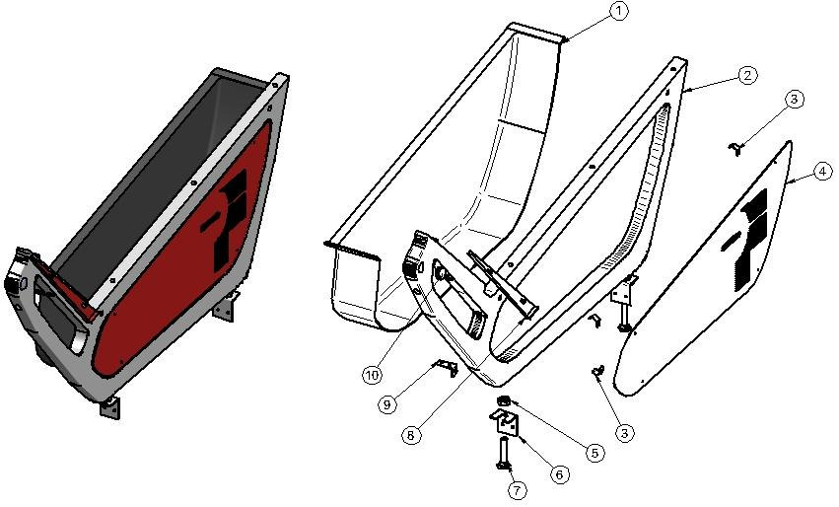

ITEM  NUMBER | DOCUMENT  NUMBER | TITLE | MATERIAL | PART NO. FOR MODULE
1. | SF0B006 | CASE CLOSURE | ABS | 4100339 (SX)
 |  |  |  | 4100338 (DX)
2. | SF0B001 | FRAME | ALUMINIUM ALLOY | 2IV125060001
3. | SF0B005 | SPRING FOR LATERAL CLOSURE COUPLIG | STAINLESS STEEL AISI301 5/10 | 4282798
4. | SF0B004 | LATERAL FRAME CLOSURE | GALVANIZED SHEET 10/10 | 2IV125080014 (SX)
 |  |  |  | 2IV125080004 (DX)
5. |  | NUT SPACER M14 | GALVANIZED IRON
6. | SF0B008 | LOADING SLIDE FIXING BRACKET | IRON SHEET 30/10 | 4282832
7. |  | BOLT M12X45 | GALVANIZED STEEL
8. | SF0J007 | FRONT SIDE WALL STOPPER | GALVANIZED SHEET 7/10 | 2IV125070005 (SX)
 |  |  |  | 2IV125070004 (DX)
9. | SF0B010 | CASE FIXING BRACKET | GALVANIZED SHEET 10/10 | 6IV125060003 (SX)
 |  |  |  | 6IV125060002 (DX)
10. |  | CHROMED STOPPER D.25 S.T.1 | PVC | 4333107

3.2. CENTRAL FRAME ASSEMBLY

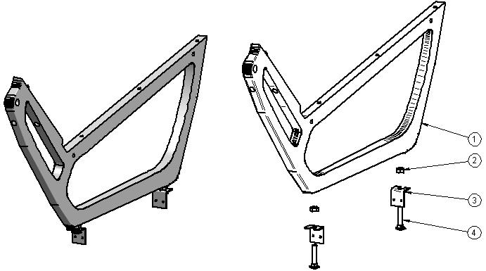

ITEM  NUMBER | DOCUMENT  NUMBER | TITLE | MATERIAL | PART NO. FOR MODULE
1. | SF0B001 | FRAME | ALUMINIUM ALLOY | 2IV125060001
2. |  | NUT SPACER M14 | GALVANIZED IRON
3. | SF0B008 | LOADING SLIDE FIXING BRACKET | IRON SHEET 30/10 | 4282832
4. |  | BOLT M12X45 | GALVANIZED STEEL

4.4. BALLAST HOLDER PANEL
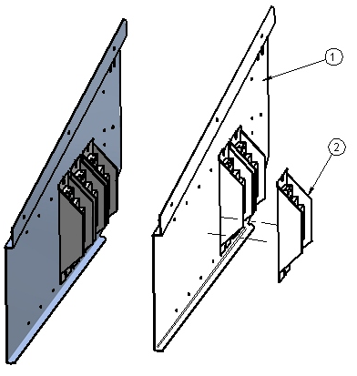

ITEM  NUMBER | DOCUMENT  NUMBER | TITLE | MATERIAL | PART NO. FOR MODULE
1. |  | BALLAST PANEL | IRON SHEET 10/10 | 2IV125090003
2. |  | BALLAST |  | 15W | 18 – 20 W | 30W | 36 – 40 W | 58 – 65 W
 |  |  |  | 4115106 | 4115102 | 4115103 | 4115104 | 4115105

===========================================





Regione Gabannone, 4 – Zona Industriale
15030 TERRUGGIA (AL) ITALY
Tel. +39 0142 433711
Fax. +39 0142 433700

