

EXPLODED VIEW

SYNUS FISH

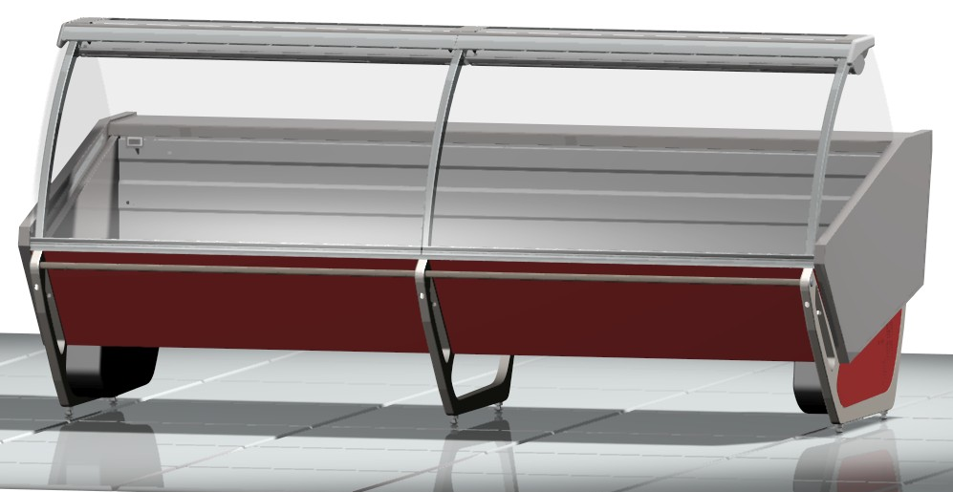

GENERAL SPLITTING UP

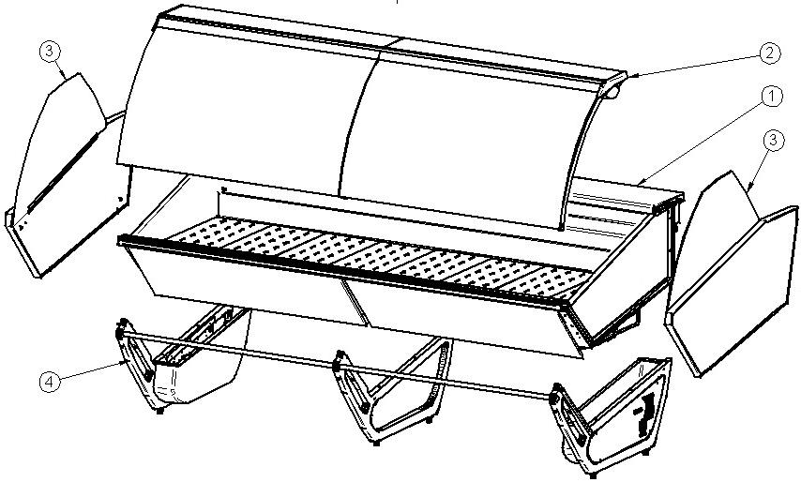

- INTERNAL FINISH, FRONTAL DECORATION
- GLASSES SUPERSTRUCTURE
- COMPLETE SIDE WALL
- FRAME – LOADING SLIDE – BALLAST HOLDER PANEL

1. INTERNAL FINISH, FRONTAL DECORATION

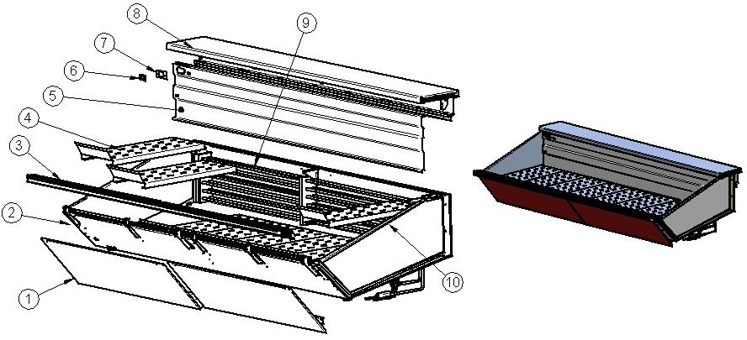

ITEM  NUMBER | DOCUMENT  NUMBER | TITLE | MATERIAL | PART NO. FOR EACH MODULE
 |  |  |  | 1250 | 2500 | 3750
1. | SF0J 009 | FRONT PANEL | GALVANIZED SHEET PAINTED, 7/10 | - | 2IV250070003(SX) | 2IV250070003 (SX)
 |  |  |  | - | 2IV250070002(DX) | 2IV250070002 (DX)
1. | SF0J008 | FRONT PANEL | GALVANIZED SHEET PAINTED, 7/10 | 2IV125070001 | - | 2IV312070001 (CX)
2. |  | BASIN INTERNAL FINISH
3. |  | FRONTAL FINISH
4. | TT5K004 | STATIC FISH PLATE AS.312 |  | 2FI125042102
5. | TT5G001 | BACK MASK |  | 6FI125042101 | 6FI250042101 | 6FI375042101
6. |  | DIGITAL THERMOMETER |  | 4131307
7. | TT5G003 | THERMOMETER HOLDER MASK | STAINLESS STEEL AISI304, 10/10
8. | TTOH017 | WORKING TABLE FIRENZE |  | 2FI125012000 | 2FI250012000 | 2FI375012000
9. |  | COMPLETE EVAPORATOR |  | 2FI125192001 | 2FI250192001 | 2FI375192001
10. | TT5K004 | STATIC FISH PLATE AS.260 |  | 2FI125042104

1.1. BASIN INTERNAL FINISH

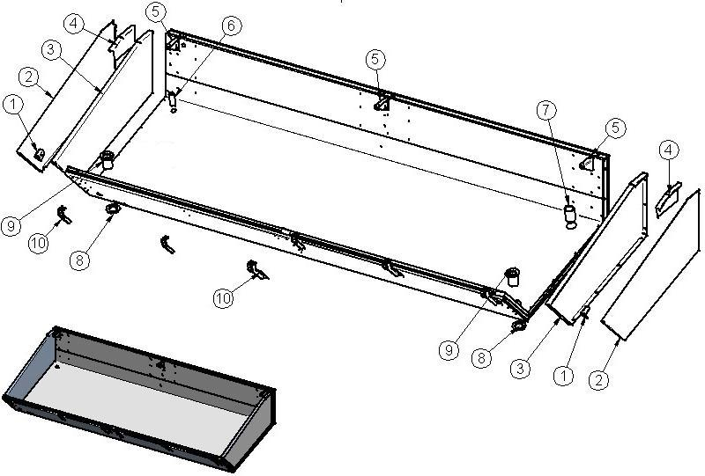

ITEM  NUMBER | DOCUMENT  NUMBER | TITLE | MATERIAL | PART NO. FOR EACH MODULE
 |  |  |  | 1250 | 2500 | 3750
1. | ST-024 | FRONT STOPPER REINFORCEMENT | STAINLESS STEEL 304 2B, 15/10 | 6PP096040153
 |  |  |  | 6PP096040154
2. | ST-026 | CLOSURE FOR HIGH BASIN STOPPER | STAINLESS STEEL 316 SB+PRO, 8/10 | 6PP096040155
 |  |  |  | 6PP096040156
3. | ST-014 | HIGH BASIN STOPPER | STAINLESS STEEL 316 SB+PRO, 8/10 | 6PP096040131
 |  |  |  | 6PP096040132
4. | ST-015 | STOPPER REINFORCEMENT | STAINLESS STEEL 304 2B, 15/10 | 6PP096040133
 |  |  |  | 6PP096040134
5. | ST-016 | WORKING TABLE INTERNAL SUPPORT | STAINLESS STEEL 304 2B, 15/10 | 6PP096010033
 |  |  |  | 6PP096010034
6. |  | STAINLESS STEEL TUBE Ø26.9 TINNED (3/4'')
7. |  | STAINLESS STEEL TUBE Ø47.8 TINNED (1''1/2)
8. |  | DRAIN NUT 1"1/2
9. | PP198 | STAINLESS STEEL DRAIN H70 1"1/2 |  | 4102052
10. | SFOL002 | GLASS REBATE PROFILE SUPPORT BRACKET | GALVANIZED SHEET 15/10 | 6IV1250F0002 (SX)
 |  |  |  | 6IV1250F0001 (DX)

1.2. EVAPORATOR

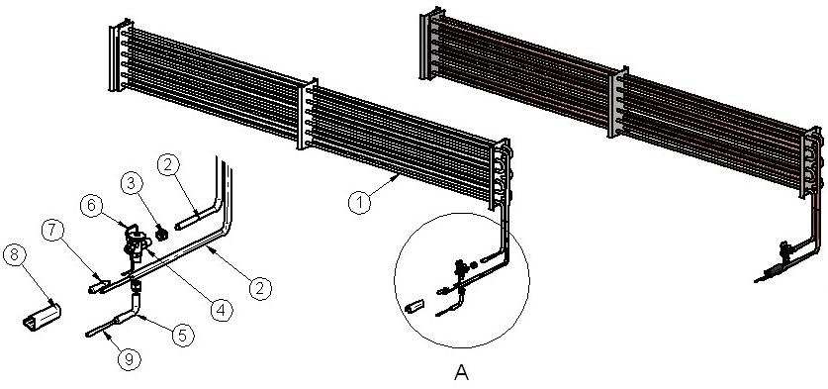
ITEM  NUMBER | DOCUMENT  NUMBER | TITLE | MATERIAL | PART NO. FOR EACH MODULE
 |  |  |  | 1250 | 2500 | 3750
1. | CC5F001 | EVAPORATATOR STATIC FISH KREA | COOPER TUBES - ALUMINIUM SHEETS | 4220375 | 4220378 | 4220381
2. |  | COOPER TUBES Ø12 X 14 (14 X 1) |  | 4260105
3. |  | PIPE UNION 3/8SAE Ø8 |  | 4272415
4. |  | VALVE THERMOSTAT. R22 TX 2 |  | 4251101
5. |  | COOPER TUBES Ø12 X 14 (14 X 1) |  | 4260105
6. |  | CAPILLARY TUBE | COOPER TUBES 1.8X3 | 4260206
7. |  | VALVE BULB
8. |  | ANTICONDENSATE TUBE | INSULATING SPONGE 6 X 22
9. |  | COOPER Ø6 X 8 ( 8 X 1) |  | 4260102

1.3. WORKING TABLE

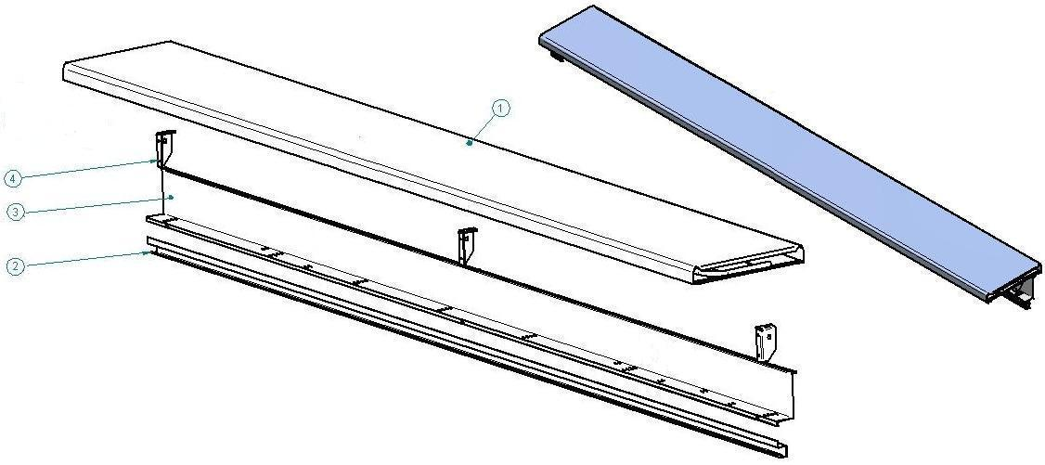

ITEM  NUMBER | DOCUMENT  NUMBER | TITLE | MATERIAL | PART NO. FOR EACH MODULE
 |  |  |  | 1250 | 2500 | 3750
1. | TT0H017 | WORKING TABLE | STAINLESS STEEL AISI304 7/10 | 2FI125010001 | 6FI250010002 | 2FI375010001
2. | TT0H014 | GUIDE FOR RAIL-HAND ACCESSORY | STAINLESS STEEL AISI304 8/10 | 6FI125010028 | 6FI250010028 | 6FI375010028
3. | TT0H013 | BLIND WIREWAY | PLAST. SHEET 8/10 | 6FI125010007 | 6FI250010007 | 6FI375010007
4. | TT0H004 | BACK LEVEL SURFACE SUPPORT | IRON SHEET 20/10 | 6FI125010011(SX)
 |  |  |  | 6FI125010009(DX)

  - FRONT FINISH

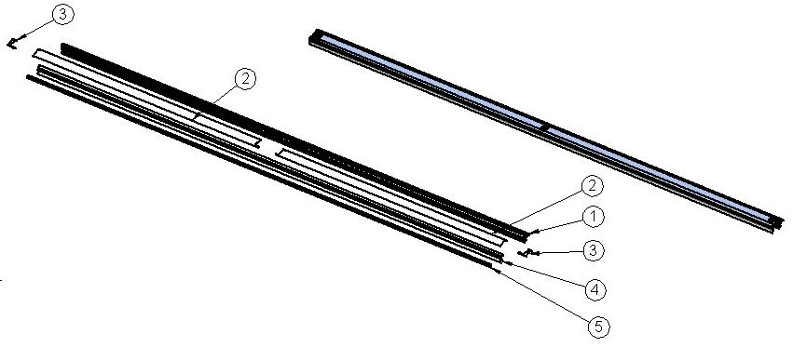

ITEM  NUMBER | DOCUMENT  NUMBER | TITLE | MATERIAL | PART NO. FOR EACH MODULE
 |  |  |  | 1250 | 2500 | 3750
1. | TT0G013 | TOP BAFFLE PROFILE | PVC | 2FI125040007 | 2FI250040007 | 2FI375040007
2. | SF0G013 | CENTRAL UPRIGHT STOPPER | STAINLESS STEEL AISI 304, 6/10 | 6IV2500F0009(SX)
 |  |  |  | 6IV2500F0008(DX)
3. | SF0G012 | LATERAL UPRIGHT STOPPER | STAINLESS STEEL AISI 304, 6/10 | 6IV1250F0007 (SX)
 |  |  |  | 6IV1250F0006 (DX)
4. | SF0L008 | FRONTAL PROFILE | ALLOY 6060 T5 | 2IV1250F0003 | 2IV2500F0003 | 2IV3750F0003
5. |  | BLACK GLASS REBATE RUBBER PROFILE | RUBBER | 4180403

2. GLASSES SUPERSTRUCTURE

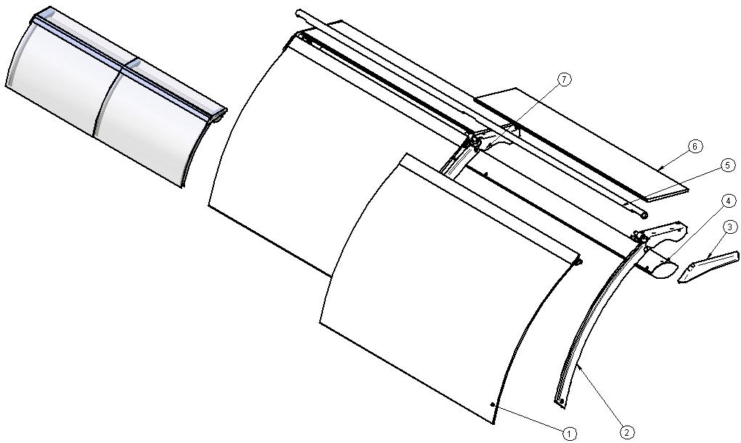

ITEM  NUMBER | DOCUMENT  NUMBER | TITLE | MATERIAL | PART NO. FOR EACH MODULE
 |  |  |  | 1250 | 2500 | 3750
1. |  | GLASS FIXING PLIERS FIRENZE 2500 |  | 2FI250030006
2. |  | LATERAL UPRIGHT
3. | SF0M003 | GLASS SIDE HEAD | RIM / PUR D. 350 Kg/m³ | 2IV125080013 (SX)
 |  |  |  | 2IV125080003 (DX)
4. |  | UPPER CEILING LAMP |  | 2FI125030009 | 2FI250030009 | 2FI375030009
5. | SF0D021 | LEVER CLOSURE TUBE | ALUMINIUM TUBE Ø28 Th. 1.5 | 2IV125030006 | `2IV250030006 | 2IV375030006
6. | SF0D002 | HEAD GLASS | FLOAT 10mm | 4199915
7. |  | CENTRAL UPRIGHT

2.1. LATERAL AND CENTRAL GLASS UPRIGHT

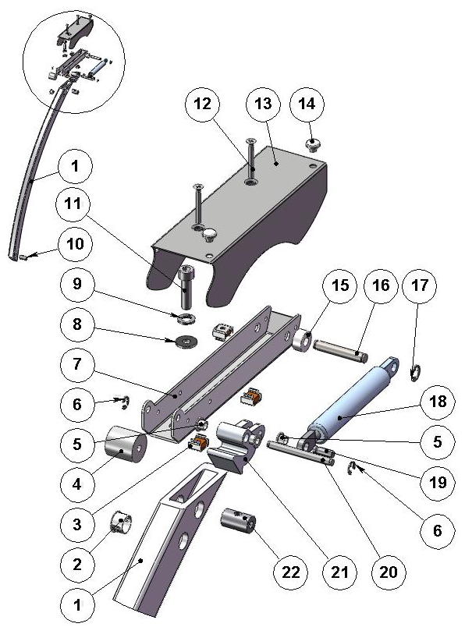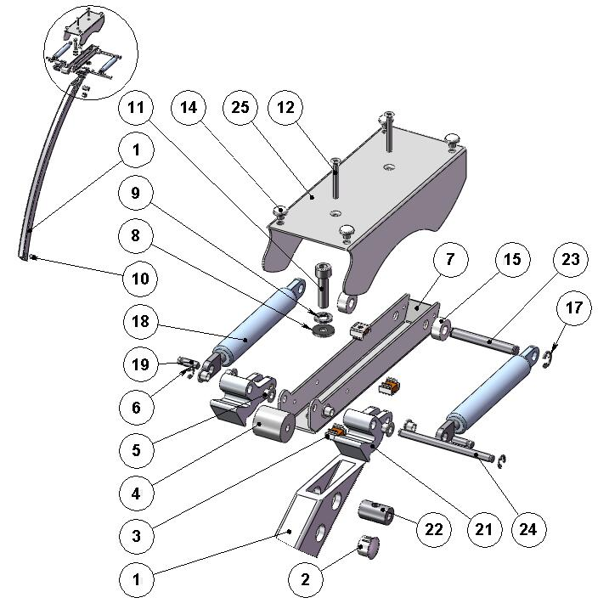

ITEM  NUMBER | DOCUMENT  NUMBER | TITLE | MATERIAL | PART NO. FOR EACH MODULE
 |  |  |  | 1250 | 2500 | 3750
1. | TT0D002 | CURVED FRONT UPRIGHT | ALLOY 6060 T5 | 4351209
2. |  | WHITE STOPPER DP500 | PLASTIC | 4333114
3. |  | CAGE NUT M5
4. |  | SPACER WITH HOLE 1D-003 | NYLON | 4331409
5. | ECAV 016 | PISTON BUSH | NYLON | 8291718
6. |  | SEGGER 5 | GALVANIZED STEEL | 8298303
7. | TT 0D001 | LEVER SUPPORT | IRON SHEET 20/10 | 2FI125030013
8. |  | PLAIN RING 8X24 | GALVANIZED STEEL
9. |  | GROWER M8
10. | RG072 | BACK GLASS UPRIGHT PIN | STEEL BAR Ø15 | 4140070
11. |  | BOLT TCEI M8X30 | GALVANIZED STEEL
12. |  | BOLT TS M05X35 | STAINLESS STEEL
13. | SF0D017 | LATERAL LEVER COVER | GALVANIZED SHEET 15/10 | 2IV125030004 (SX)
 |  |  |  | 2IV125030003 (DX)
14. |  | RUBBER BUFFER |  | 4332602
15. |  | SPACER WITH HOLE DCS79B 6R ELECTROZUB | NYLON
16. | TT0D005 | LATERAL BACK PIN | GROUND DRAWN STEEL Ø8 | 4140086
17. |  | SEGGER 7 | GALVANIZED STEEL | 8298304
18. |  | PISTON VS-SV R 1000 084034 700 N | STAINLESS STEEL | 4145022
19. | ECAV018 | PISTON FRONT PIN | GROUND DRAWN STEEL Ø6
20. | TT0D003 | LATERAL FRONT PIN | GROUND DRAWN STEEL Ø6 | 4140085
21. | AV011 | ROTATION LEVER PRESSOFUS | ALUMINIUM ALLOY | 4282114 (SX)
 |  |  |  | 4282113 (DX)
22. | TT0D013 | GLASS UPRIGHT PIN | STEEL BAR Ø15 | 4140088
23. | TT0D006 | CENTRAL BACK PIN | GROUND DRAWN STEEL Ø8 | 4140087
24. | TT0D004 | CENTRAL FRONT PIN | GROUND DRAWN STEEL Ø6 | 4140084
25. | SF0D018 | CENTRAL LEVER COVER | GALVANIZED STEEL 15/10 | 2IV187030005

2.2. CEILING LAMP
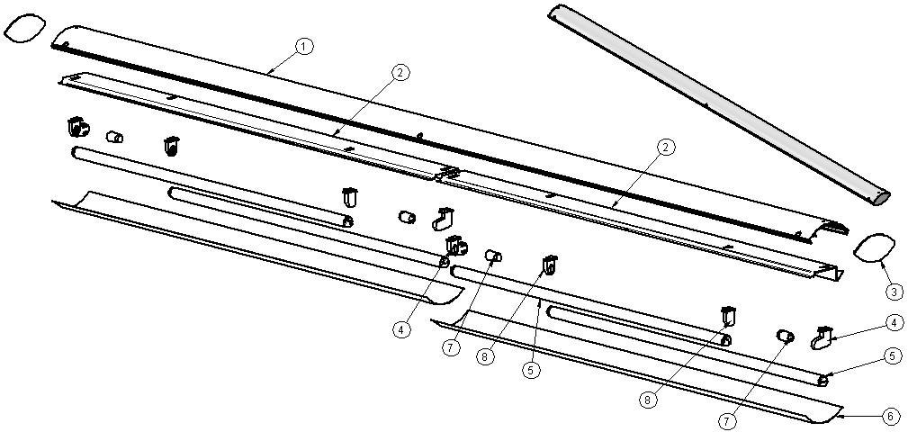

ITEM  NUMBER | DOCUMENT  NUMBER | TITLE | MATERIAL | PART NO. FOR EACH MODULE
 |  |  |  | 1250 | 2500 | 3750
1. | TT0E002 | CEILING LAMP PROFILE | ANODIZED ALUMINIUM | 2FI125030010 | 2FI250030010 | 2FI375030010
2. | TT0E014 | TOP LAMPS HOLDER | PLAST. SHEET, 8/10 | 6FI125030011
3. | CC0D023.1 | PLEXIGLAS FOR CEILING LAMP | OPAL GLASS 3mm | 4082305
4. |  | LAMPS HOLDER + STARTERS HOLDER STUCCHI 255/C | PVC | 4114710
5. |  | NEON 30 W/76 D.26 L 900 |  | 4114510
6. | TT0E015 | TOP POLYCARBONATE CEILING LAMP | POLYCARBONATE 7/10 | 6FI125030012
7. |  | UNIVERSAL STARTER FS 11 |  | 4116001
8. |  | LAMP HOLDER STUCCHI 255/S 2A 250V | PVC | 4114709

2.3. FRONT GLASS
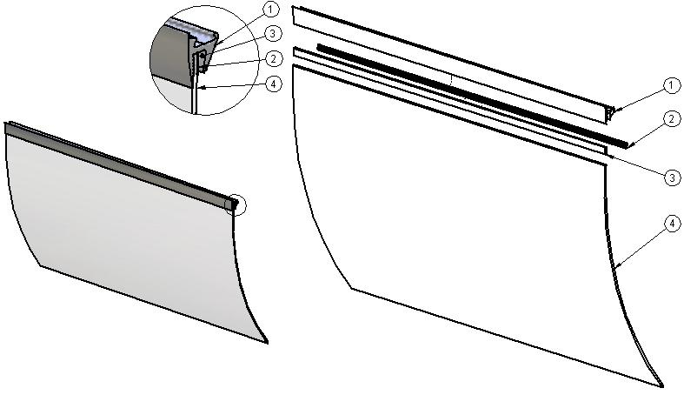

ITEM  NUMBER | DOCUMENT  NUMBER | TITLE | MATERIAL | PART NO. FOR EACH MODULE
 |  |  |  | 1250 | 2500 | 3750
1. | TT0D011 | JAW PROFILE | JAW ALUMINIUM PROFILE | 2FI125030007
2. | TT0D031 | JAW INSERT PROFILE | ALUMINIUM PROFILE | 2FI125030008
3. |  | GLASS GASKET PROFILE | PVC | 4180100
4. | RG004.1 | CURVED GLASS | FLOAT 6 mm | 4190739

3. COMPLETE SIDE WALL
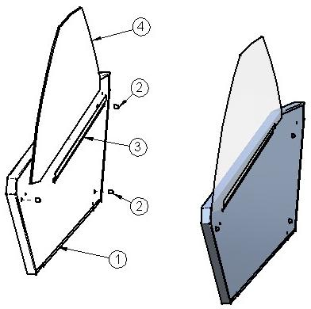

ITEM  NUMBER | DOCUMENT  NUMBER | TITLE | MATERIAL | PART NO. FOR EACH MODULE
 |  |  |  | 1250 | 2500 | 3750
1. | SF5M001 | SIDE WALL ASSEMBLED |  | 2IV125083002 (DX)
 |  |  |  | 2IV125083012 (SX)
2. |  | CENTERING BUSH | ALLUMINIUM ROUND TUBE PROFILE 4200 - 10 X 12 | 2BV1200C0006
3. | TT5M011 | SIDE GLASS FIXING PROFILE | STAINLESS STEEL 316 SB+PRO, 8/10 | 6FI125082001
4. | SF5M007 | SIDE GLASS HARDENED SY FISH | FLOAT 6 mm | 4190362

4. FRAME – LOADING SLIDE – BALLAST HOLDER PANEL

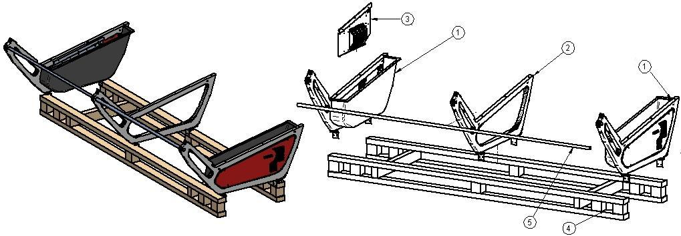

ITEM  NUMBER | DOCUMENT  NUMBER | TITLE | MATERIAL | PART NO. FOR EACH MODULE
 |  |  |  | 1250 | 2500 | 3750
1. |  | LATERAL FRAME ASSEMBLY
2. |  | CENTRAL FRAME ASSEMBLY
3. |  | BALLAST HOLDER PANEL
4. |  | LOADING SLIDE
5. | SF0L003 | TROLLEY STOPPER TUBE | TUBE PROFILE STAINLESS STEEL 22X1,5 L.6000 | 2IV1250F0004 | 2IV2500F0004 | 2IV3750F0004

4.1. LATERAL AND CENTRAL FRAME ASSEMBLY
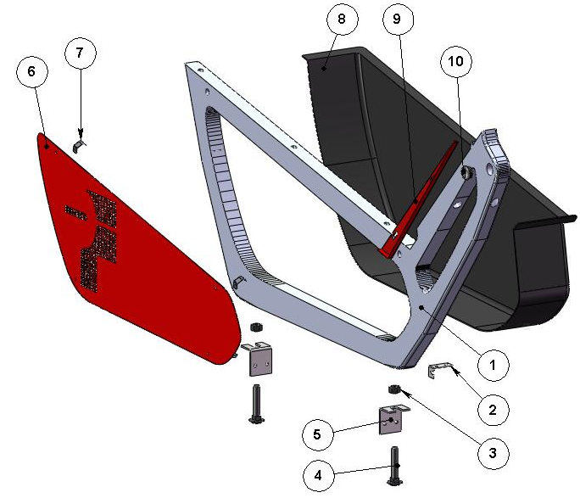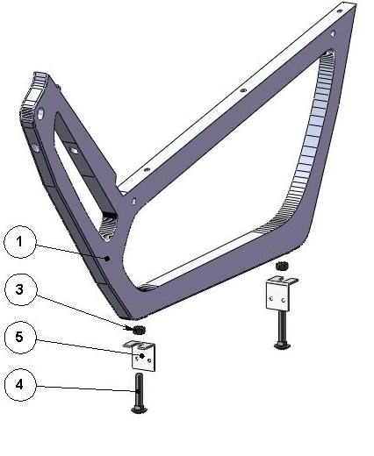
ITEM  NUMBER | DOCUMENT  NUMBER | TITLE | MATERIAL | PART NO. FOR EACH MODULE
 |  |  |  | 1250 | 2500 | 3750
1. | SF0B001 | FRAME | ALUMINIUM ALLOY | 2IV125060001
2. | SF0B 010 | CASE FIXING BRACKET | GALVANIZED SHEET 10/10 | 6IV125060003 (SX)
 |  |  |  | 6IV125060002 (DX)
3. |  | NUT SPACER M14 | GALVANIZED IRON
4. |  | BOLT M12X45 | GALVANIZED STEEL
5. | SF0B008 | LOADING SLIDE FIXING BRACKET | IRON SHEET 30/10 | 4282832
6. | SF0B004 | LATERAL FRAME CLOSURE | GALVANIZED SHEET 10/10 | 2IV125080014 (SX)
 |  |  |  | 2IV125080004 (DX)
7. | SF0B005 | SPRING FOR LATERAL CLOSURE COUPLIG | STAINLESS STEEL AISI301 5/10 | 4282798
8. | SF0B003 | CASE CLOSURE | ABS | 4100339 (SX)
 |  |  |  | 4100338 (DX)
9. | SF0J007 | FRONT SIDE WALL STOPPER | GALVANIZED SHEET 7/10 | 2IV125070005 (SX)
 |  |  |  | 2IV125070004 (DX)
10. |  | STOPPER P.V.C.CHROMED D.25 S.T.1 |  | 4333107

4.2. LOADING SLIDE

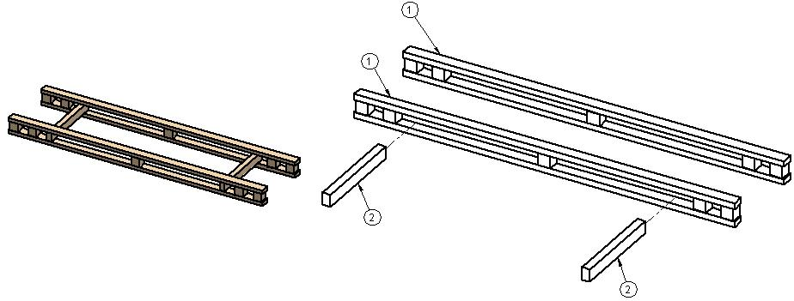

ITEM  NUMBER | DOCUMENT  NUMBER | TITLE | MATERIAL | PART NO. FOR EACH MODULE
 |  |  |  | 1250 | 2500 | 3750
1. | TT0B014 | LOADING SLIDE | SPRUCE WOOD | 4321345
2. |  | SPLINE | WOOD 80 X 50 X 630 | 4321248

4.4. BALLAST HOLDER PANEL
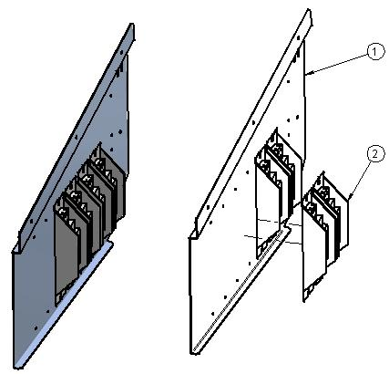

ITEM  NUMBER | DOCUMENT  NUMBER | TITLE | MATERIAL | PART NO. FOR EACH MODULE
 |  |  |  | 1250 |  | 2500 |  |  | 3750
1. |  | BALLAST PANEL | IRON SHEET 10/10 | 2IV125090003
2. |  | BALLAST |  | 15W | 18 – 20 W |  | 30W | 36 – 40 W |  | 58 – 65 W
 |  |  |  | 4115106 | 4115102 |  | 4115103 | 4115104 |  | 4115105

===========================================





Regione Gabannone, 4 – Zona Industriale
15030 TERRUGGIA (AL) ITALY
Tel. +39 0142 433711
Fax. +39 0142 433700

