

EXPLODED VIEW

FIRENZE
45º INTERNAL CORNER

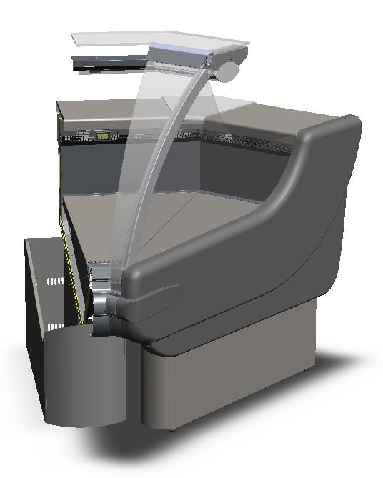

GENERAL SPLITTING UP
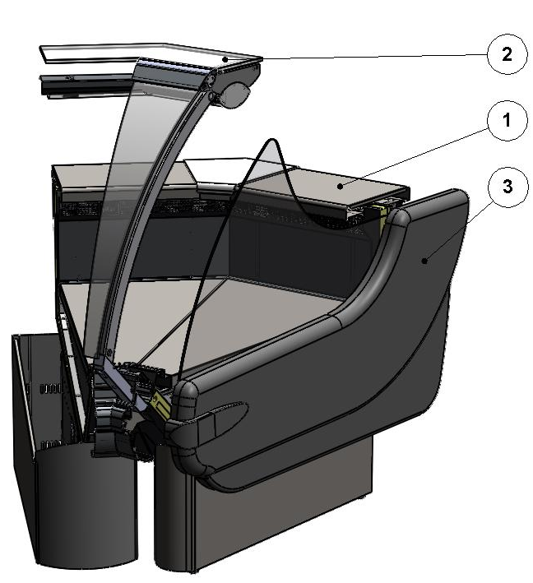

- INTERNAL FINISH, FRONTAL DECORATION
- GLASSES SUPERSTRUCTURE
- COMPLETE SIDE WALL

1. INTERNAL FINISH, FRONTAL DECORATION
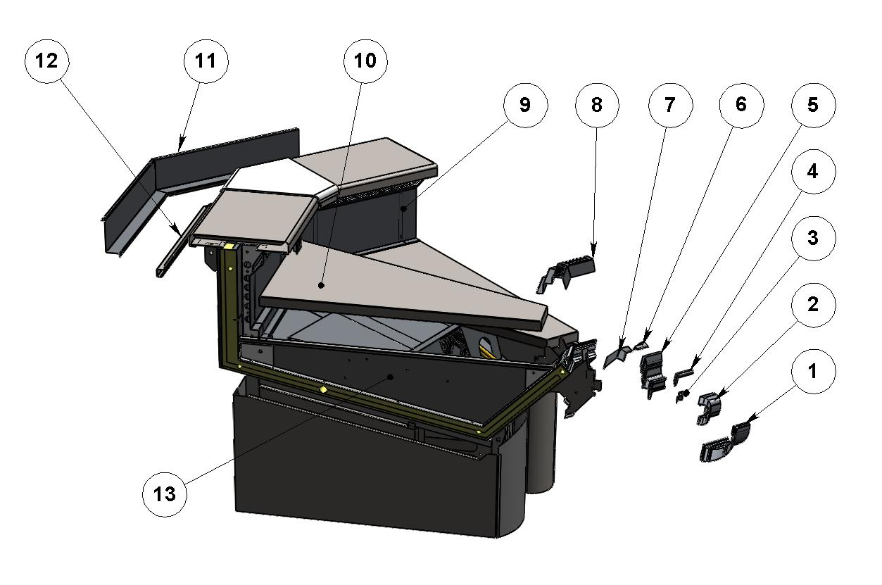

ITEM  NUMBER | DOCUMENT  NUMBER | TITLE | MATERIAL | PART NO. FOR MODULE
1. | TT0L014 | UPPER DECORATION PROFILE | ALUMINIUM | 2FI45I0F0031 (R)
 |  |  |  | 2FI45I0F0051 (L)
2. | TT0L012 | BUMPER RAIL PROFILE | PVC | 2FI45I0F0029 (R)
 |  |  |  | 2FI45I0F0049 (L)
3. | TT0L004 | BUMPER RAIL COUPLER BRACKET |  | 6FI1250F0008
4. |  | GLASS REBATE GUMMY PROFILE BETA BLACK P0391 | PVC | 4180403
5. | TT0L038 | GLASS REBATE PROFILE |  | 2FI45I0F0027 (R)
 |  |  |  | 2FI45I0F0047 (L)
6. | TT0G002 | LATERAL UPRIGHT STOPPER | GREY PLAST. N1 6/10 | 6FI1250F0003 (L)
7. | TT0G023 | LATERAL UPRIGHT STOPPER | GREY PLAST. N1 6/10 | 6FI45I0F0002 (R)
 |  |  |  | 6FI45I0F0003 (L)
8. | TT0G011 | SUCTION GRID 135°I |  | 6FI45I040031 (R)
 |  |  |  | 6FI45I040051 (L)
9. | TT0G009 | AIR OUTLET GRID 135°I |  | 6FI45I040029 (R)
 |  |  |  | 6FI45I040049 (L)
10. |  | REMOVABLE PLATE EXTERNAL CORNER (ASSEMBLY) |  | 2FI45I040001 (R)
 |  |  |  | 2FI45I040003 (L)
11. | TT0H012 | BLIND WIREWAY | GREY PLAST. N1 6/10 | 6FI45I010027 (R)
 |  |  |  | 6FI45I010047 (L)
12. | PP102 | SLIDING FOR ACCESSORY | STAINLESS STEEL AISI304 8/10 | 6PP45I010009
13. |  | BASIN INTERNAL FINISH

1.1. BASIN INTERNAL FINISH
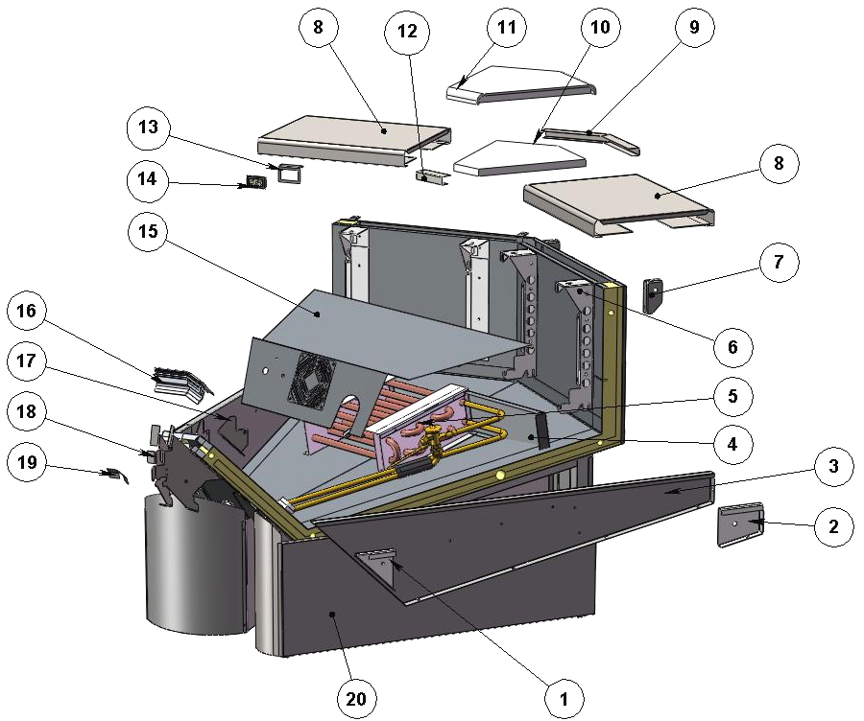

ITEM  NUMBER | DOCUMENT  NUMBER | TITLE | MATERIAL | PART NO. FOR MODULE
1. | RG034 | SIDE WALL FIXING BRACKET | IRON SHEET 15/10 | 6SV072040039 (L)
 |  |  |  | 6SV072040038 (R)
2. | RG106 | BACK STOPPER BRACKET | IRON SHEET 15/10 | 6SV072040041 (L)
 |  |  |  | 6SV072040040 (R)
3. | PP013 | BASIN STOPPER | STAINLESS STEEL AISI304 5/10 | 6PP096040001 (L)
 |  |  |  | 6PP096040000 (R)
4. | PP179 | LATERAL EVAPORATOR COVER 135°I. | WHITE PLAST. A1SA 6/10 | 6SV45I040006
5. |  | EVAPORATOR
6. | TT0G006 | BACK GRID SUPPORT BRACKET | IRON SHEET 15/10 | 6FI125040113 (L)
 |  |  |  | 6FI125040112 (R)
7. | TT0H004 | BACK LEVEL SURFACE SUPPORT | IRON SHEET 20/10 | 6FI125010011 (L)
 |  |  |  | 6FI125010009 (R)
8. | PP061 | STAINLESS STEEL PLAIN | STAINLESS STEEL AISI304 7/10 | 6PP45I010002
9. | PP211 | BACK PLAST. STAINLESS STEEL CLOSURE 45E | STAINLESS STEEL AISI304 DEC9 BA + PRO + SAT80 H435X 7/10 | 6PP45E010007
10. | PP210 | PLAST. STOPPER INT. CORNER ALPHA | POLYETHYLENE Thickness 18mm | 4081128
11. | PP062 | JUNCTION PLANES FOR CORNERS | POLYETHYLENE Thickness 25mm | 4081121
12. | PP211 | FRONT PLAST. STAILESS STEEL CLOSURE 45E | STAINLESS STEEL AISI304 DEC9 BA + PRO + SAT80 H435X7/10 | 6PP45E010008
13. | TT0C002 | THERMOMETER HOLDER | STAINLESS STEEL AISI304 15/10 | 6FI125020007
14. |  | DIGITAL THERMOMETER |  | 4131307
15. |  | FANS HOLDER
16. | TT0G015 | TOP DEFLECTOR PROFILE 135°I | ATOXIC PVC PROFILE GLASS DEFL.4400 0G 001 | 2FI45I040027 (R)
 |  |  |  | 2FI45I040047 (L)
17 | TT0G007 | FRONT GRID SUPPORT BRACKET | STAINLESS STEEL AISI304 15/10 | 6FI125040014 (R)
 |  |  |  | 6FI125040015 (L)
18. | TT0L001 | TOP PANEL SUPPORT BRACKET | GALVANIZED SHEET 15/10 | 6FI1250F0001
19. | TT0L022 | STOPPER SUPPORT PST | GALVANIZED SHEET SKIMPAS 7/10 | 6FI1250F0012
20. |  | BOTTOM BASIN ASSEMBLY

1.1.1. FANS HOLDER. EVAPORATOR

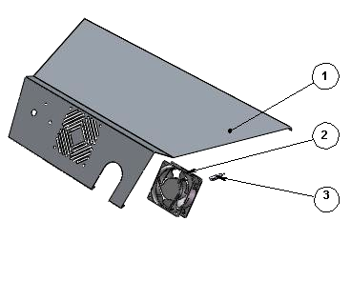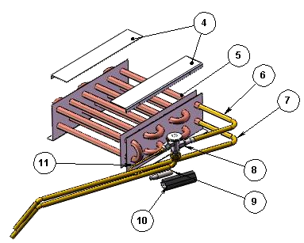
ITEM  NUMBER | DOCUMENT  NUMBER | TITLE | MATERIAL | PART NO. FOR MODULE
1. | PP179 | EVAPORATOR COVER 135°INT CORNER | STAINLESS STEEL AISI 304 6/10 | 6SV45I040005
2. |  | MOTORFAN “PP” 4715 MS23TB10 A00 |  | 4241007
3. |  | CABLE CONNECTOR L. 1525 MM |  | 4110606
4. | CC0F012 | EVAPORATOR COVER SUPPORT BRACKET | SILVER PLATED +PLASTICIZED ALUMINIUM 20/10 | 6PP096040036
5. |  | EVAPORATOR KING V. 135 E – I COATED | COOPER TUBES - ALUMINIUM SHEETS | 4220300
6. | PP440 | TUBE FOR VALVE, LIQUID LINE | COOPER TUBES D.6 X 8 | 4272415
7. | PP441 | TUBE FOR VALVE, EXTERNAL EQUALIZATION | COOPER TUBES D.4 X 6 | 4272414
8. |  | WELDED VALVE THERMOSTAT.R404 TES/2 |  | 4251311
9. |  | VALVE BULB
10. |  | ANTICONDENSATE TUBE | INSULATING SPONGE 6 X 22 | 4270505
11. |  | CAPILLARY TUBE | COOPER TUBES 1.8X3 | 4260206

1.1.2. BOTTOM BASIN ASSEMBLY
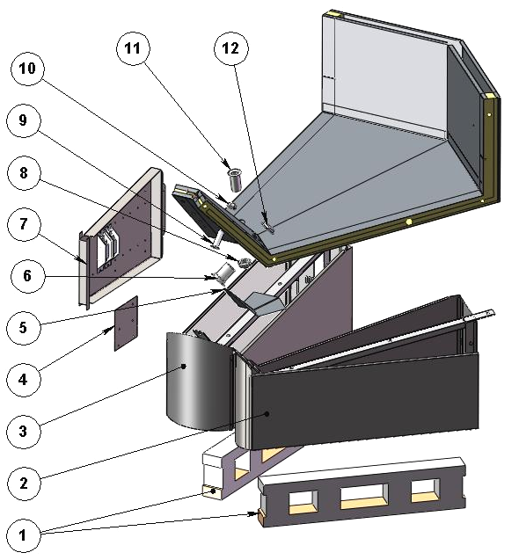

ITEM  NUMBER | DOCUMENT  NUMBER | TITLE | MATERIAL | PART NO. FOR MODULE
1. | PP178 | WOOD SLIDE ”ALPHA” H80 L. 720 | SPRUCE WOOD | 4321310
2. |  | LEFT FRAME
3. |  | RIGHT FRAME
4. | RGSD016 | SUPPORT FOR BALLASTS PANEL TERMINAL BOARD | GALVANIZED SHEET 10/10 | 6SV072090010
5. | TT0J047 | BASIN COVER PANNEL 135°I | PLAST. SHEET N12SM 6/10 | 6FI45I070005 (R)
 |  |  |  | 6FI45I070006 (L)
6. |  | DRAIN D. 44 | ABS | 4102106
7. |  | BALLASTS HOLDER PANEL |  | 2FI125090107
8. |  | DRAIN NUT 1’’1/2 | ABS
9. |  | DRAIN D. 20 | ABS | 4102101
10. |  | DRAIN NUT D. 20 | ABS | 4102101
11. |  | DRAIN 10124 1’1/2 GAS L.75 MM | ABS | 4102132
12. |  | DRAIN NUT D. 44 | ABS | 4102106

1.1.2.1. BALLASTS HOLDER PANEL

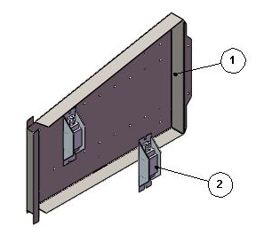

ITEM  NUMBER | DOCUMENT  NUMBER | TITLE | MATERIAL | PART NO. FOR MODULE
1. | TT0C001 | BALLASTS HOLDER | IRON SHEET 10/10 | 6FI125090108
2. |  | BALLAST |  | 18 – 20 W
 |  |  |  | 4115102

1.1.2.2. FRAME
LEFT | RIGHT
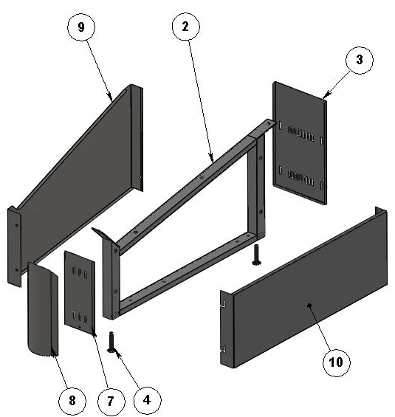 | 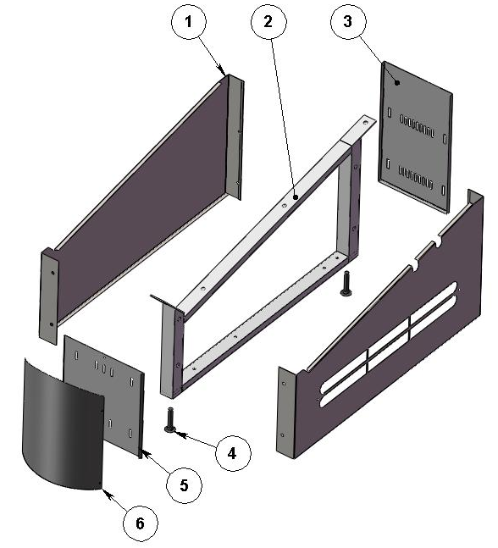

ITEM  NUMBER | DOCUMENT  NUMBER | TITLE | MATERIAL | PART NO. FOR MODULE
1. | TT0J003 | UNDER BASIN DECORATION | PLASTICIZED SHEET 8/10 | 6FI125070004 (L)
 |  |  |  | 6FI125070003 (R)
2. | TT0B006 | FRAME | IRON TUBE | 2FI125060001
3. | TT0J007 | LEG BACK CLOSURE (P) | GREY PLASTICIZED SHEET 6/10 | 6FI125060002
4. |  | BOLT M12X45 | GALVANIZED STEEL
5. | TT0J005 | FRONT DECORATION SUPPORT ANTHRAC. | PLASTICIZED SHEET 8/10 | 6FI125070002
6. | TT0J001 | CAMBERED ANTHRAC. FRONT DECORATION | PLASTICIZED SHEET 8/10 | 6FI125070001
7. | TT0J053 | DECORATION SUPPORT 45I SIDE WALL TERM. | PLASTICIZED SHEET 8/10 | -
8. | TT0J052 | CAMBERED FRONT DECORATION 45I SIDE WALL TERM. | PLASTICIZED SHEET 8/10 | -
9. | TT0J054 | UNDER BASIN DECORATION INTERNAL CORNER SIDE WALL TERM. | PLASTICIZED SHEET 8/10 | -
10. | TT0J002 | UNDER SIDE WALL DECORATION | PLASTICIZED SHEET 8/10 | 6FI125080012 (DX)
 |  |  |  | 6FI125080013 (SX)

2. GLASSES SUPERSTRUCTURE
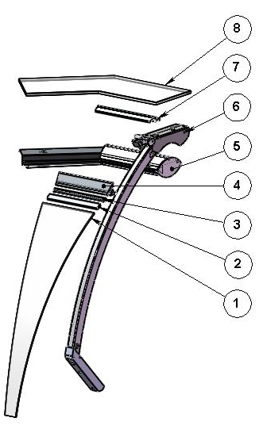

ITEM  NUMBER | DOCUMENT  NUMBER | TITLE | MATERIAL | PART NO. FOR MODULE
1. | RG045 | GLASS 45I | FLOAT 6mm | 4191472 (L)
2. |  | GLASS GASKET PROFILE | PVC | 4180100
3. | TT0D031 | JAW INSERT PROFILE | ALUMINIUM PROFILE E5628A
4. | RG061.1 | JAW PROFILE 45I | ALUMINIUM PROFILE
5. |  | UPPER CEILING LAMP FI 45°I C.T.M |  | 2FI45I030009
6. |  | LATERAL UPRIGHT
7. | TT0D023 | COVER PROFILE 45I | ALUMINIUM PROFILE
8. |  | TOP GLASS 45I | FLOAT 10mm | 4199913

2.1. CEILING LAMP
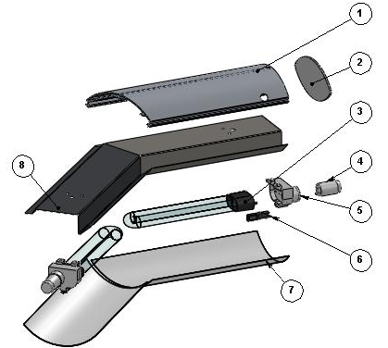

ITEM  NUMBER | DOCUMENT  NUMBER | TITLE | MATERIAL | PART NO. FOR MODULE
1. | TT0E008 | CEILING LAMP PROFILE | ALUMINIUM PROFILE | 2FI90I030010 (R)
2. | CC0D023.1 | CEILING LAMP HEAD | OPAL GLASS 3mm | 4082305
3. |  | COMPACT LAMP DULUX L18W/76 |  | 4113623
4. |  | UNIVERSAL STARTER FS 11 |  | 4116001
5. |  | LAMPS HOLDER + STARTERS HOLDER 441/V-16 |  | 4114712
6. |  | LAMP STOP DEVICE "120" |  | 4114713
7. | TT0E029 | CEILING LAMP SHIELD POLYCARBONATE | POLYC. PLEX. LEXAN PC 2050X1250X0,75 | 6FI45E030032 (R)
 |  |  |  | 6FI45E030052 (L)
8. | TT0E005 | TOP LAMPS HOLDER | PLASTICIZED SHEET 8/10 | 6FI45I030031 (R)
 |  |  |  | 6FI45I030051 (L)

2.2. LATERAL UPRIGHT
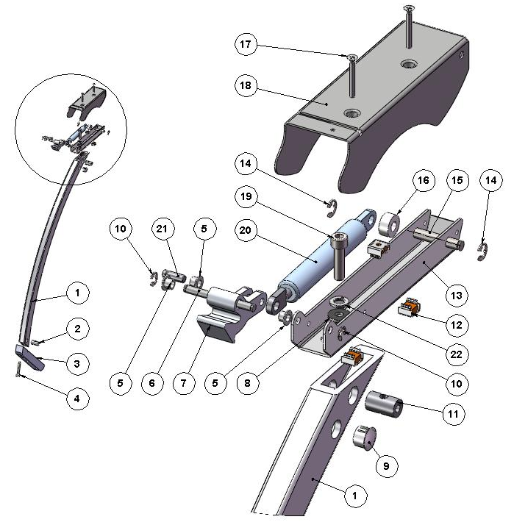

ITEM  NUMBER | DOCUMENT  NUMBER | TITLE | MATERIAL | PART NO. FOR MODULE
1. | TT0D002 | CURVED FRONT UPRIGHT FIR. | ALLOY 6060 T5 | 4351209
2. | RG072 | BACK GLASS UPRIGHT PIN "SIGMA" GALVANIZED | STEEL BAR Ø15 | 4140070
3. | CC0D010 | GLASS UPRIGHT SUPPORT KREA | ALUMINIUM ALLOY 6060 (FLAT PROFILE 30X30) | 4282116
4. |  | BOLT TCEI M8X50 | GALVANIZED STEEL
5. | ECAV 016 | PISTON BUSH | NYLON | 8291718
6. | TT0D003 | LATERAL BACK PIN | GROUND DRAWN STEEL Ø6 | 4140085
7. | AV011 | ROTATION LEVER PRESSOFUS | ALUMINIUM ALLOY | 4282114 (L)
 |  |  |  | 4282113 (R)
8. |  | PLAIN WASHER 8X24 | GALVANIZED STEEL
9. |  | WHITE STOPPER DP500 | PLASTIC | 4333114
10. |  | SEGGER 5 | GALVANIZED STEEL | 8298303
11. | TT0D013 | GLASS UPRIGHT PIN | STEEL BAR Ø15 | 4140088
12. |  | CAGE NUT M5
13. | TT 0D001 | LEVER SUPPORT | IRON SHEET 20/10 | 2FI125030013
14. |  | SEGGER 7 | GALVANIZED STEEL | 8298304
15. | TT0D005 | LATERAL BACK PIN | GROUND DRAWN STEEL Ø8 | 4140086
16. |  | SPACER WITH HOLE DCS79B 6R | NYLON
17. |  | BOLT TS+ M5X35 | STAINLESS STEEL
18. | TT0D007 | LEVER COVER | IRON SHEET 15/10 | 2FI125030016 (L)
19. |  | BOLT TCEI M8X30 | GALVANIZED STEEL
20. |  | PISTON VS-SV R 1000 | STAINLESS STEEL | 4145020
21. | ECAV018 | PISTON FRONT PIN | GROUND DRAWN STEEL Ø6
22. |  | GROWER M8

3. COMPLETE SIDE WALL

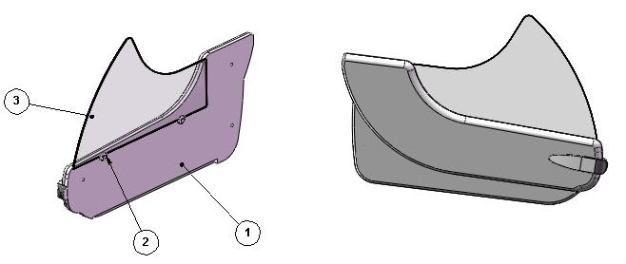

ITEM  NUMBER | DOCUMENT  NUMBER | TITLE | MATERIAL | PART NO. FOR MODULE
1. | TT0M001 | SIDE WALL | POLYURETHANE Thickness 50mm | (L)
 |  |  |  | (R)
2. |  | LATERAL GLASS BLOCK | PVC | 4100313
3. | TT0M009 | SIDE GLASS FIRENZE | FLOAT 6 mm | 4190150

===========================================





Regione Gabannone, 4 – Zona Industriale
15030 TERRUGGIA (AL) ITALY
Tel. +39 0142 433711
Fax. +39 0142 433700

