

EXPLODED VIEW

VS-PORTOFINO FAN ASSISTED
45º INTERNAL CORNER

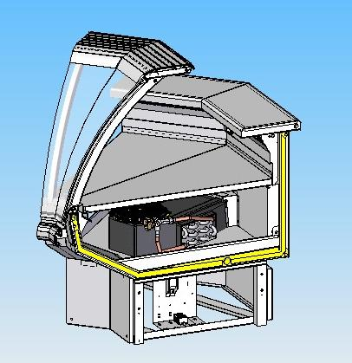

GENERAL SPLITTING UP

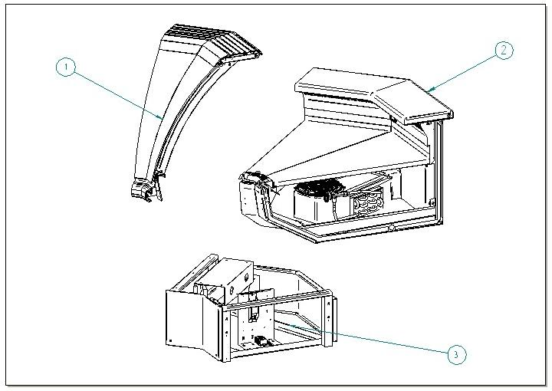

- GLASSES SUPERSTRUCTURE – ALUMINIUM TOP AND LAMPS – BUMPER BAND
- INTERNAL FINISH – WORKING TABLE – DISPLAY PLATE – EVAPORATOR
- FRONT DECORATION – FRAME – DRAIN – CONTROL BOARD

  - GLASSES SUPERSTRUCTURE

1.1 LEFT GLASS AND PROFILES
1.2 LEFT GLASS UPRIGHT
1.3 ALUMINIUM TOP AND LAMPS
1.4 RIGHT GLASS UPRIGHT
1.5 RIGHT GLASS AND PROFILES
1.6 BUMPER BAND

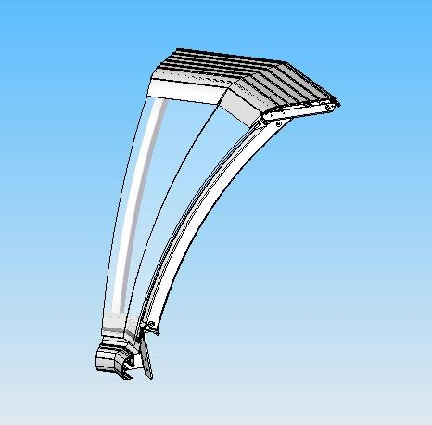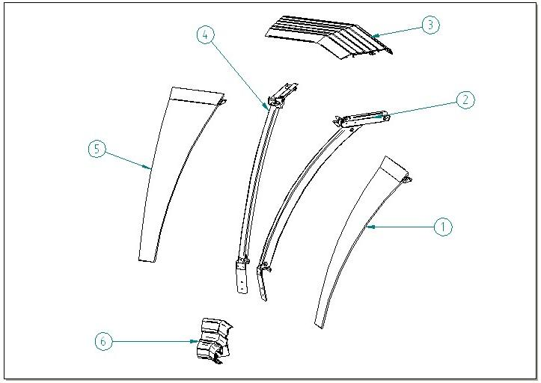

  - LEFT GLASS AND PROFILES

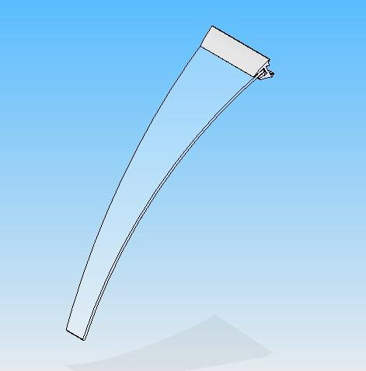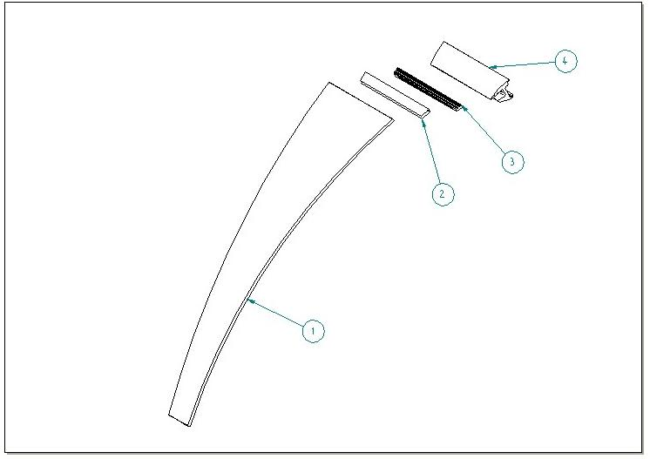

ITEM  NUMBER | DOCUMENT  NUMBER | TITLE | MATERIAL | PART NO.
1 | DA0D 003 | LEFT CURVED TRAPEZOIDAL SILKSCREEN AND TEMPERED GLASS FOR CORNER 45º I | FLOAT 6mm | 4191557
2 |  | GLASS GASKET PROFILE | PVC | 4180100
3 |  | LEFT JAW INSERT PROFILE FOR 135 º INT. | ALU. PROFILE E5628A | 2PV45I030046
4 | DA0D 012 | LEFT JAW PROFILE CUT | ALUMINIUM | 2PV45I030045

  - LEFT GLASS UPRIGHT
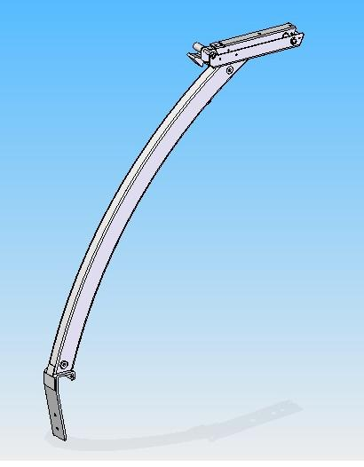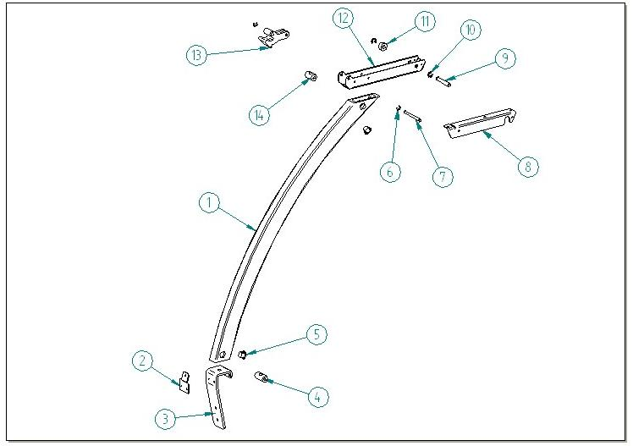

ITEM  NUMBER | DOCUMENT  NUMBER | TITLE | MATERIAL | PART NO.
1 | DA0D 006 | PORTOFINO FRONT UPRIGHT | ALUMINIUM ALLOY 6060 T5 | 4351214
2 | DA0D 014 | RINFORCEMENT FOR FRONT UPRIGHT | GALVANIZED SHEET 15/10 | 6PV120030002
3 | DA0D 005 | FRONT UPRIGHT SUPPORT | DRAWN IRON 4X40 | 2PV120030009
4 | RG 072 | BACK UPRIGHT PIN “SIGMA” | RUNG STEEL Ø15 | 4140070
5 |  | WHITE CAP DP500 |  | 4333114
6 |  | SEGGER 5 | GALVANIZED STEEL | 8298303
7 | TT0D 003 | FRONTSIDE PIN | DRAWN GROUND STEEL D 6 | 4140085
8 | TT0D 024 | LEFT TOP FIXING BRACKET | IRON SHEET 15/10 | 2FI125030202
9 | TT0D 005 | BACKSIDE PIN | DRAWN GROUND STEEL D 6 | 4140086
10 |  | SEGGER 7 | GALVANIZED STEEL | 8298304
11 |  | SPACER WITH HOLE DCS79B NYLON 6R ELECTROZUB | NYLON | 150
12 | TT0D 001 | LEVER SUPPORT | IRON SHEET 20/10 | 2FI125030013
13 | EEAV 011 | LEFT ROTATION LEVER PRESSOFUS | ALUMINIUM ALLOY | 4282114
14 | TT0D 013 | FIRENZE UPRIGHT PIN | RUNG STEEL Ø15 | 4140088

  - ALUMINIUM TOP AND LAMPS

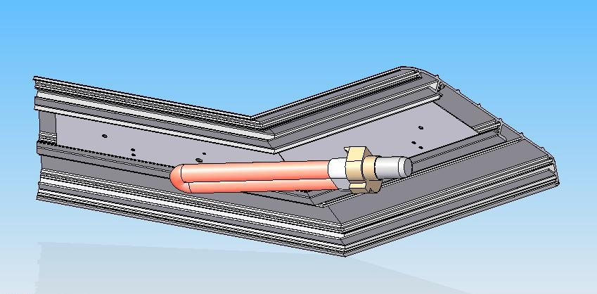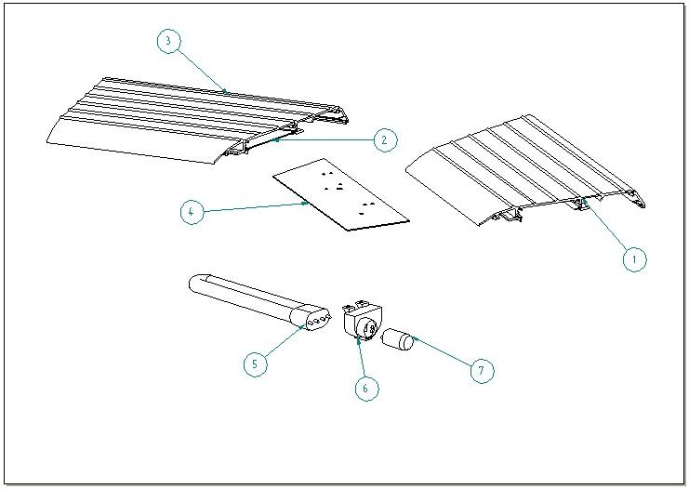

ITEM  NUMBER | DOCUMENT  NUMBER | TITLE | MATERIAL | PART NO.
1 | DA0D 011 | LEFT 135º I TOP PROFILE | ALUMINIUM PROFILE Q 1238 | 2PV45I030047
2 | DA0E 001 | RIGHT LAMP-HOLDER PV 135º I | PLASTICIZED SHEET 8/10 | 6PV45I020006
3 | DA0D 011 | LEFT 135º I TOP PROFILE | ALUMINIUM PROFILE Q 1238 | 2PV45I030027
4 | DA0E 001 | LEFT LAMP-HOLDER PV 135º I | PLASTICIZED SHEET 8/10 | 6PV45I020046
5 |  | COMPACT LAMP DULUX L18W/76 |  | 4113623
6 |  | LAMP-HOLDER + STARTER-HOLDER 441/V-16 | ALUMINIUM | 4114712
7 |  | UNIVERSAL STARTER FS 11 |  | 4116001

  - RIGHT GLASS UPRIGHT
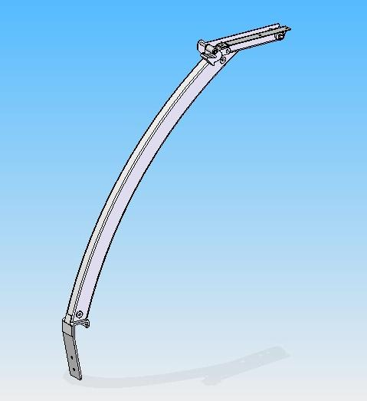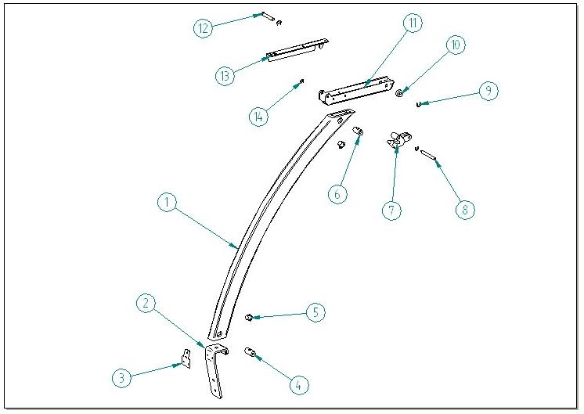

ITEM  NUMBER | DOCUMENT  NUMBER | TITLE | MATERIAL | PART NO.
1 | DA0D 006 | PORTOFINO FRONT UPRIGHT | ALUMINIUM ALLOY 6060 T5 | 4351214
2 | DA0D 014 | RINFORCEMENT FOR FRONT UPRIGHT | GALVANIZED SHEET 15/10 | 6PV120030002
3 | DA0D 005 | FRONT UPRIGHT SUPPORT | DRAWN IRON 4X40 | 2PV120030009
4 | RG 072 | BACK UPRIGHT PIN “SIGMA” | RUNG STEEL Ø15 | 4140070
5 |  | WHITE CAP DP500 | PLAST. | 4333114
6 | TT0D 013 | UPRIGHT PIN FIRENZE | RUNG STEEL Ø15 | 4140088
7 | EEAV 011 | RIGHT ROTATION LEVER PRESSOFUS | ALUMINIUM ALLOY | 4282113
8 | TT0D 003 | FRONTSIDE PIN | DRAWN GROUND STEEL D 6 | 4140085
9 |  | SEGGER 7 | GALVANIZED STEEL | 8298304
10 |  | SPACER WITH HOLE DCS79B NYLON 6R ELECTROZUB | NYLON | 150
11 | TT0D 001 | LEVER SUPPORT | IRON SHEET 20/10 | 2FI125030013
12 | TT0D 005 | BACKSIDE PIN | DRAWN GROUND STEEL D 6 | 4140086
13 | TT0D 024 | RIGHT TOP FIXING BRACKET | IRON SHEET 15/10 | 2FI125030201
14 |  | SEGGER 5 | GALVANIZED STEEL | 8298303

1.5 RIGHT GLASS AND PROFILES

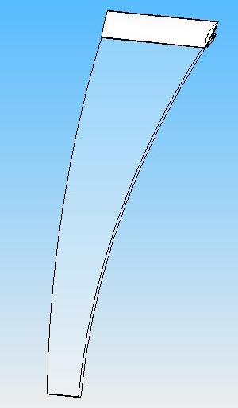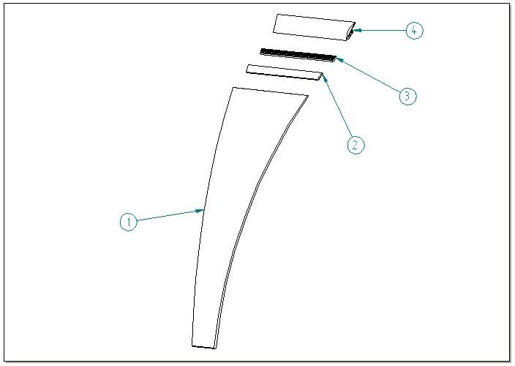

ITEM  NUMBER | DOCUMENT  NUMBER | TITLE | MATERIAL | PART NO.
1 | DA0D 003 | RIGHT CURVED TRAPEZOIDAL SILKSCREEN AND TEMPERED GLASS FOR CORNER 45º INT. | FLOAT 6mm | 4191556
2 |  | GLASS GASKET PROFILE | PVC | 4180100
3 |  | RIGHT JAW INSERT PROFILE FOR 135 º INT. | ALUMINIUM PROFILE E5628A | 2PV45I030026
4 | DA0D 012 | LEFT JAW PROFILE CUT | ALUMINIUM | 2PV45I030025

1.6 BUMPER BAND
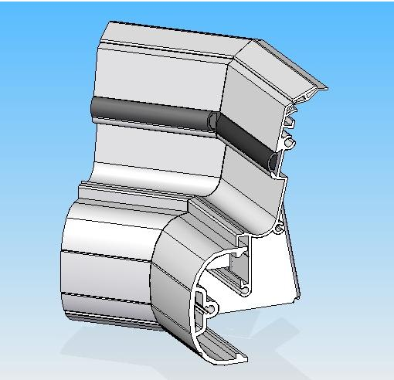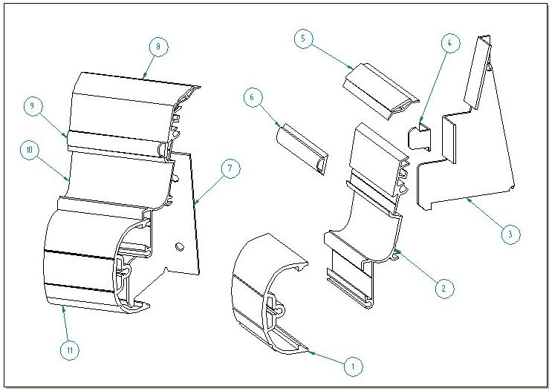

ITEM  NUMBER | DOCUMENT  NUMBER | TITLE | MATERIAL | PART NO.
1 | DAOL 005 | LEFT BUMPER RAIL PV 135º | PVC ANTI-CRASH PROFILE | 2PV45I0F0021
2 | DA0L 006 | LEFT GLASS LEDGE PROFILE | ALUMINIUM PROFILE | 2PV45I0F0025
3 | DA0L 001 | LEFT FRONT SUPPORT BRACKET | SHEET 15/10 | 6PV1200F0003
4 | TT0L 004 | BUMPER RAIL HOOK BRACKET | SHEET 15/10 | 6FI1250F0008
5 | DA0L 009 | LEFT JOINING PROFILE PV 135º | PVC IMAP PROFILE | 2PV45I0F0024
6 | P0391 | BLACK GUM GLASS LEDGE PROFILE |  | 4180403
7 | DA0L 001 | RIGHT FRONT SUPPORT BRACKET | SHEET 15/10 | 6PV1200F0002
8 | DA0L 009 | RIGHT JOINING PROFILE PV 135º | PVC IMAP PROFILE | 2PV45I0F0014
9 | P0391 | BLACK GUM GLASS LEDGE PROFILE |  | 4180403
10 | DA0L 006 | LEFT GLASS LEDGE PROFILE | ALUMINIUM PROFILE | 2PV45I0F0015
11 | DAOL 005 | LEFT BUMPER RAIL PV 135º | PVC ANTI-CRASH PROFILE | 2PV45I0F0011

  - INTERNAL FINISH

2.1 WORKING TABLE
2.2 DISPLAY PLATE
2.3 FANS-HOLDER
2.4 EVAPORATOR
2.5 INTERNAL FINISH

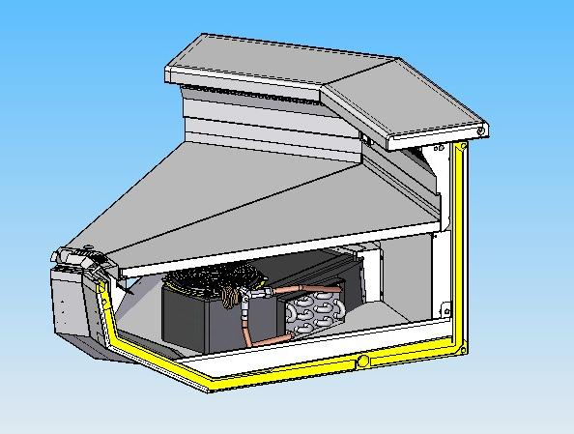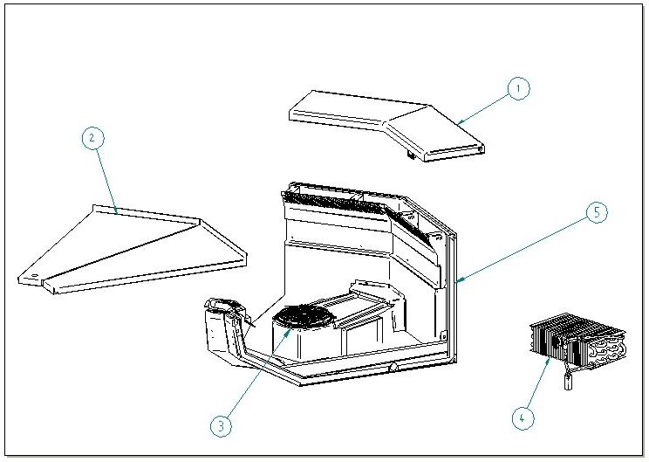

2.1 WORKING TABLE
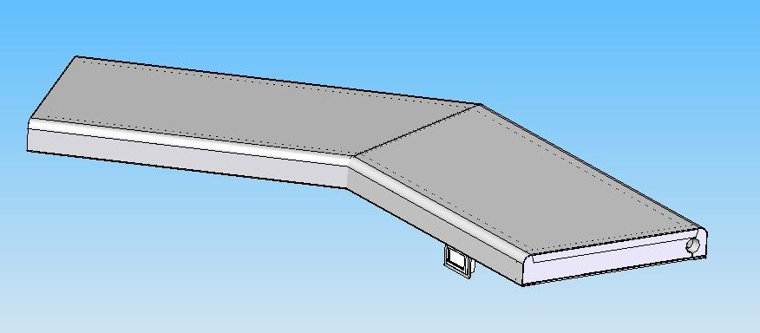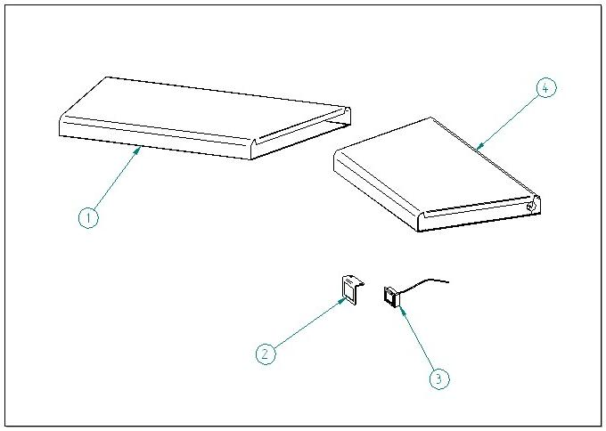

ITEM  NUMBER | DOCUMENT  NUMBER | TITLE | MATERIAL | PART NO.
1 | DA0H 008 | RIGHT WORKING TABLE PV 135º I R1 SCHIU. |  | 2PV45I010021
2 | TT0C 002 | THERMOMETER-HOLDER | STAINLESS STEEL AISI304 15/10 | 6FI125020007
3 |  | DIGITAL THERMOMETER CC10030000-A |  | 4131307
4 | DA0H 008 | LEFT WORKING TABLE PV 135º I R1 SCHIU. |  | 2PV45I010041

2.2 DISPLAY PLATE

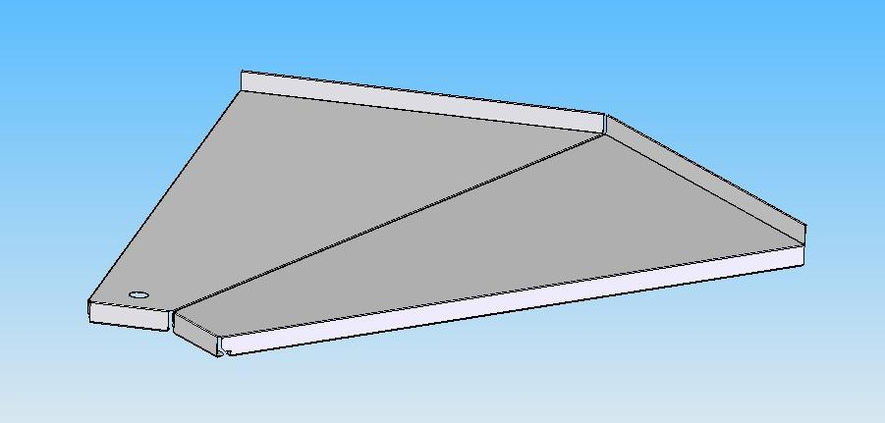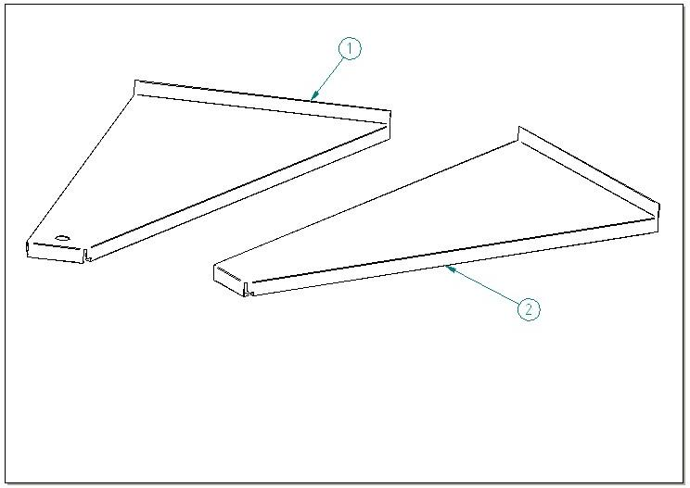

ITEM  NUMBER | DOCUMENT  NUMBER | TITLE | MATERIAL | PART NO.
1 | DA0K 002 | RIGHT PLATE 135º INTERNAL CORNER | STAINLESS STELL AISI304 8/10 | 6PV45I0A0011
2 | DA0K 002 | LEFT PLATE 135º INTERNAL CORNER | STAINLESS STELL AISI304 8/10 | 6PV45I0A0012

2.3 FANS HOLDER

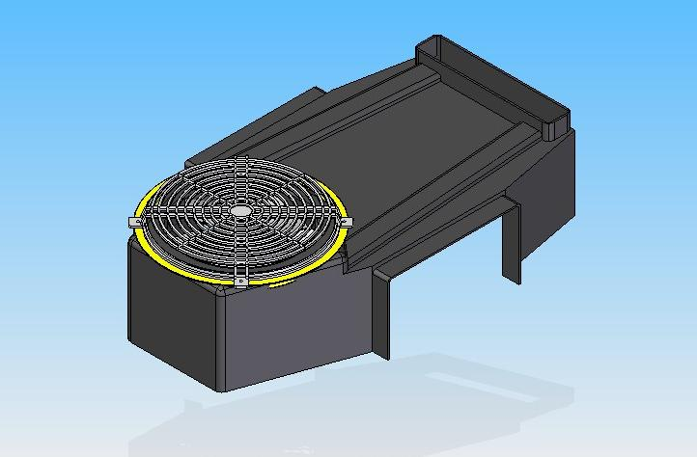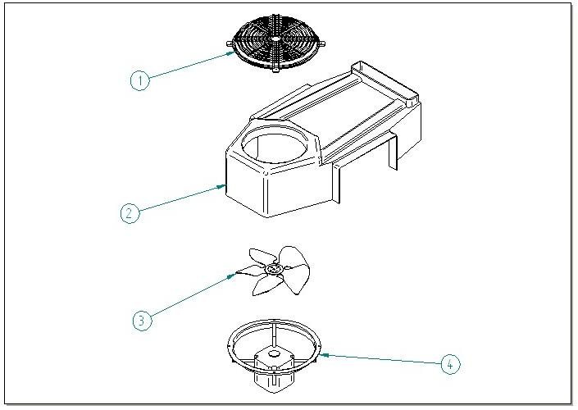

ITEM  NUMBER | DOCUMENT  NUMBER | TITLE | MATERIAL | PART NO.
1 | 0BP0201 | PROTECTION GRID D.200 | PVC | 4271908
2 |  | EVOPORATOR COVER SHELL CORNER | PST VACUUM | 4101230
3 |  | FAN D.154 18º H22MM.ASP.VSV | ALUMINIUM | 4249926
4 |  | MOTORFAN 5W D.154 |  | 4240501

2.4 EVAPORATOR BV 45º E R404 PIPE UNION
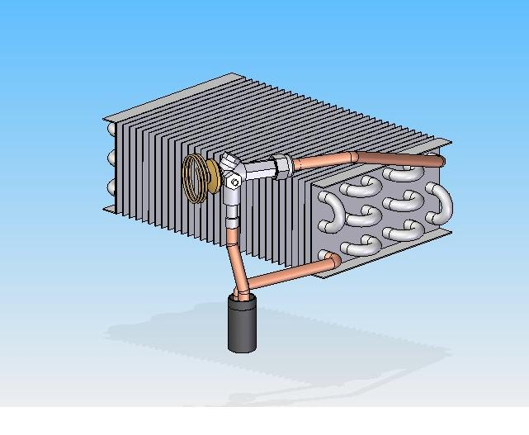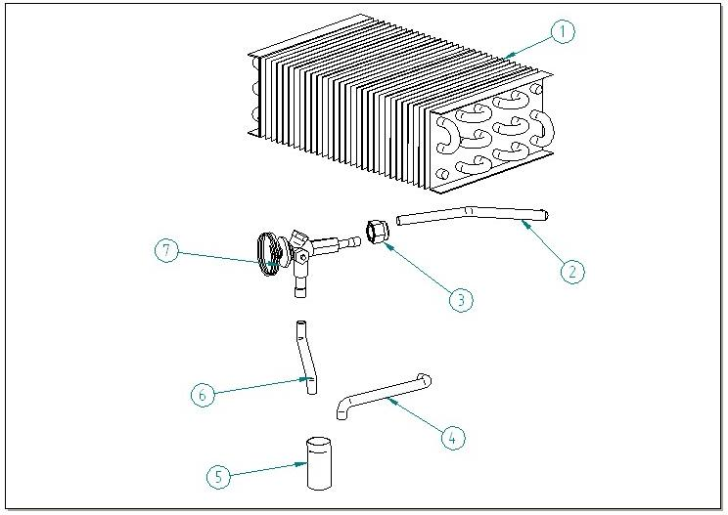

ITEM  NUMBER | DOCUMENT  NUMBER | TITLE | MATERIAL | PART NO.
1 | EEB0 103 | EVAPORATOR EXC. S/B 135º CORNER | COOPER TUBES - ALU. SHEET | 4222005
2 | PP440 | EVAPORATOR – VALVE TUBE | COOPER D. 6X8 | 4272415
3 |  | PIPE UNION ½ SAE D.12 7030/4M12 |  | 4271204
4 | ET0F 010 | SUCTION TUBE FOR VALVE SYSTEM | COOPER D. 8 X 10 (10 X 1) | 4272425
5 |  | ANTICONDENSATE TUBE | INSULATING SPONGE 6 X 15 | 4270503
6 |  | DELIVERY TUBE FOR VALVE SYSTEM | COOPER D. 4X6 | 4272413
7 |  | VALVE THERMOSTAT. R404 TS 2 CART. |  | 4251312

2.5 INTERNAL FINISH

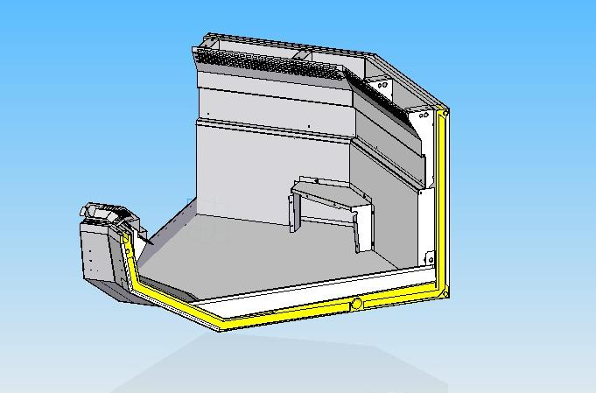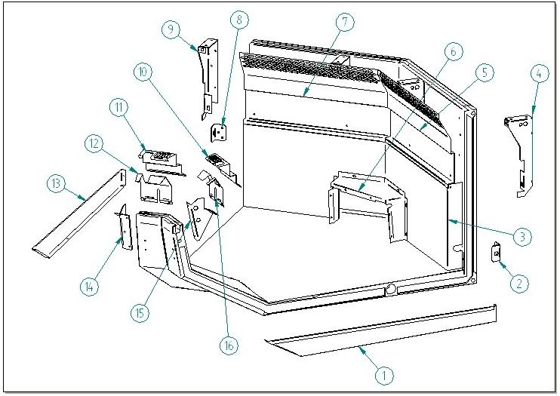

ITEM  NUMBER | DOCUMENT  NUMBER | TITLE | MATERIAL | PART NO.
1 | DA0A 031 | LEFT BODY HEAD | STAINLESS STEEL AISI304 6/10 | 6PV45E040029
2 | ET0U 001 | MULTIPLEXING BRACKET | STAINLESS STEEL AISI304 30/10 | 4282119
3 | DA0G 026 | AIR CHANNEL CLOSURE – EXTERNAL CORNER | PLAST. SHEET 6/10 | 6PV45I040012
4 | DA0G 052 | BACK BRACKET – LEFT FROM SERVICE SIDE | SHEET 15/10 | 6PV120040002
5 | DA0G 013 | LEFT AIR OUTLET GRID | PLAST. SHEET 8/10 | 6PV45I040105
6 | DA0G 025 | EVAPORATOR COVER COMPENSATION EXTERNAL CORNER | PLAST. SHEET 6/10 | 6PV45I040011
7 | DA0G 013 | RIGHT AIR OUTLET GRID | PLAST. SHEET 8/10 | 6PV45I040085
8 | ET0U 001 | MULTIPLEXING BRACKET | STAINLESS STEEL AISI304 30/10 | 4282119
9 | DA0G 052 | BACK BRACKET – RIGHT FROM SERVICE SIDE | SHEET 15/10 | 6PV120040001
10 | DA0G 011 | LEFT SUCTION GRID | STAINLESS STEEL AISI304 8/10 | 6PV45I040103
11 | DA0G 011 | RIGHT SUCTION GRID | STAINLESS STEEL AISI304 8/10 | 6PV45I040083
12 | DA0G 009 | RIGHT SUCTION GRID CLOSURE | STAINLESS STEEL AISI304 6/10 | 6PV45I040084
13 | DA0A 031 | RIGHT BODY HEAD | STAINLESS STEEL AISI304 6/10 | 6PV45E040029
14 | ET0G 001 | FRONT BRACKET – RIGHT FROM SERVICE SIDE | STAINLESS STEEL AISI304 15/10 | 6BV120042002
15 | ET0G 001 | FRONT BRACKET – LEFT FROM SERVICE SIDE | STAINLESS STEEL AISI304 15/10 | 6BV120042003
16 | DA0G 009 | LEFT SUCTION GRID CLOSURE | STAINLESS STEEL AISI304 6/10 | 6PV45I040104

- DECORATION – FRAME – DRAIN – CONTROL PANEL

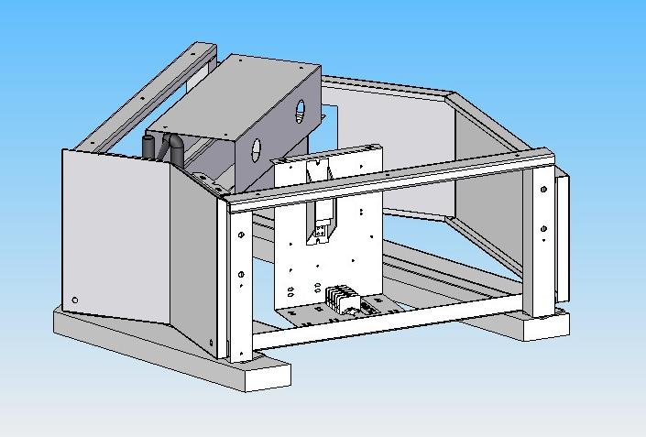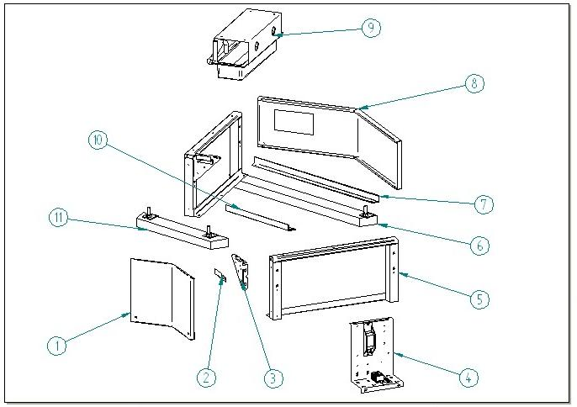

ITEM  NUMBER | DOCUMENT  NUMBER | TITLE | MATERIAL | PART NO.
1 | DA0J 007 | FRONTAL DECORATION PANEL 135º I CORNER | PLAST. SHEET 6/10 | 2PV45I070011
2 | ET0J 001 | DECORATION REST BRACKET | SHEET 15/10 | 6BV120072007
3 | ET0B 002 | FRAME BRACKET | SHEET 15/10 | 6BV120002017
4 |  | CONTROL BOARD
5 | ET0B 001 | GALVANIZED FRAME BETA | IRON PROFILES 360 | 4280114
6 | ET0B 007 | LOADING SLIDE EE 845 | SPRUCE WOOD | 4321296
7 | DA0B 004 | BACK FRAME CROSS MEMBER INT. CORNER | SHEET 20/10 | 6PV45I000014
8 | DA0J 008-2 | PIERCED BACK PANEL 135º E CORNER | PLAST. SHEET 6/10 | 6PV45I070004
9 |  | DRAIN
10 | DA0B 004 | FRONT FRAME CROSS MEMBER INT. CORNER | SHEET 20/10 | 6PV45I000015
11 | ET0B 007 | LOADING SLIDE EE 505 | SPRUCE WOOD | 4321295

3.1 CONTROL PANEL

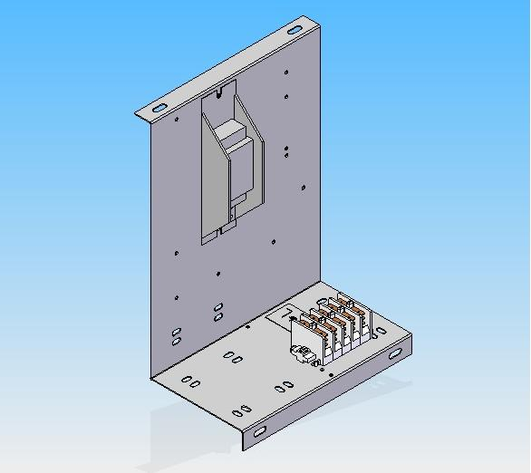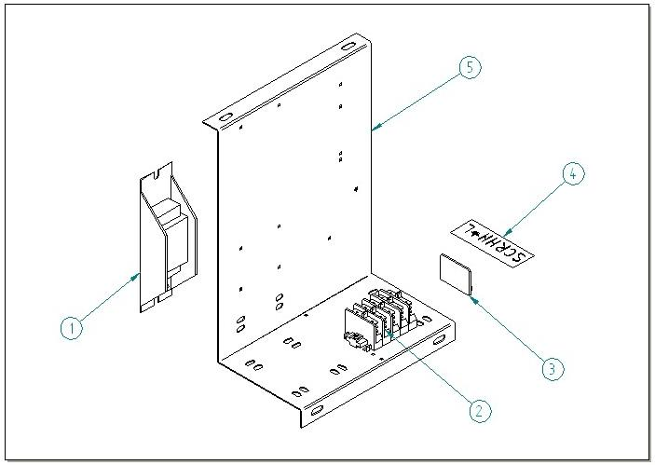

ITEM  NUMBER | DOCUMENT  NUMBER | TITLE | MATERIAL | PART NO.
1 |  | BALLAST 18-20 W |  | 4115102
2 |  | FASTON TERMINAL SCREW PA 80 |  | 4113722
3 |  | END TERMINAL PA 81 |  | 4113703
4 | VS6C 001 | ELECTRIC SYSTEM TERMINAL BOARD LABEL VS-BT | PVC INDELIBLE ADHESIVE | 4335649
5 | DA0C 003 | BALLAST HOLDER BOARD | SHEET 10/10 | 6PV45E020008

3.2 DRAIN IN BASIN

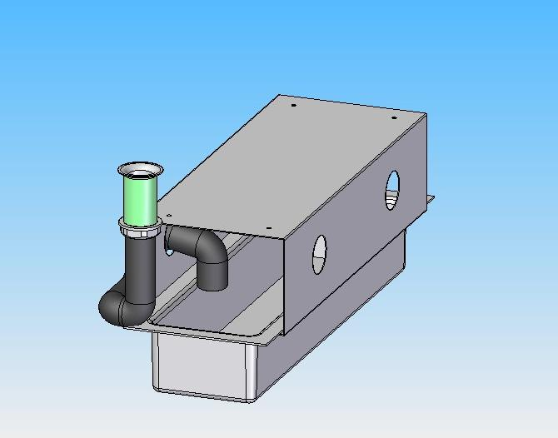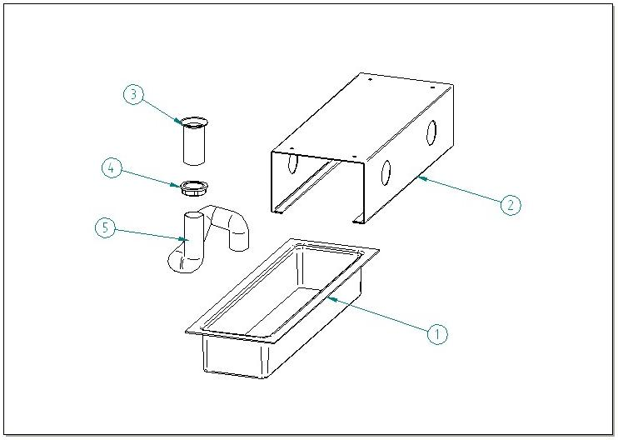

ITEM  NUMBER | DOCUMENT  NUMBER | TITLE | MATERIAL | PART NO.
1 |  | PST WHITE BASIN | PVC | 4100105
2 | ET0I 002 | CORNER BASIN GUIDE | SHEET 10/10 | 6BV90E052001
3 |  | PIPE D32 | ABS | 4102125
4 |  | PIPE NUT D32 | ABS | 4102125
5 |  | OREGON TUBE UL94V2 DIAMETER 32 | PVC | 4180815

3.3 DRAIN IN EVAPORATOR BASIN

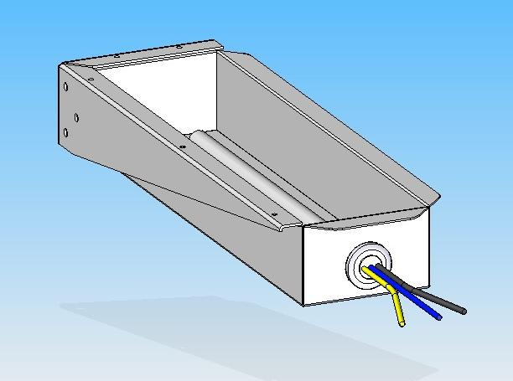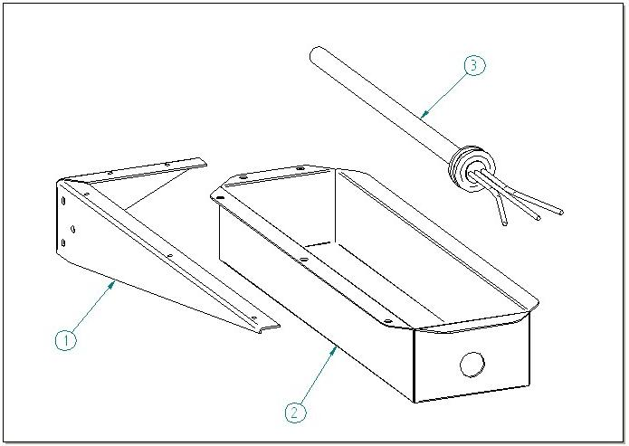

ITEM  NUMBER | DOCUMENT  NUMBER | TITLE | MATERIAL | PART NO.
1 | MV 351 | BASIN BRACKET
2 | MV 349 | EVAPORATOR BASIN | STAINLESS STEEL
3 | MV 350 | CARTRIDGE HEATER 230W |  | 4402711

3.4 DIRECT DRAIN

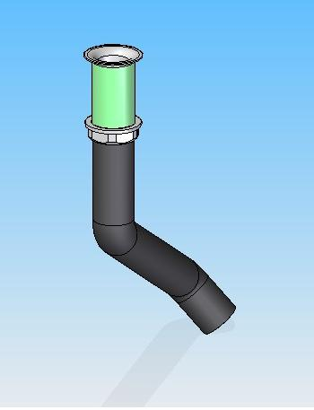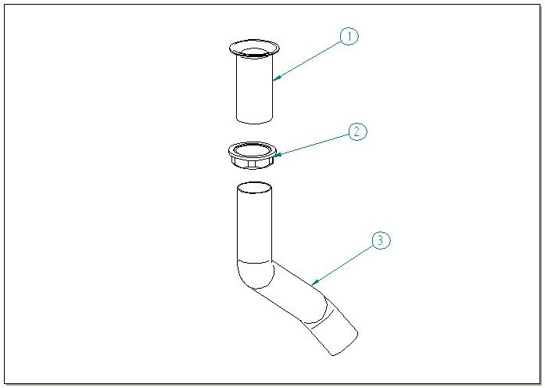

ITEM  NUMBER | DOCUMENT  NUMBER | TITLE | MATERIAL | PART NO.
1 |  | PIPE D32 | ABS | 4102125
2 |  | PIPE NUT D32 | ABS | 4102125
3 |  | OREGON TUBE UL94V2 DIAMETER 32 | PVC | 4180815

===========================================





Regione Gabannone, 4 – Zona Industriale
15030 TERRUGGIA (AL) ITALY
Tel. +39 0142 433711
Fax. +39 0142 433700

