

EXPLODED VIEW

SYNUS HOT SECTION

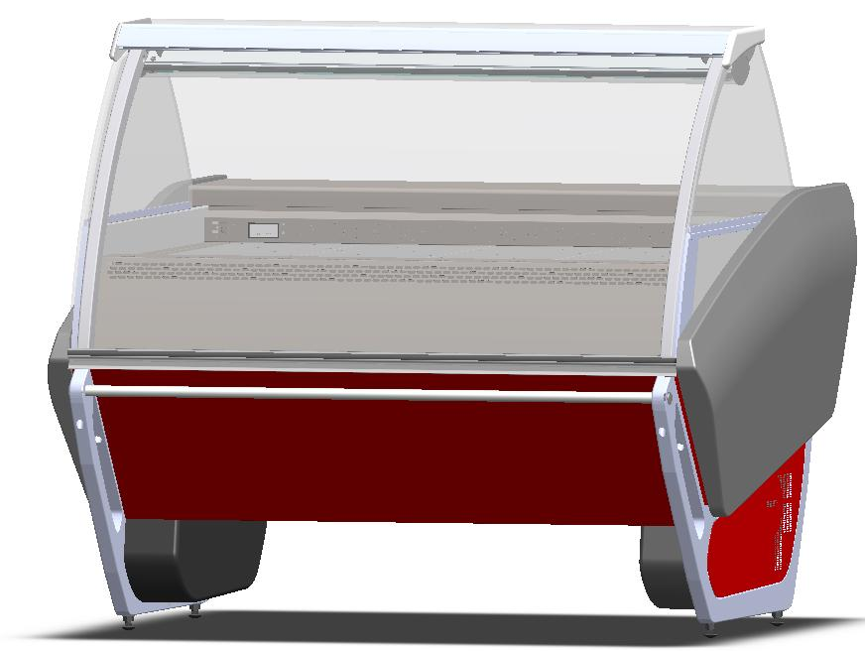

GENERAL SPLITTING UP

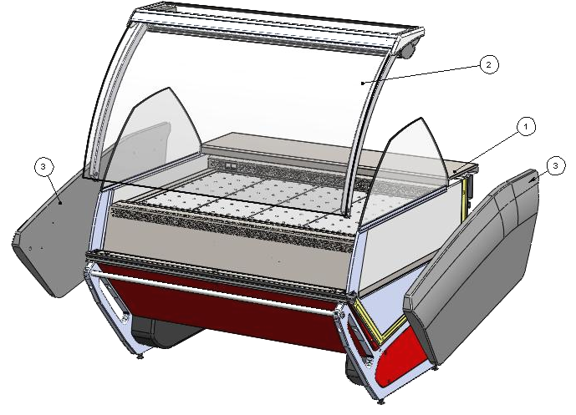

- INTERNAL FINISH, FRONTAL DECORATION
- GLASSES SUPERSTRUCTURE
- LATERAL SIDE WALL

1. INTERNAL FINISH, FRONTAL DECORATION

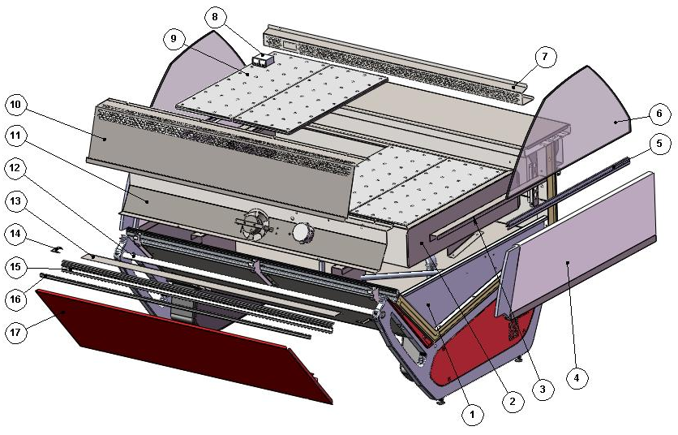

ITEM  NUMBER | DOCUMENT  NUMBER | TITLE | MATERIAL | PART NO. FOR MODULE
 |  |  |  | 1250
1. |  | BASIN INTERNAL FINISH
2. |  | BAIN-MARIE BASIN ASSEMBLY 1200
3. | TT2G004 | BASIN COMPENSATION BM 1250 | STAINLESS STEEL AISI304 SB+PRO, 10/10 | 6FI12504T006
4. |  | HOT SECTION FIXED DIVIDER |  | 2IV12504T103 (DX)
 |  |  |  | 2IV12504T104 (SX)
5. | TT0U018 | GLASS HANDLE | ALUMINIUM PROFILE
6. | SF0U003 | HIGH GLASS ON FIXED DIVIDER | FLOAT 6mm TRANSPARENT | 4190408
7. | TT2G006 | BACK GRID 1250 BM | STAINLESS STEEL AISI304 SB+PRO, 8/10 | 6FI12504T001
8. |  | THERMOMETER 0/120°C C°+ F°RO-88 BLACK |  | 4131306
9. | VLTC037 | BORED SHELFS | STAINLESS STEEL AISI304 SB+PRO, 8/10 | 6PP09604T029
10. | TT2G003 | FRONT GRID BM 1250 |  | 6FI12504T002
11. |  | HOT SECTION FANS HOLDER |  | 2FI12504T007
12. | SF0L003 | BUMPER RAIL TUBE | STAINLESS STEEL ROUND TUBE PROFILE 22X1,5 L.6000 | 2IV1250F0004
13. | SF0G013 | CENTRAL UPRIGHT STOPPER | PLAST. SHEET 6/10 | 6IV1250F0005
14. | SF0G012 | LATERAL UPRIGHT STOPPER | PLAST. SHEET 6/10 | 6IV1250F0007 (SX)
 |  |  |  | 6IV1250F0006 (DX)
15. | SF0L008 | FRONT PROFILE | ALLOY 6060 T5 | 2IV1250F0003
16. |  | GUMMY INSERT PROFILE | PVC | 4180409
17. | SF0J008 | FRONT PANEL | GALVANIZED SHEET 7/10, PAINTED | 2IV125070001

1.1. FANS HOLDER

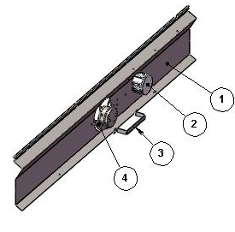

ITEM  NUMBER | DOCUMENT  NUMBER | TITLE | MATERIAL | PART NO. FOR MODULE
 |  |  |  | 1250
1. | TT2G001 | FANS HOLDER | STAINLESS STEEL AISI304 1F/2B-2F/S4, 6/10 | 6FI12504T008
2. |  | SHUNT BOX D.65 GEWISS | PLAST INSULATING MAT. GW | 4115401
3. | VLTC020 | SUPPORT FOR MNB FAN |  | 6PP09604T021
4. |  | MOTORFAN A12W23 HWBRF0 IP55 |  | 4240308

1.2. BAIN MARIE BASIN ASSEMBLY 1200

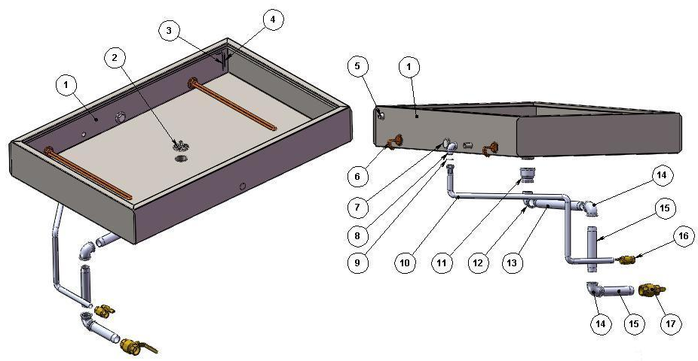

ITEM  NUMBER | DOCUMENT  NUMBER | TITLE | MATERIAL | PART NO. FOR MODULE
 |  |  |  | 1250
1. | VLTC003 | BAIN MARIE BASIN 1200 |  | 4335762
2. | VSTC021 | GRID FOR BAIN MARIE HS BASIN | STAINLESS STEEL AISI304 1F/2B-2F/S4, 6/10 | 2BV12004T012
3. | 2G012 | MINIMUM LEVEL SENSOR HS | STAINLESS STEEL WIRE D.2 | 2BV12005T004
4. | 2G012 | MAXIMUM LEVEL SENSOR HS | STAINLESS STEEL WIRE D.2 | 2BV12005T005
5. |  | THREADED SCREW TAP STOPPER ½” | PVC | 4401208
6. | KTC040 | HOT SECTION RESISTOR L.470 1000W |  | 4121408
7. |  | COLLETTOR STOPPER.1” RG92 BRASS HS |  | 4401249
8. |  | CHROMATED 90° STREET ELBOW ½” |  | 4401224
9. |  | PIPE UNION GASKET ½” |  | 4401233
10. |  | ANTIVIBRATION HOSE MALE / FEMALE , ½” X 1000 |  | 4401251
11. |  | FEMALE THREADED COUPLING 1” ½” GAS |  | 4401271
12. |  | STREET ELBOW 90° 1 ½” |  | 4401270
13. |  | EXTENDED SCREW 1" L.485 | ZINC | 4401349
14. |  | STREET ELBOW 90° 1 ½” |  | 4401346
15. |  | EXTENDED SCREW 1" L.150 | ZINC | 4401350
16. |  | BALL VALVE EFFBI FF 1/2” |  | 4401261
17. |  | BALL VALVE FF. 1’ |  | 4401302

1.3. BASIN INTERNAL FINISH

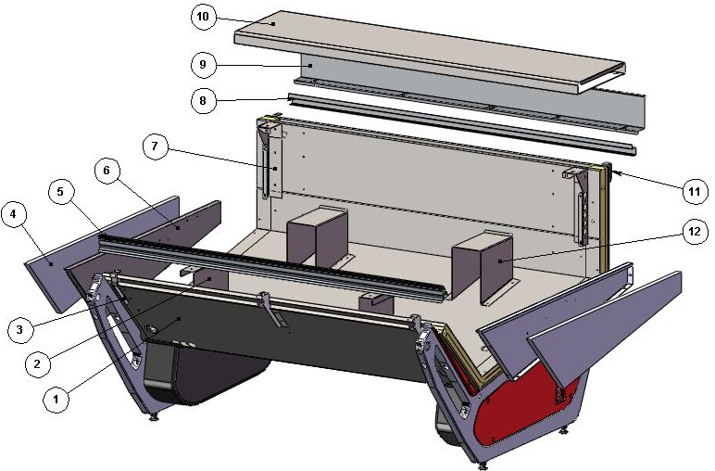

ITEM  NUMBER | DOCUMENT  NUMBER | TITLE | MATERIAL | PART NO. FOR MODULE
 |  |  |  | 1250
1. |  | BOTTOM BASIN ASSEMBLY
2. | TT2G009 | BASIN FRONT SUPPORT OMEGA | STAINLESS STEEL AISI304 2B, 15/10 | 6FI12504T011 (DX)
 |  |  |  | 6FI12504T012 (SX)
3. | SFOL002 | GLASS REBATE PROFILE SUPPORT BRACKET | GALVANIZED SHEET 15/10 | 6IV1250F0002 (SX)
 |  |  |  | 6IV1250F0001 (DX)
4. | PP042 | BASIN STOPPER INSULATION | POLYSTYRENE D.30 | 2PP096040006
5. | TT0G013 | TOP BAFFLE PROFILE | PVC | 2FI125040007
6. | PP013 | BASIN STOPPER |  | 6PP096040000 (DX)
 |  |  |  | 6PP096040001 (SX)
7. | RG110.2 | PLATFORM SUPPORT AND AIR OUTLET GRID | STAINLESS STEEL AISI304 15/10 | 4281936 (DX)
 |  |  |  | 4282029 (SX)
8. | TT0H014 | GUIDE FOR SLIDING ACCESORIES | STAINLESS STEEL AISI304 8/10 | 6FI125010028
9. | TT0H013 | BLIND WIREWAY | PLAST. SHEET 8/10 | 6FI125010007
10. |  | WORKING TABLE FIRENZE |  | 2FI12501T001
11. | TT0H004 | BACK PLATFORM SUPPORT | IRON SHEET 20/10 | 6FI125010011(SX)
 |  |  |  | 6FI125010009(DX)
12. | TT2G008 | BASIN BACK SUPPORT OMEGA | STAINLESS STEEL AISI304 2B, 15/10 | 6FI12504T010

1.3.1. BOTTOM BASIN ASSEMBLY
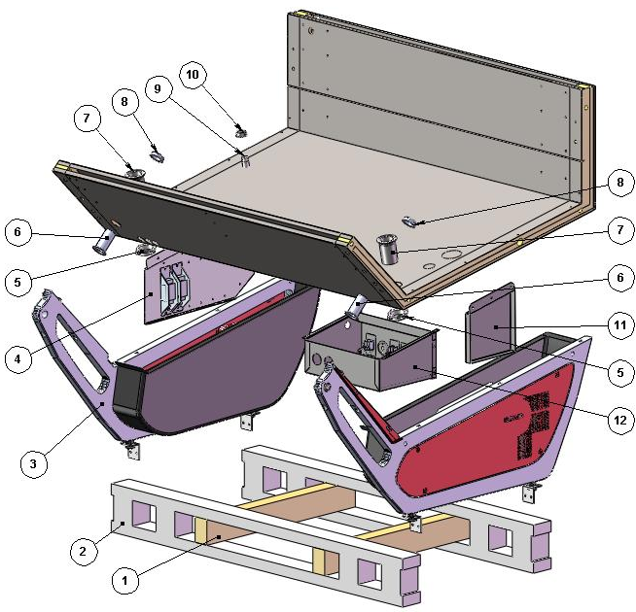

ITEM  NUMBER | DOCUMENT  NUMBER | TITLE | MATERIAL | PART NO. FOR MODULE
 |  |  |  | 1250
1. |  | SPLINE | WOOD 80 X 50 X 630
2. | TT0B014 | LOADING SLIDE | SPRUCE WOOD | 4321345
3. |  | LATERAL FRAME
4. |  | BALLASTS HOLDER PANEL
5. |  | DRAIN NUT 1” 1/2 GAS | ABS | 4102132
6. |  | NUT EXCELLEN. H90 D32-10106 | ABS | 4102125
7. |  | NUT 10124 1'1/2 GAS L.75 MM | ABS | 4102132
8. |  | DRAIN NUT D32 | ABS
9. |  | NUT D. 20 | ABS | 4102101
10. |  | DRAIN NUT D. 20 | ABS | 4102101
11. | SF2I001 | DRAIN – LOAD SUPPORT BOARD | GALVANIZED SHEET 10/10 | 6IV12504T102
12. |  | CONTROL BOARD HS + IL.S.O I. |  | 2FI12502T000

1.3.1.1. LATERAL FRAME
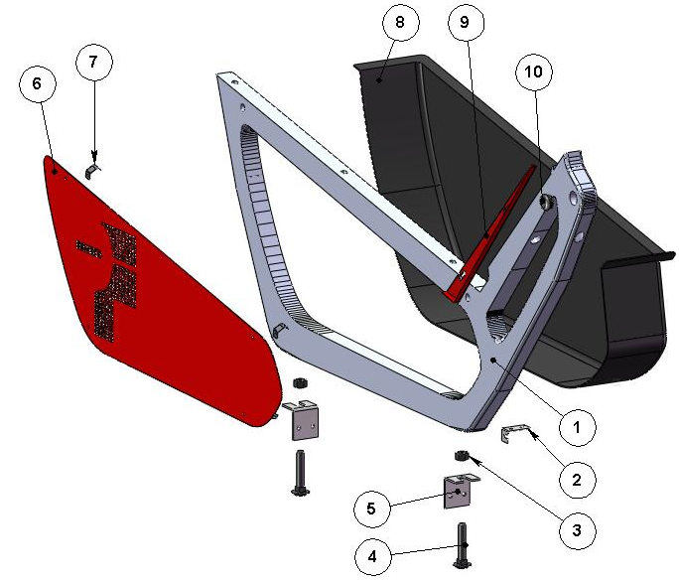
ITEM  NUMBER | DOCUMENT  NUMBER | TITLE | MATERIAL | PART NO. FOR MODULE
 |  |  |  | 1250
1. | SF0B001 | FRAME | ALUMINIUM ALLOY | 2IV125060001
2. | SF0B 010 | CASE FIXING BRACKET | GALVANIZED SHEET 10/10 | 6IV125060003 (SX)
 |  |  |  | 6IV125060002 (DX)
3. |  | NUT SPACER M14 | GALVANIZED IRON
4. |  | BOLT M12X45 | GALVANIZED STEEL
5. | SF0B008 | LOADING SLIDE FIXING BRACKET | IRON SHEET 30/10 | 4282832
6. | SF0B004 | LATERAL FRAME CLOSURE | GALVANIZED SHEET 10/10 | 2IV125080014 (SX)
 |  |  |  | 2IV125080004 (DX)
7. | SF0B005 | SPRING FOR LATERAL CLOSURE COUPLIG | STAINLESS STEEL AISI301 5/10 | 4282798
8. | SF0B003 | CASE CLOSURE | ABS | 4100339 (SX)
 |  |  |  | 4100338 (DX)
9. | SF0J007 | FRONT SIDE WALL STOPPER | GALVANIZED SHEET 7/10 | 2IV125070005 (SX)
 |  |  |  | 2IV125070004 (DX)
10. |  | STOPPER P.V.C.CHROMED D.25 S.T.1 |  | 4333107

1.3.1.2. BALLASTS HOLDER PANEL AND CONTROL BOARD HOT SECTION

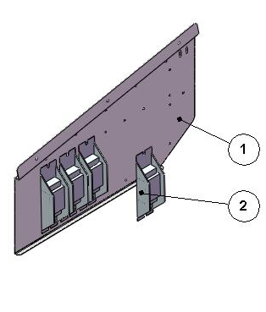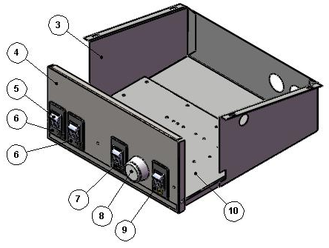

ITEM  NUMBER | DOCUMENT  NUMBER | TITLE | MATERIAL | PART NO. FOR MODULE
 |  |  |  | 1250
1. |  | BALLASTS PANEL | IRON SHEET 10/10 | 2IV125090003
2. |  | BALLAST |  | 15W | 18 – 20 W | 30W | 36 – 40 W | 58 – 65 W
 |  |  |  | 4115106 | 4115102 | 4115103 | 4115104 | 4115105
3. | RG053 | ELECTRICAL COMPONENT COMPARTIMENT (310X230) | GALVANIZED SHEET SKIMPAS, 7/10 | 6SV096020002
4. | VLTC068Q | FRONT CONTROL BAIN MARIE R.I. | PLASTICIZED SHEET N38PP, 6/10 | 6KV000000284
5. |  | BLACK BIPOLAR SWITCH R515KKFTOFA BOARD |  | 4113524
6. | RG040 | ADHESIVE LIGHT PLATE "SIGMA" |  | 4335638
7. | RG058 | RESISTOR PLATE |  | 4335639
8. |  | THERMOSTAT TR/86 30900-05 +30°+90° |  | 4130107
9. | RG059 | FANS PLATE |  | 4335640
10. | RG054 | ELECTRICAL COMPONENTS SUPPORT (BOARD HOLDER ) | GALVANIZED SHEET 10/10 | 6SV096020003

2. GLASSES SUPERSTRUCTURE

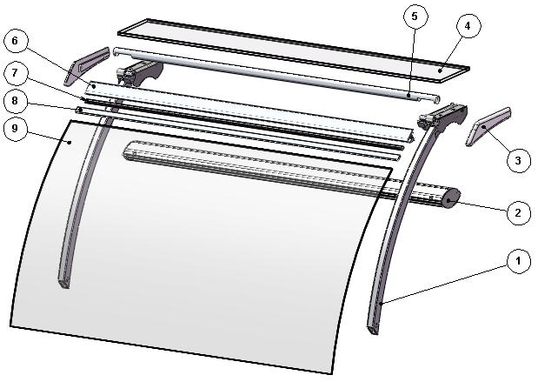

ITEM  NUMBER | DOCUMENT  NUMBER | TITLE | MATERIAL | PART NO. FOR MODULE
 |  |  |  | 1250
1. |  | LATERAL UPRIGHT
2. |  | TOP CEILING LAMP FI |  | 2FI125030009
3. | SF0M003 | GLASS SIDE HEAD | RIM / PUR D. 350 Kg/m³ | 2IV125080013 (SX)
 |  |  |  | 2IV125080003 (DX)
4. | SF0D002 | HEAD GLASS | FLOAT 10mm | 4199915
5. | SF0D021 | LEVER CLOSURE TUBE | ALUMINIUM TUBE Ø28 Th. 1.5 | 2IV125030006
6. | TT0D011 | JAW PROFILE | JAW ALUMINIUM PROFILE | 4190739
7. | TT0D031 | JAW INSERT PROFILE | ALUMINIUM PROFILE E5628A | 2FI125030008
8. |  | GLASS GASKET PROFILE | PVC | 4180100
9. | RG004.1 | CURVED GLASS R1000, L.1250 | FLOAT 6 mm | 4190739

2.1. LATERAL GLASS UPRIGHT
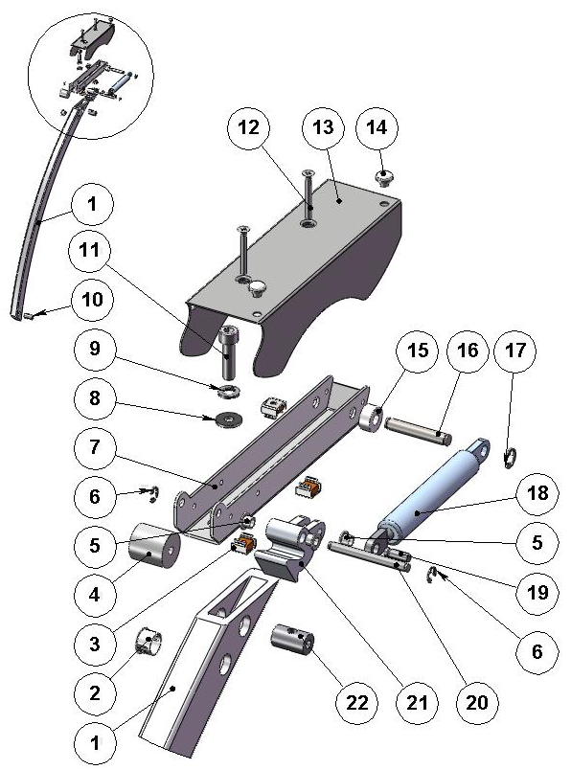

ITEM  NUMBER | DOCUMENT  NUMBER | TITLE | MATERIAL | PART NO. FOR MODULE
 |  |  |  | 1250
1. | TT0D002 | CURVED FRONT UPRIGHT | ALLOY 6060 T5 | 4351209
2. |  | WHITE STOPPER DP500 | PLASTIC | 4333114
3. |  | CAGE NUT M5
4. |  | SPACER WITH HOLE | NYLON | 4331409
5. | ECAV 016 | PISTON BUSH | NYLON | 8291718
6. |  | SEGGER 5 | GALVANIZED STEEL | 8298303
7. | TT 0D001 | LEVER SUPPORT | IRON SHEET 20/10 | 2FI125030013
8. |  | PLAIN WASHER 8X24 | GALVANIZED STEEL
9. |  | GROWER M8
10. | RG072 | BACK GLASS UPRIGHT PIN | STEEL BAR Ø15 | 4140070
11. |  | BOLT TCEI M8X30 | GALVANIZED STEEL
12. |  | BOLT TS+ M5X35 | STAINLESS STEEL
13. | SF0D017 | LATERAL LEVER COVER | GALVANIZED SHEET 15/10 | 2IV125030004 (SX)
 |  |  |  | 2IV125030003 (DX)
14. |  | RUBBER BUFFER |  | 4332602
15. |  | SPACER WITH HOLE DCS79B 6R ELECTROZUB | NYLON
16. | TT0D005 | LATERAL BACK PIN | GROUND DRAWN STEEL Ø8 | 4140086
17. |  | SEGGER 7 | GALVANIZED STEEL | 8298304
18. |  | PISTON VS-SV R 1000 084034 700 N | STAINLESS STEEL | 4145022
19. | ECAV018 | PISTON FRONT PIN | GROUND DRAWN STEEL Ø6
20. | TT0D003 | LATERAL FRONT PIN | GROUND DRAWN STEEL Ø6 | 4140085
21. | AV011 | ROTATION LEVER PRESSOFUS | ALUMINIUM ALLOY | 4282114 (SX)
 |  |  |  | 4282113 (DX)
22. | TT0D013 | GLASS UPRIGHT PIN | STEEL BAR Ø15 | 4140088

2.3. CEILING LAMP

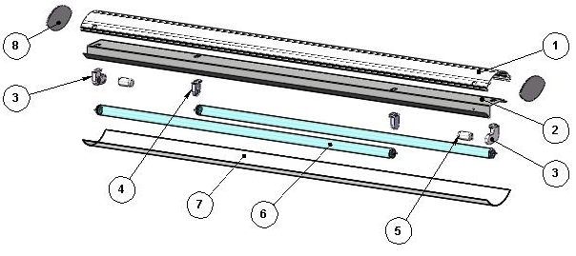

ITEM  NUMBER | DOCUMENT  NUMBER | TITLE | MATERIAL | PART NO. FOR MODULE
 |  |  |  | 1250
1. | TT0E002 | CEILING LAMP PROFILE | ANODIZED ALUMINIUM | 2FI125030010
2. | TT0E014 | TOP LAMPS HOLDER | PLASTICIZED SHEET 8/10 | 6FI125030011
3. |  | LAMPS HOLDER + STARTERS HOLDER STUCCHI 255/C | PVC | 4114710
4. |  | LAMP HOLDER STUCCHI 255/S 2A 250V | PVC | 4114709
5. |  | UNIVERSAL STARTER FS 11 |  | 4116001
6. |  | NEON 30 W/76 D.26 L 900 |  | 4114510
7. | TT0E015 | TOP POLYCARBONATE CEILING LAMP | POLYCARBONATE 7/10 | 6FI125030012
8. | CC0D023.1 | PLEXIGLAS FOR CEILING LAMP | OPAL GLASS 3mm | 4082305

3. LATERAL SIDE WALL

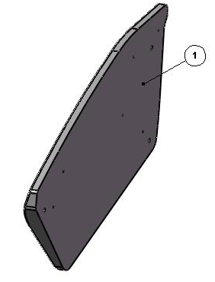

ITEM  NUMBER | DOCUMENT  NUMBER | TITLE | MATERIAL | PART NO. FOR MODULE
 |  |  |  | 1250
1. | SF0M001 | SIDE WALL SYNUS POL. PAINTED | POLYURETHANE Thickness 50mm | 2IV125080012 (SX)
 |  |  |  | 2IV125080002 (DX)

===========================================





Regione Gabannone, 4 – Zona Industriale
15030 TERRUGGIA (AL) ITALY
Tel. +39 0142 433711
Fax. +39 0142 433700

